POLYMERS, PLASTICS, AND BIOPLASTICS

NAME:

CLASS HOUR:


Part 1: What Do You Know?

Directions: Fill in what you already know about plastics and what you wonder or are curious about.

I Know... | I Wonder...
Example: Plastic is used in water bottles. | Example: Can plastic be made from plants?

 Part 2: Plastic in Your Life

Circle all the items where you’ve seen plastic used in your daily life:

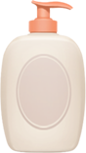 Water bottles 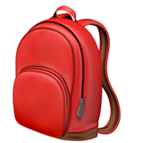 Backpacks  Food wrappers 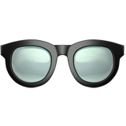 Eyeglasses 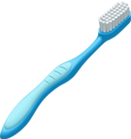 Toothbrush

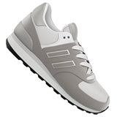 Shoes 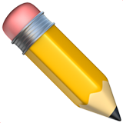 School supplies  Cell phone

Why do you think plastic is used in so many things?

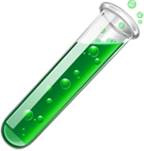
Part 3: Quick Predictions

Write Yes or No next to each question:
- Can plastic harm the environment?
- Is it possible to make plastic from corn or other plants?
- Does plastic ever break down completely?
- Is all plastic bad?

Natural polymers
List or draw some items in the box below.


Synthetic polymers
List or draw some items in the box below.

CONSTRUCT A POLYMER MODEL FROM PAPERCLIPS

You will work with your table partner on this activity. Read the instructions carefully as you design your polymer chain.

Instructions: Each group will receive 30 paper clips. You are constructing polymers. Polymers are made up of monomers. Each paper clip is considered a monomer. Begin building chains and answer the following questions as you work.

- Start building a chain that is 10 clips long. How does your chain move when you pull on it?

- Add more monomers to your chain to change the shape of your polymer. (Example: You could add branches or cross-link.) Draw a picture of your new polymer below.

- How does the new shape of your polymer affect how it moves or bends?

- Gently pull on the ends of your polymer. How did your changes affect the strength of your polymer when compared to your answer in #1?

BIOPLASTICS PRE-ACTIVITY SHEET

What if we could create plastics out of biological products that are sustainable and compostable? We will be making bioplastics from two diﬀerent products that are renewable: Gelatin and corn starch.

- Think about some of the ways you use plastic every day. List them here.

- What are some of the properties of those plastics? (bendable, stretchable, etc.)

- Do you think bioplastic products could replace plastic products? Name some products that you think could be made with bioplastics.

Let’s look at the ingredients in the activity. Write what they will DO in the recipe.

Corn starch
Gelatin
Vinegar
Glycerin

What products in the recipe do you think will aﬀect the final product? (Remember: What role does each product play in the recipe?)

PLANT-BASED BIOPLASTIC – RECIPE #1

Instructions: Follow the recipe below to design your bioplastic. Carefully read through the
whole procedure before you begin.

Supplies:
- 10 mL distilled water
- 0.5-1.5 g glycerol
- 1.5 g cornstarch
- 1 mL white vinegar
- 1-2 drops food coloring
Equipment:
- 1 small saucepan
- 1 spatula
- 1 hot plate
- 1 piece of aluminum foil or parchment paper (30 cm x 30 cm)

- Take a piece of parchment paper or aluminum foil and write your group number and hour on one of the corners.

- Combine all of the ingredients in the saucepan and stir together with the spatula. Stir until you get rid of most of the lumps in the mixture. At this stage, the mixture will be a milky white color and quite watery.

- Place the saucepan on the stove and turn the heat to medium-low. Stir continuously as the mixture heats. Bring it to a gentle boil. As the mixture heats, it will become more translucent and begin to thicken.

- Remove the mixture from the heat when it becomes clear and thick. Total heating time will be around 10-15 minutes. Don’t overheat! Lumps may begin to form if the mixture gets overheated.

- Pour your plastic out onto the aluminum or parchment sheet. Spread it out so it is all the same thickness.

- Measure the length and width (in cm) of your plastic and write it here:

L: W: (L x W = Area) A=

- Let the bioplastic cool at your table for a few minutes and then move it to the cooling racks.

- Clean up your area! Clean equipment and put it away.

ANIMAL-BASED BIOPLASTIC – RECIPE #2

Instructions Follow the recipe below to design your bioplastic. Carefully read through the whole procedure before you begin.

Recipe:
- 240 mL cold water
- 48 g gelatin powder
- 12 g glycerol
- 1-2 drops food coloring
- (optional) 1 drop essential oil (scent)
Equipment:
- 1 small sauce pan
- 1 spatula
- 1 hot plate
- 1 piece of aluminum foil or parchment paper (30 cm x 30 cm)

- Prepare your aluminum foil or parchment paper by making a shape with shallow sides. The foil can be bent; the paper can be taped to hold the edges together. Write your team number and class hour on the corner of the foil/paper.

- First mix the cold water and the gelatin powder in the pan without heating. Gradually, the mixture will turn into a granular yellow pale paste.

- Put the pan on your hot plate and turn it to medium. Keep stirring the mixture while you are heating so that there are no lumps.

- Once the preparation has become liquid and thoroughly mixed, add the glycerin, essential oil, and food coloring into the mixture.

- Continue mixing and heating until you begin to see a whitish deposit on the surface of the mixture. If you want a transparent matter you must completely remove this white foam with a spoon. Otherwise, you can keep it inside the mixture; it will dry on the surface and create a fluffy part.

- Now pour your mixture into the prepared surface. Measure the length and width (in cm) of your plastic and write it here: L: W: L x W = area. A=

- After your plastic has cooled enough to handle, move it to the drying rack.

- Clean up your area! Clean equipment and put it away.

Drying Day – Measurements

- Measure the length and width of your bioplastic in cm.
L: W: . Now L x W = Area. A=
Compare that with the original sizes: L: W: Area:
How much shrinkage has occurred? Here’s how you will figure it out:

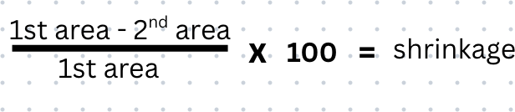

- Flexibility test: Circle one (carefully bend your plastic)

Very flexible Somewhat flexible Not flexible

- Rigidity test: Circle one (put it flat on the table and press down on the center of the plastic)

- Does it hold its shape (rigid)?

- Does it flatten or bend (soft or flexible)?

***The challenge for tomorrow’s activity will be to change the outcome of your bioplastic.

If your plastic is rigid, you need to change ONE variable in your recipe to make the new batch flexible.

If your plastic is flexible, you need to change ONE variable in your recipe to make the new batch more rigid.

Discuss this as a group and choose the variable you plan to change.

Remaking your bioplastic!

Now you will remake your recipe but change ONE variable. (Examples: doubling the amount of glycerin or halving the amount of cornstarch.)

List what you are changing here:

What do you think the change will do to the outcome of the bioplastic?

Why did your group choose this variable?

Gather your supplies and make your new bioplastic! Follow the same directions EXCEPT for the ONE variable you are changing.

Batch 2:
Length: width: L x W = area:

Next Day:
L: W: area: . Difference:

Compare the flexibility or the rigidity of your first batch and your second batch. Record your results below.

Flexibility: Rigidity:

Bioplastic Activity Wrap-up

- What ingredients did you use to make your bioplastic?

- What surprised you about your bioplastic?

- What variable(s) did you change to make your second bioplastic batch, and how did you alter them? (Example: I changed the amount of from to .)

- Which characteristic were you trying to change in your second bioplastic?

- Think about your design challenge for the second batch of bioplastic (i.e., to make it more rigid or more flexible). If your changes did work, explain what you think you did right. If your changes didn’t work, what do you think you would try diﬀerently?

- Would it be possible to replace some of the plastic we use regularly with bioplastic? Why or why not?

- What product(s) could your bioplastic be used for?

