**Plastic Brick Kit Components**

|  |  |  |
| --- | --- | --- |
| **Type** | **Size** | **TOTAL** |
| Brick | 1x1 | 100 |
| 1x2 | 100 |
| 1x3 | 40 |
| 1x4 | 40 |
| 2x2 | 24 |
| Plate | 2x2 | 60 |
| 2x6 | 20 |
| 2x8 | 30 |
| 2x10 | 15 |
| 4x6 | 20 |
| 4x10 | 2 |
|  | 1x2 | 50 |
| 1x2 (open) | 50 |
| 2x2 | 40 |
|  | Large | 4 |
| Medium Soft | 28 |
| Solid - Hard | 28 |
| Small | 28 |
| Axle  https://sh-s7-live-s.legocdn.com/is/image/LEGOPCS/460026?$PABthumb$  https://sh-s7-live-s.legocdn.com/is/image/LEGOPCS/6092658?$PABthumb$ | Big | 4 |
| Small One Side | 68 |
| Small Two Sided | 14 |
|  | Large | 4 |
| Medium | 28 |
| Small | 28 |
| Steering Wheel  https://sh-s7-live-s.legocdn.com/is/image/LEGOPCS/9551?$PABthumb$ | One Size | 20 |
| Wind Shield   | 2x4 | 20 |
| 3x6 | 3 |
| Driver | One Size | 2 |

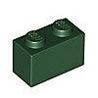

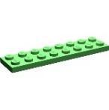

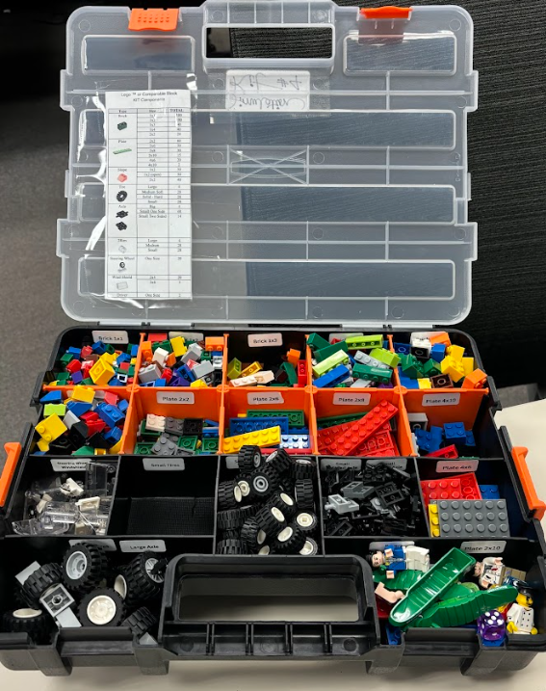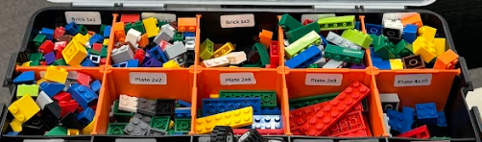

*“Plastic Brick Kit - Labeled”*