**Manufacturing Performance Review Sheet**

1. Open the [Spreadsheet](https://docs.google.com/presentation/d/12kVqZJU4ij8lCrxBDAoEc9EB5FtdjCYy/edit?usp=sharing&ouid=107755347891828983268&rtpof=true&sd=true) and make a copy. Rename the file with the following format: Company’s Name_Data Analysis.

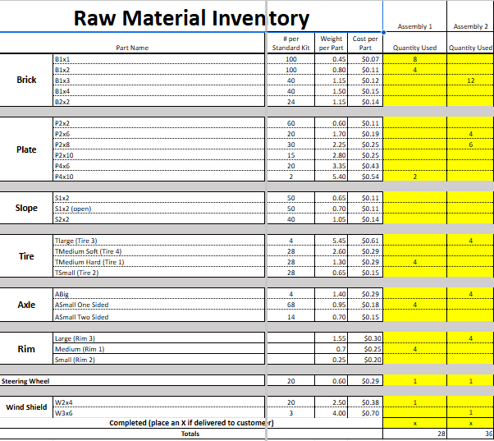

1. Access the saved Customer Order Forms from your company’s production line in the last activity.
2. Enter the raw material amounts for each vehicle into the columns labeled Assembly 1, Assembly 2, etc. Replace any existing data—it is just sample information. Each Assembly column represents ONE vehicle.

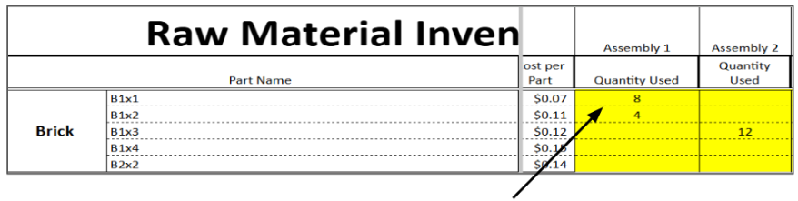

1. In Row 40, put an “X” if a vehicle passed quality testing. Leave it blank if it did not.
2. Use the scroll bar at the bottom to move to the right of the spreadsheet. Enter data in all yellow sections. Do not change anything in the white boxes.
3. Production Time will be how much allotted time was given for the production run. (Your teacher will give you this amount.)
4. If you double-click a box where you are entering a value, you might see a formula. It is helpful to understand what the formula is calculating. For example:

**Total Cost of Labor = U19 × U20 × U21**

= (Number of Employees) × (Labor Rate per Minute) × (Total Time in Minutes)

1. Use the spreadsheet to see how well your updated craft production system works by looking at how many cars you made and how much money you earned. Try changing things like the labor rate, material costs, and how long it takes to build the cars. See how these changes affect your profit and find ways to improve your system to make more money.
2. Reflect as a team, using the following questions as a guide.

### **Time Management**

* How effectively did your team manage the allocated time for the production process?
* Were there any stages where time was wasted or bottlenecks occurred? If so, which stages, and why?
* What strategies did you implement to improve time management during the simulation?
* In hindsight, how could you have better scheduled the different stages of production?

### 

### **Overall Cost**

* How did you track and manage costs throughout the production process?
* What were the major cost drivers in your production?
* Did you encounter any unexpected costs? How did you handle them?
* How could you reduce costs in future production cycles without compromising quality?

### 

### **Manufacturing Efficiency**

* How efficient was your production process from start to finish?
* Were there any steps in the process that could be streamlined or automated?
* Did you face any challenges that affected the efficiency of your production? How did you overcome them?
* What changes could you implement to improve manufacturing efficiency in future simulations?

### 

### **Effectiveness of Quality Testing**

* How did you incorporate quality testing into your production process?
* Was your quality testing effective in identifying defects or issues? Why or why not?
* How did the results of quality testing impact your overall production?
* What improvements could be made to your quality testing procedures to ensure better outcomes?
* How did you determine the pricing strategy for your products?
* What factors influenced the revenue generated from your production?
* Did you meet, exceed, or fall short of your revenue expectations? What contributed to this outcome?
* What strategies could you implement to increase revenue in future production cycles?

### 

### **Improvement Recommendations**

* Based on your experience, what are the key areas for improvement in your production process?
* What specific actions would you recommend to enhance time management in your company?
* How can your company better manage and reduce overall production costs?
* What steps can be taken to improve manufacturing efficiency and reduce waste?
* How can your company enhance the effectiveness of quality testing to ensure product excellence?
* What marketing or sales strategies could be employed to boost revenue generation?

### 

### **Reflection and Future Planning**

* What was the most significant lesson you learned from this simulation?
* How will you apply the insights gained from this simulation to real-world manufacturing scenarios?
* If you could restart the simulation, what would you do differently, and why?
* What additional skills or knowledge do you think are necessary to improve your performance in future simulations?