What is Python? Activity Answer Key

Directions
Open the file WhatIsPython_NOTEBOOK.ipynb in Google Colaboratory by selecting “File->Open Notebook” (NOTE: You will need a Google Account to use Google Colaboratory.) Read each cell (block) of text, and run each cell of code by clicking the play button on the left side of the block as indicated by the red circle in the figure below.

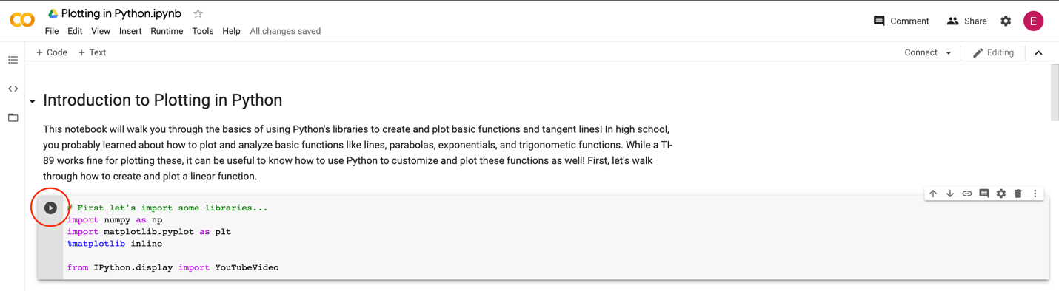

As you read, watch, and run each cell, answer the following questions:

- Plotting a line. Watch the video on “Slope-intercept form” by Khan Academy that is linked in the notebook. Then, run the code to plot a line. Using the code as a guide, answer the following:

  - What is the role of the function create_line()? What does it do?
Create_line() takes a set of x values and returns the corresponding y values for a line, given the line’s slope and y-intercept

  - What do you think np.arange() does? (HINT: look at the comments in the code!)
Np.arange() creates a sequence of values that starts at the first argument value and ends at the second argument value

  - Change the plotted line so that it has a slope of -7 and a y-intercept of 4. What did you need to change in the code to make these changes?
Changed the variable slope to a value of -7 and the variable y_int to a value of 4

- Plotting points on a line. Change the line-plotting code back so that it has a slope of 2 and a y-intercept of 1. Run the code to plot the line, then run the code to plot two points on the line. Using the code as a guide, answer the following:

  - What function was used to create the y coordinate for our point? (HINT: y_pt is the variable used for the y coordinate.)
Create_line()

  - In your own words, explain how the create_line() function works in this code block.
Create_line() takes an x value (and returns the corresponding y value given a slope and y-intercept

- Plotting a quadratic function. Watch the video on “Graphing quadratics” by Khan Academy that is linked in the notebook. Then, run the code to plot a parabola and the code to plot a point on the parabola. Using the code as a guide, answer the following:

  - What is the role of the function create_para()? What does it do?
Create_para() takes a set of x values and returns the corresponding y values for a parabola given the parabola’s vertex coordinates and amplitude

  - What value does each of the following variables hold? (HINT: the answer is NOT the numeric value, think about each part of the quadratic equation.)
    - a: amplitude

    - n: power/exponent

    - xv: x coordinate of vertex

    - yv: y coordinate of vertex

  - Change the plotted parabola so that is has a vertex at (-2, 10). What did you need to change in the code to make these changes?
Changed xv to -2 and yv to 10

- Plotting a secant line. Read the cell describing derivative estimation and plotting a secant line. Then, run the code to plot the secant line and answer the following:

  - What is the role of the function line2pts()? What does it do? (HINT: You may want to review how to find an equation using two points.)
Line2pts() takes a set of x values and determines the corresponding y values for a line given the x and y coordinates for two points on the line

- Plotting the derivative of a parabola. Run the code for calculating and plotting the derivative of a parabola and answer the following:

  - What is the role of the function derive_para()? What does it do?
Derive_para() takes the y values from a parabola and calculates the y values for the parabola’s derivative

  - Based on what you know about the derivative of a parabola, what should the derivative look like? Is it a parabola, line, or some other type of function?
The derivative of a parabola is a line

- Plotting the integral of a parabola. Run the code for calculating and plotting the integral of a parabola and answer the following:

  - What is the role of the function integrate_para()? What does it do?
Integrate_para() takes the y values from a parabola and calculates the y values for the parabola’s integral

  - Based on what you know about the integral of a parabola, what should the integral look like? Is it a parabola, line, or some other type of function?
The integral of a parabola is a cubic function

