Section 3: Independent Practice Worksheet Answer Key

Instructions: We know from the Netcat network reconnaissance guided practice that the Kali username and password consists of eight alpha characters and the letters a, d, f, i, m, n s. However, pretend we are not sure of the order of those characters except for the first four characters (msfa. . . .). Use Maskprocessor to generate both your user and password wordlists in the /root/wordlists folder. The more accurate your wordlist, the better the time savings.

(Suggested Solution)
Given that we know the order of the first six lower case characters (msfadm _ _), the total characters (adfimns), and the length (8 characters) of the Metasploitable2 username and password, we can use Maskprocessor to output the following strategic wordlist:

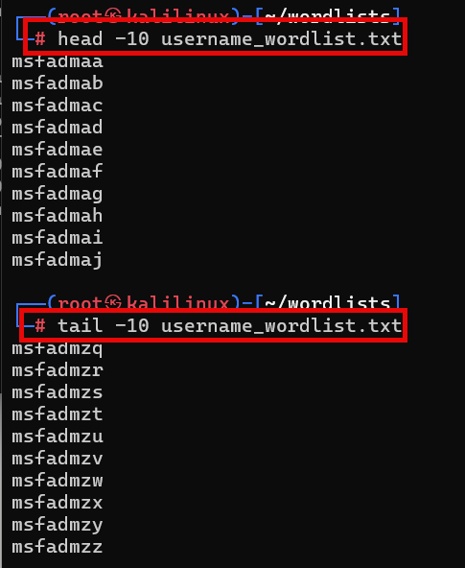

The outputs begin with “msfad” and all eight-character possibilities are completed. The user and password wordlists will be the same.

