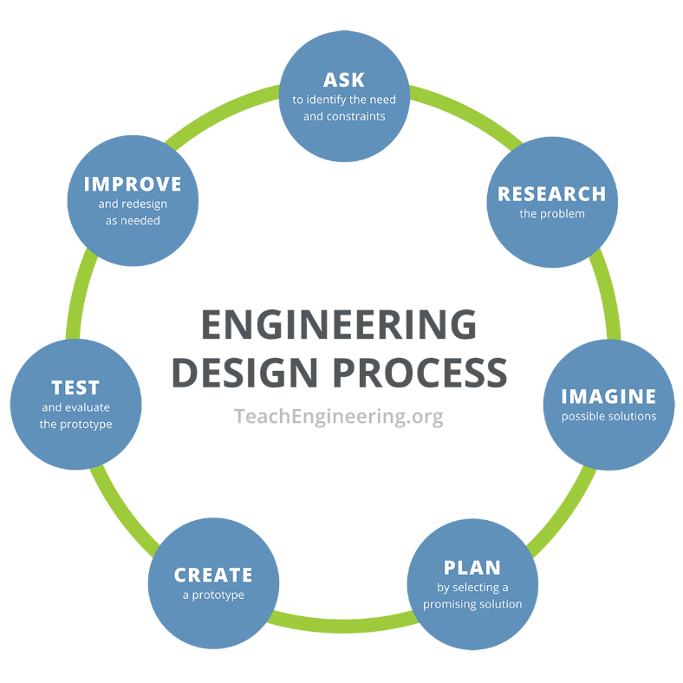**Gatorade Gravity Machine Worksheet – Answer Key**

**Step 1: Ask**

1. In your own words, what problem are you trying to solve?

A local soccer team needs a gravity-powered Gatorade machine that can mix at least two different Gatorade powder flavors together. This machine must be able to stand on its own, have two separate areas to hold the two different powders, and allow water to flow through the machine into both powders and then into one final cup. The final cup much be removable so that the soccer player can drink their cup of Gatorade.

1. In your own words, what are the constraints of the problem?

* Machine is self-supporting (you can’t use your hands to hold it together).
* The initial water must be placed in a cup without the Gatorade powder.
* The powders must be placed in two separate cups.
* Machine must fit on the provided tray.
* The final cup must be removable.

1. In your own words, what is the goal of your machine? Or what should your machine be able to do?

* Overall: The machine should mix water and two Gatorade powders together to make one cup of Gatorade.
* There should be minimal loss of liquid.
* The final cup of Gatorade should be flavorful (i.e., plenty of powder mixed in).

**Step 2: Research**

1. What machines you have seen or used that combine two flavors or two ingredients?

Answers vary. Potential answers:

**Soda fountains** – These machines allow you to mix different sodas or flavors into one drink, like combining cherry and cola.

**Soft-serve ice cream machines** – Many of these machines can swirl two different ice cream flavors together, like vanilla and chocolate.

**Slushie machines** – Some slushie machines let you mix different flavors of frozen drinks.

**Vending machines for hot chocolate or coffee** – These machines often mix powdered ingredients like cocoa or coffee with water or milk to create the final drink.

1. What are some things you have seen that have water flow through them?

Answers vary. Potential answers:

**Fountains** – Water flows through pipes and sprays out in patterns or cascades down tiers.

**Water slides** – Water flows down the slide to help people glide smoothly.

**Water hoses** – Water flows through the hose to water plants or clean surfaces.

**Water filters** – Water flows through the filter to remove impurities.

**Toilets** – Water flows through the tank and bowl to flush away waste.

**Aquariums or fish tanks** – Water flows through filters to keep the tank clean.

1. How could you get water to flow from one cup to another without tipping either cup? (Draw a picture to help explain)

Answers vary. Potential answers:

* **Tube or straw:** Place a tube or straw in the first cup and direct the other end into the second cup. The water will flow through the tube due to gravity if the tube is positioned correctly.
* **Spout or funnel:** Use a small spout or funnel to channel the water from one cup to the other. The spout or funnel should be angled so that gravity helps guide the water into the second cup.
* **Siphoning:** Start a siphon by filling a tube with water and placing one end in the first cup and the other end in the second cup, lower than the first cup. Once water starts flowing through the tube, it will continue to transfer from the first cup to the second due to gravity.
* **Inclined plane:** Tilt the first cup slightly to pour water into the second cup, using a sloped surface or inclined plane to help guide the water flow while keeping both cups mostly upright.

**Step 3: Imagine**

1. Individually brainstorm and sketch 5-6 ideas of potential machines with the materials presented.

|  |  |
| --- | --- |
| 1. Answers vary. |  |
|  |  |
|  |  |

**Step 4: Plan**

1. New constraint: Each group has **$900** to spend on the materials listed below. (Note: Gatorade powder and water are provided for free.)

|  |  |  |  |
| --- | --- | --- | --- |
| **Materials** | **Price** | **# to Purchase** | **Amount Spent** |
| 5 small cups | $100 |  |  |
| 2 pieces of cardboard | $100 |  |  |
| 4 straws | $100 |  |  |
| 5 popsicle sticks | $100 |  |  |
| 6 toothpicks | $100 |  |  |
| 4 unsharpened pencils | $100 |  |  |
| 2 plastic spoons | $100 |  |  |
| 2 ft. string | $100 |  |  |
| 1 ft. duct tape | $100 |  |  |
|  |  | Total Cost |  |

1. New constraint: Judging Criteria

* 10 points for each $100 saved
* 100 points if water makes it to bottom cup
* 50 points if the water only mixes with one powder OR 150 points if water mixes with both powders
* 10 points for each cup the water reaches

1. Plan: Draw your group’s chosen design below. Make sure to identify the materials to be used and the dimensions of each component.

Answers vary.

**Step 5: Create**

1. Build your design!
   1. Buy your materials.
   2. You have 30 minutes to build your design.
   3. During the build, you may make changes from your design and buy more materials, but you MUST note it in your design drawing.
   4. You may conduct unofficial tests with just water. (Remember: In engineering, we use tests to gather information and improve designs.)

**Step 6: Test**

1. Test your team’s design by placing 2 tablespoons of Gatorade powder in two separate cups. Pour 6-12 oz. of water through the machine.
2. Answer the following questions after you test your design:
   1. What worked?

Answers vary.

* 1. What didn’t work?

Answers vary.

**Step 7: Improve**

1. In engineering, we are always working to improve technology. We make sure to test all new ideas to understand how we can make our ideas better. What do you think you would want to improve on your design?

Answers vary.

1. What was the most challenging part of this design process?

Answers vary.