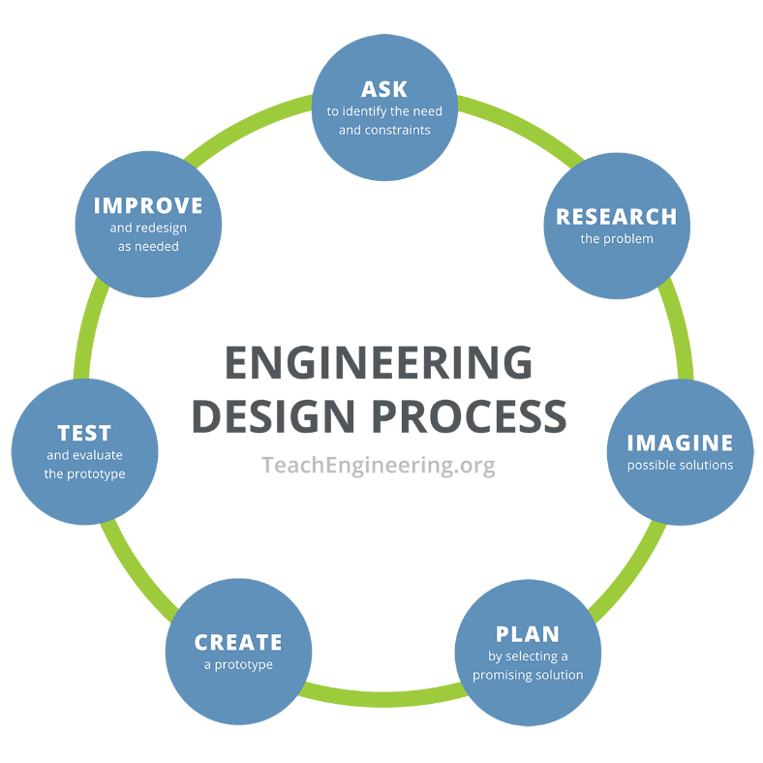**Gatorade Gravity Machine Worksheet**

**Step 1: Ask**

1. In your own words, what problem are you trying to solve?
2. In your own words, what are the constraints of the problem?
3. In your own words, what is the goal of your machine? Or what should your machine be able to do?

**Step 2: Research**

1. What machines you have seen or used that combine two flavors or two ingredients?
2. What are some things you have seen that have water flow through them?
3. How could you get water to flow from one cup to another without tipping either cup? (Draw a picture to help explain.)

**Step 3: Imagine**

1. Individually brainstorm and sketch 5-6 ideas of potential machines with the materials presented.

|  |  |
| --- | --- |
|  |  |
|  |  |
|  |  |

**Step 4: Plan**

1. New constraint: Each group has **$900** to spend on the materials listed below. (Note: Gatorade powder and water are provided for free.)

|  |  |  |  |
| --- | --- | --- | --- |
| **Materials** | **Price** | **# to Purchase** | **Amount Spent** |
| 5 small cups | $100 |  |  |
| 2 pieces of cardboard | $100 |  |  |
| 4 straws | $100 |  |  |
| 5 popsicle sticks | $100 |  |  |
| 6 toothpicks | $100 |  |  |
| 4 unsharpened pencils | $100 |  |  |
| 2 plastic spoons | $100 |  |  |
| 2 ft. string | $100 |  |  |
| 1 ft. duct tape | $100 |  |  |
|  |  | Total Cost |  |

1. New constraint: Judging Criteria

* 10 points for each $100 saved
* 100 points if water makes it to bottom cup
* 50 points if the water only mixes with one powder OR 150 points if the water mixes with both powders
* 10 points for each cup the water reaches

1. Plan: Draw your group’s chosen design below. Make sure to identify the materials to be used and the dimensions of each component.

**Step 5: Create**

1. Build your design!
   1. Buy your materials.
   2. You have 30 minutes to build your design.
   3. During the build, you may make changes from your design and buy more materials, but you MUST note it in your design drawing.
   4. You may conduct unofficial tests with just water. (Remember: In engineering, we use tests to gather information and improve designs.)

**Step 6: Test**

1. Test your team’s design by placing 2 tablespoons of Gatorade powder in two separate cups. Pour 6-12 oz. of water through the machine.
2. Answer the following questions after you test your design:
   1. What worked?
   2. What didn’t work?

**Step 7: Improve**

1. In engineering, we are always working to improve technology. We make sure to test all new ideas to understand how we can make our ideas better. What do you think you would want to improve on your design?
2. What was the most challenging part of this design process?