Extension: Learning More About Metastasis and ECM Rigidity Answer Key
Read “Tension on gut muscles induces cell invasion in zebrafish intestine, mimicking cancer metastasis”
article.

Then answer the following questions:

- What changes occur to breast cancer cells when grown on 3-D gels of increasing rigidity?
Breast cancer cells grown on a 3-D gel have enhanced cell replication and decreased organization as rigidity increases.

- How are the epithelial cells of the zebrafish able to invade the surrounding tissue?
During cell invasion, epithelial cells breach the basement membrane and invade the adjacent connective tissue where the organ's blood vessels and lymphatic channels are located.

- What is meant by an invasive cancer?
This means that cells have broken out of the lobule where they began and have the potential to spread to the lymph nodes and other areas of the body.

- How is this related to human cancer?
Invasive cancers are metastasis, which is spreading of cancer throughout the body. This article states that if the cancer protrusions can be blocked then the cancer spread could be slowed.

- Use the diagram below and based on what you have learned in this lesson, explain why breast and lung cancer are more likely to metastasis then bone cancer?

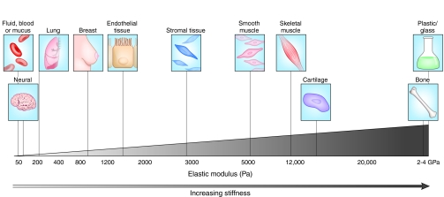
Cox, Thomas & Erler, Janine. (2011). Remodeling and homeostasis of the extracellular matrix: implications for fibrotic diseases and cancer.. Disease models & mechanisms. 4. 165-78. 10.1242/dmm.004077

These cancers are on softer matrixes, therefore have an easier time to form protrusions and therefore spread and metastasize.

- The data pictured below show the mutations found in various cancers, which are also varying in tissue stiffness. If the stiffness increases across the x-axis (the top here) from softer to stiffer tissues, what can you conclude about the relationship between mutation rate and tumor stiffness?

Constricted cell migration causes nuclear lamina damage, DNA breaks, and squeeze-out of repair factors

Jerome Irianto, Charlotte R. Pfeifer, Yuntao Xia, Avathamsa Athirasala, Irena L. Ivanovska, Roger A. Greenberg, Dennis E. Discher
doi: https://doi.org/10.1101/035626

The stiffer the tissue the higher the rate of mutations.

