Bacterial Adaptations and Their Application in Genetic Engineering: Student Lab Sheet Part 2

Part 2 – Cell Pelleting and Analysis
Materials:
To share with the entire class:
- One micro-centrifuge

Each group needs:
- One 1000 µL micropipette
- Two 1000 µL micropipette tips (sterile)
- Two 1.5 ml micro-centrifuge tubes
- A micro-tube rack
- Fine-tip labeling marker

Procedure:
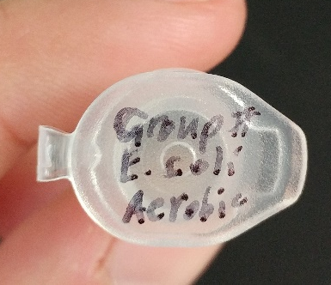
- Put on protective equipment.
- Pick up your group’s two culture tubes in a test tube rack.
- Discuss and write down your observations of the cell cultures below.
- Pick up a micro-tube rack with two micro-centrifuge tubes.
- Label the tubes: Group # E. coli Aerobic and Group # E. coli Anaerobic.
- Using the micropipettes, draw up all 1000 µL of the aerobic culture and transfer it to the corresponding micro-tube. Dispose of the tip.
- Using the other tip, repeat the previous step with the anaerobic culture.
- Take your group’s two tubes to your teacher to be placed into the centrifuge and spun for 5 minutes at a speed of around 6000 rcf.
- After the spin, pick up your group’s tubes and analyze the resulting cell pellet.
- Write down observations of the cell pellets below.

Cell Culture Observations
 | Before Spinning | After Spinning
Aerobic
Anaerobic

