Rock Candy Instructions and Observations Sheet

Rock Candy Instructions

- Gather the following materials; small glass jar (mason jars work well), kitchen grade string, pencil or popsicle stick, sugar, water, and food coloring
- In a pot (or sterile beaker) boil water stirring in sugar until solution is saturated. This is about a 2:1 sugar to water ratio.
- After sugar is completely dissolved carefully pour into glass jars leaving about 1 inch of space from the top.
- At this time you can add food coloring of choice to the sugar water and stir until well mixed.
- Tie a string to a pencil or popsicle stick so that it will be about ½ inch from the bottom of the jar when balanced on the top of the jar. See the diagram below for reference.

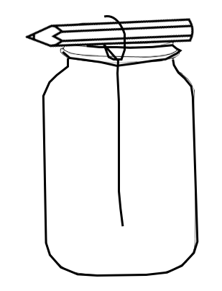

Rock Candy Observations
For each day draw what you observe in the chart below. Below each drawn observation write down a sentence about your observations as well.

1 Day | 2 Days | 3 Days
4 Days | 5 Days | 6 Days

