States of Matter Post-Quiz - Answer Key

Questions & Answers
- What is the name that we use to refer to a form of matter, such as solid, liquid, or gas?

- conductor
- solid
- insulator
- states of matter

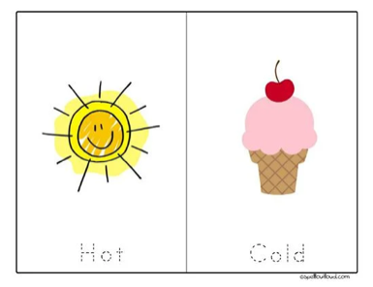
- What is a form of energy at work when you place a hot object near a cold object?
- heat
- water
- gas
- liquid


- Where does thermal energy come from?
- sun
- hot air
- moving particles
- fire


- What is a tool that is used to measure temperature?
- barometer
- thermometer
- ruler
- scale
- What is the state of matter with definite volume but no definite shape?

- solid
- liquid
- gas
- heat
- What is a state of matter that has a definite shape and a definite volume?

- solid
- liquid
- gas
- heat

- What is a state of matter that has no definite shape or volume?
- solid
- liquid
- gas
- heat
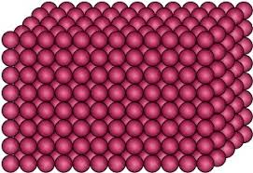
- What state of matter is pictured here?
- plasma
- liquid
- gas
- solid
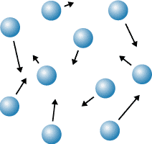
- What state of matter is pictured here?
- solid
- liquid
- gas
- plasma
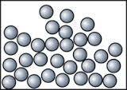
- What state of matter is pictured here?
- solid
- liquid
- gas
- plasma


- Which state of matter can change shape?
- solid
- liquid
- gas
- heat

- What happens when an object gains thermal energy?
- It melts.
- It turns into a gas.
- It expands.
- It turns into a solid.
- What would happen if you placed a metal spoon in a hot bowl of soup?

- The soup would cool off.
- The temperature of the spoon would stay the same.
- The spoon would heat up because it is metal.
- The soup would cool off and the spoon will keep the same temperature.

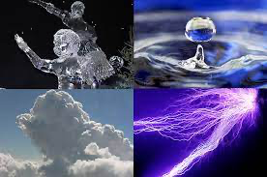
- What is matter?
- Matter is anything that has a weight and takes up space.
- Matter is something that exists outside of this universe.
- Matter is something that you cannot see or touch.
- Matter is something very special.
- On a hot day, the sweat on your skin disappears. What is the name of the process

that happens to the sweat?
- condensation
- evaporation
- gasification
- transformation

