Group Prototype Testing Worksheet

Prototype Sketch (with labels)

Test 1: Scrub the Scum (See Protocol for Testing Procedure)
Maximizing Surface Cleaning

Compare the appearance of your coin surface to the visual guide below to estimate the percentage of the surface cleaned by your design. Estimate the percentages based on the reference examples.

0% cleaned | 25% cleaned | 50% cleaned | 75% cleaned | 100% cleaned
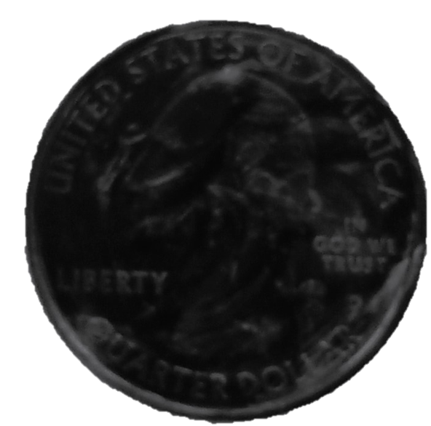 | 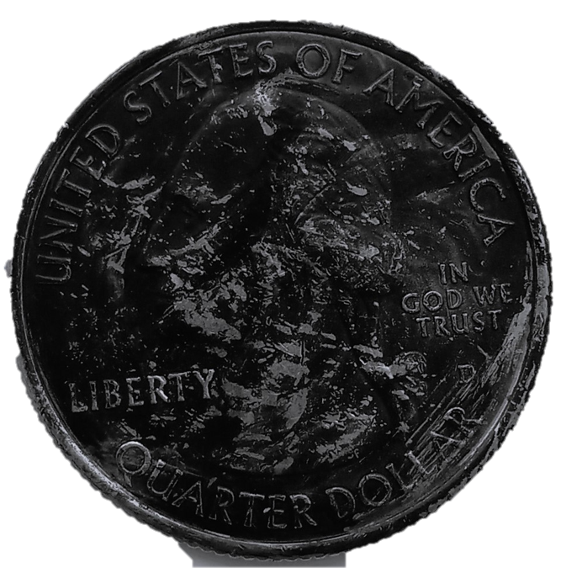 | 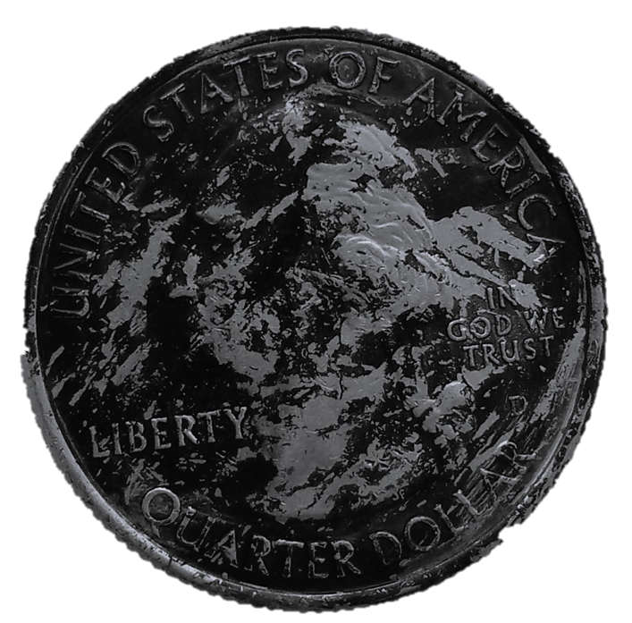 | 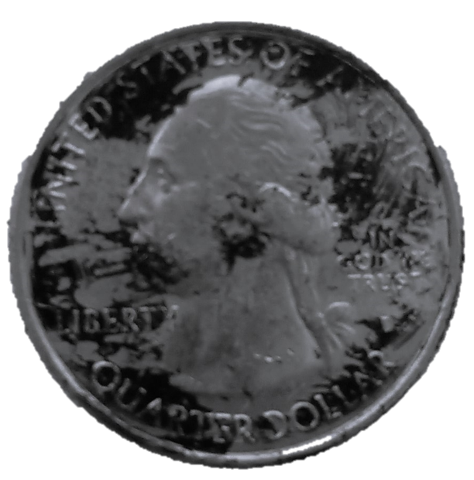 | 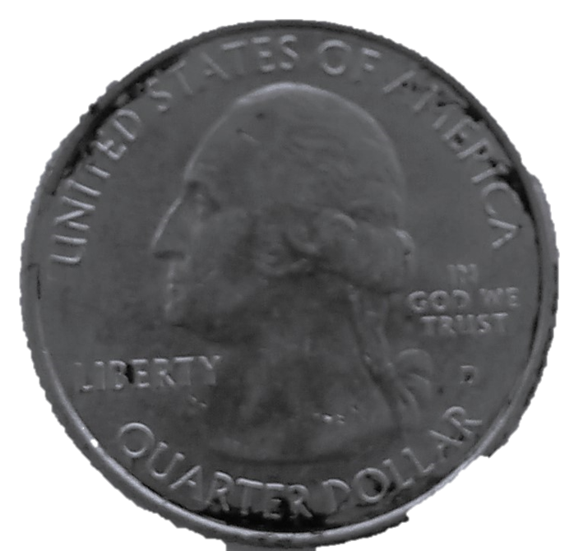

Scum Scrubbing Visual Evaluation
Trial # | Sketch or Picture | Estimated % Cleaned

Test 2: Save the Shine (See Protocol for Testing Procedure)
Minimizing Surface Wear
Scum Scrubbing Visual Evaluation
Trial # | Original Thickness (mm) | Thickness after Testing (mm)

Post-Testing Reflection:

- In what ways did your group’s prototype perform better (or worse) than each member’s individual prototype?

- What specific component of your design do you think contributed to the strengths of your design?

- Please have each team member answer the following question individually and attach your individual responses to this worksheet when turning it in:
In what ways did your experience with your original prototype help inform your approach to designing a new prototype with your team? In other words, what did you do differently on the second prototype based on what you learned with your first prototype design and testing?

