Individual Prototype Testing Worksheet

Sketch of prototype as built; this might be the same as or different from your initial design sketch plan.

Test 1: Scrub the Scum (See Protocol for Testing Procedure)
Maximizing Surface Cleaning

Compare the appearance of your coin surface to the visual guide below to estimate the percentage of the surface cleaned by your design. Estimate the percentages based on the reference examples.

0% cleaned | 25% cleaned | 50% cleaned | 75% cleaned | 100% cleaned
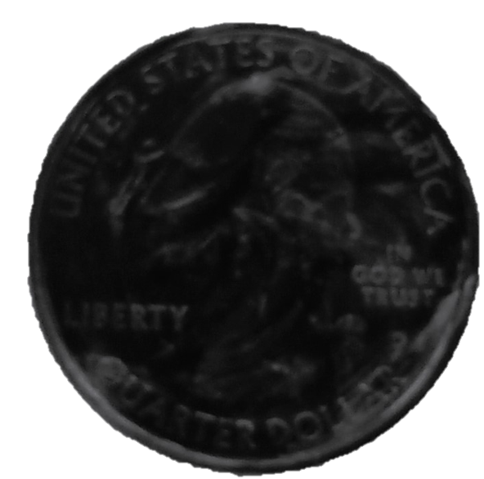 | 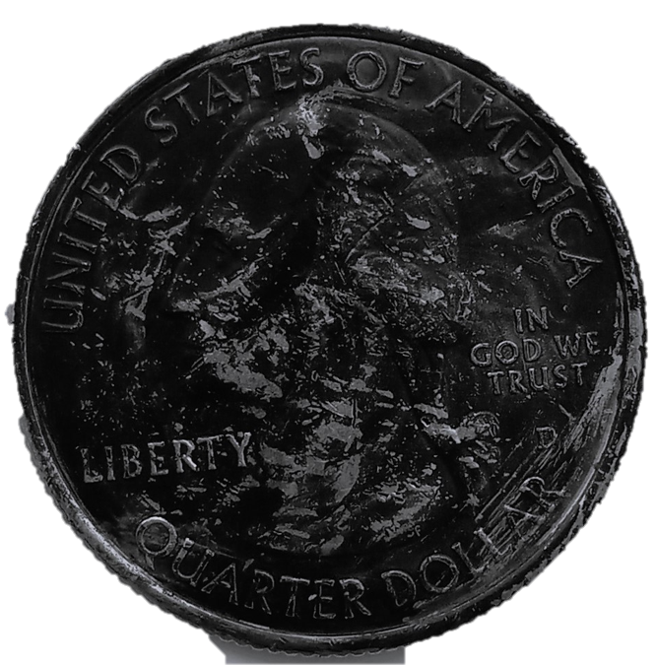 | 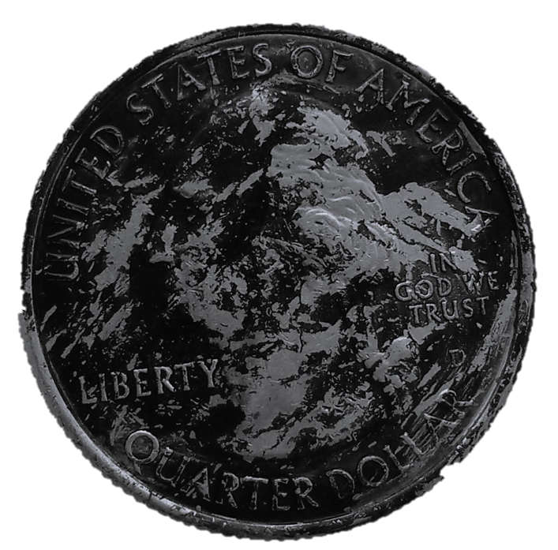 | 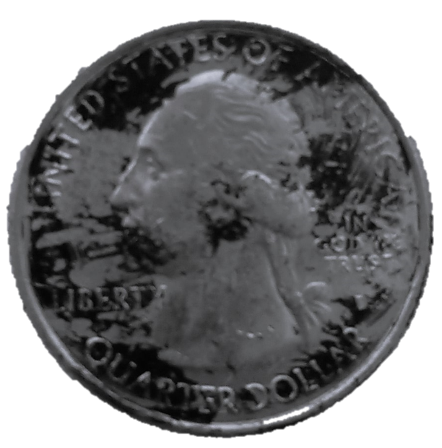 | 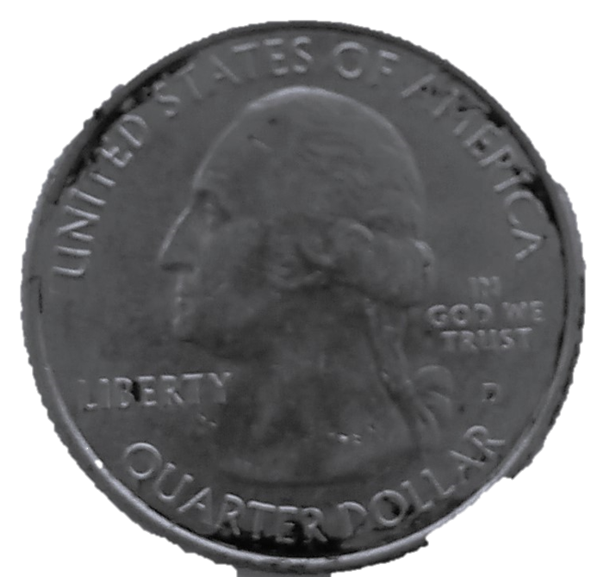

Scum Scrubbing Visual Evaluation
Trial # | Sketch or Picture | Estimated % Cleaned

Post-Testing Reflection:

- What were 1-2 strengths of your prototype design? In other words, what did your prototype do well??

- What specific component of your design do you think contributed to the strengths of your design?

- What were 2-3 areas of improvement where you think you could make your next design better? Explain.

- What is something you learned or were surprised by during your design and testing process?

