Activity Packet Answer Key

Use this activity guide to collect findings, draw models, store data, and determine where your microscope falls on the rubric.

Step #1: ASK
Notice  (What do you notice about the video and graph?) | Wonder  (What questions or thoughts does this bring up?)
Answers will vary. Look for:  - Purple and red are different amounts.  - There is more government money provided  for schools in some countries and more  money coming from home in other countries.  - Some countries do not get the same amount  of money from the government.  - Many countries who spend more out of their  own pocket on school are respectfully poorer  countries.  - People in these countries on the graph are  getting sick, but they do not know why because they cannot see it; it is too small. | Answers will vary. Look for:  - Why are poorer countries spending more on schooling than wealthier countries?  - Why does the government not give  money to schools equally?  - Will the margins be even larger if the same  data was taken now? How would the graph  look in (current year)?

Guiding Question:
How can we…
Answers will vary.
- How can we create a tool that can see small things?
- How can we create a budget-friendly tool that can see small things?

Step #2: RESEARCH
Explore the articles, catalogs, diagrams, and different mediums while answering the questions below.
Useful words: reflection, refraction, diffraction transmit, absorb, wave
Question | Research Findings
How do lenses change how we see things? | Answers will vary. Findings to look for:  - Lenses make things look upside down and backwards  - Lenses bend light  - Lenses help us see small things  - Lenses help us see better; glasses
How does adding more lenses affect how we see things? | Answers will vary. Findings to look for:  - Objects got bigger  - Objects got more blurry
How does the distance between two lenses affect what you see? | Answers will vary. Findings to look for:  - Depending on the distance between two lenses, the object may seem blurry, clear, and even larger
How does the angle of the laser beam affect how it exits the lens? | Answers will vary. Findings to look for:  - When the laser beam hits a lens at an angle, sometimes it exits straight  - When a laser beam hits a lens straight, sometimes it exits at an angle or straight  - Laser beams sometimes bend when going through a lens, but they bend differently with different lenses
How does light travel through space? | Answers will vary. Findings to look for:  - Light travels in a beam  - Light travels by the molecules in the air  - (correct) Light travels in a wave
How does light change when entering and exiting different mediums? | Answers will vary. Findings to look for:  - Light bends and bounces  - Light refracts and reflects  - Light is sometimes absorbed

Step #3: IMAGINE

Criteria: Standards that must be met by the design.
- The microscope must be able to focus an image.
- The microscope must be able to enlarge a specimen.
- The microscope must be durable enough to go through testing without being damaged.
Other:

Constraints: Limitations to what can be designed.
- Use recycled materials, other than lenses.
- Keep cost low and affordable (less than $0.50 for the whole microscope).
Other:
Explore the supplies provided. Using the supplies given, draw a model of how you would create a durable and useful budget-friendly microscope. Use words, colors, and labels to explain your model.
Useful words: reflection, refraction, diffraction transmit, absorb, wave
Models will vary. Below is an example.

Toilet Paper Roll #1
25 mm Convex Lens
45 mm Convex Lens

Toilet Paper Roll #2 (cut down)

Toilet Paper roll #2 will be smaller and able to move up & down

Stage- Cardboard

Flashlight
Refraction & Reflection
Refraction & Reflection
Refraction, Reflection, and Absorption

Step #4: PLAN
After completing the Decision Matrix, draw your group's final model of a durable and useful budget-friendly microscope below. Use words, colors, and labels to explain your model.
Models will vary. Use the Imagine model as a reference for expectations.

Step #5: CREATE
What roles will each of your group members play in the creation process?
What roles are needed to accomplish your goal? | What does the person do in this role? | Group Member Name
Role #1: Materials Manager | Collects materials, measures and cuts tape, makes sure materials are brought from home if necessary, keeps lenses clean, etc. | (Name)
Role #2: Finance Analyst | Helps team stay within the budget. Works closely with materials manager to calculate amounts of materials used. | (Name)
Role #3: Builder | Builds the microscope design. | (Name)
Role #4: Builder | Builds the microscope design. | (Name)
Optional: Assistant | Optional: Gathers samples from outside; records changes to model; helps build; tests the microscope. | (Name)

Step #6: TEST
Budget-Friendly Test | 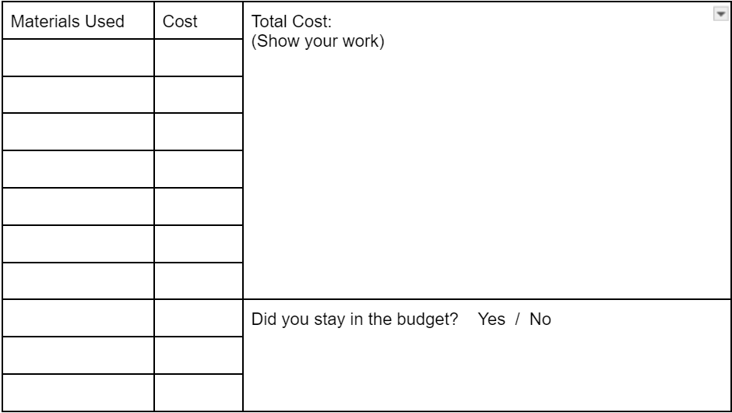  Toilet Paper Roll $0.03  Toilet Paper Roll $0.03  Tape (12 inches) $0.12  42 mm lens $0.15  25 mm lens $0.10  Black Paper $0.02  3 drops of Hot Glue $0.03  $0.03  $0.03  $0.12  $0.15  $0.10  $0.02  $0.03  $0.03  $0.51  3 x3 in Cardboard $0.03  We went over the budget by $0.01  EXAMPLE
Image Resolution (Focus) Test  Students may need help with the resolution and/or determining which choice to make with their microscope | 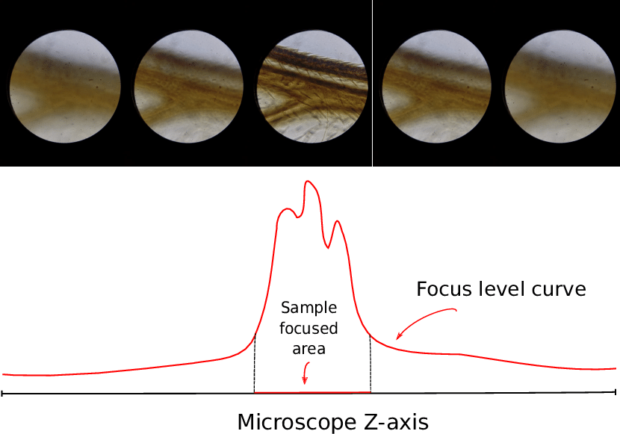 Image appears very blurry.  Image appears somewhat blurry.  Image appears focused. X
Using the 1-5 scale below, rate the other groups' microscope based on durability. Focus on whether the microscope was able to stay together when used, if parts fell off, if parts would not move like they were supposed to, or if it felt flimsy while operating it.

1 2 3 4 5
Broke apart Stayed together & felt strong while using it

Step #7: IMPROVE
Based on your testing data, work with your group to decide 1-2 design features you would like to change or improve about your current microscope model.
Feature #1  Features to change will vary:  Sample stage position  Adding foil to reflect light  Using a flashlight as the light source  Lens position  etc. | Final Model:  Models will vary. Use the Imagine model as a reference for expectations.
Feature #2

Features to change will vary:
Sample stage position
Adding foil to reflect light
Using a flashlight as the light source
Lens position
etc.

Reflection

- Describe a challenge you and your group faced at any time during the engineering design process. How did your team overcome the challenge?

Answers will vary: Example - A challenge that our group had was figuring out where to put the lenses in our design. It was hard to have the lenses at the right distance to make the image appear in our microscope. We overcame this challenge by brainstorming ways in which we could put the lenses together to get the best image. Then we tested it, and it was like what we did when we were allowed to play with the lenses back at the beginning of the project.

- Glows: Below, provide two examples from the project that YOU are proud of. Explain.
Answers will vary: Example - We were proud of the image we were able to get with our microscope because it was just like having a microscope that you would buy from a store! We also are proud of the fact that we only went over our budget by one cent, unlike other groups that went way over their budgets.

- Grow: Below, provide one or two examples of an area YOU would like to improve while working on this project with your team. Explain.
Answers will vary: Example - An improvement I would like to change about our microscope is the materials we worked with. I would like to try more lenses of different sizes to see if having different size lenses would make the image bigger and better. I would also like to make our microscope more durable. If these microscopes were being used in low-income countries, I would want them to last a long time so students could use them longer.

