Activity Packet

Use this activity guide to collect findings, draw models, store data, and determine where your microscope falls on the rubric.

Step #1: ASK
Notice  (What do you notice about the video and graph?) | Wonder  (What questions or thoughts does this bring up?)

Guiding Question:
How can we…

Step #2: RESEARCH
Explore the articles, catalogs, diagrams, and different mediums while answering the questions below.
Useful words: reflection, refraction, diffraction transmit, absorb, wave
Question | Research Findings
How do lenses change how we see things?
How does adding more lenses affect how we see things?
How does the distance between two lenses affect what you see?
How does the angle of the laser beam affect how it exits the lens?
How does light travel through space?
How does light change when entering and exiting different mediums?
Step #3: IMAGINE
Criteria: Standards that must be met by the design.
- Microscope must be able to focus an image.
- Microscope must be able to enlarge a specimen.
- Microscope must be durable enough to go through testing without being damaged.
Other:

Constraints: Limitations to what can be designed.
- Use recycled materials, other than lenses.
- Keep cost low and affordable (less than $0.50 for whole microscope).
Other:
Explore the supplies provided. Using the supplies given, draw a model of how you would create a durable and useful budget-friendly microscope. Use words, colors, and labels to explain your model.
Useful words: reflection, refraction, diffraction transmit, absorb, wave

Step #4: PLAN
After completing the Decision Matrix, draw your group's final model of a durable and useful budget-friendly microscope below. Use words, colors, and labels to explain your model.

Step #5: CREATE
What roles will each of your group members play in the creation process?
What roles are needed to accomplish your goal? | What does the person do in this role? | Group Member Name
Role #1:
Role #2:
Role #3:
Role #4:

Step #6: TEST
Budget-Friendly Test | 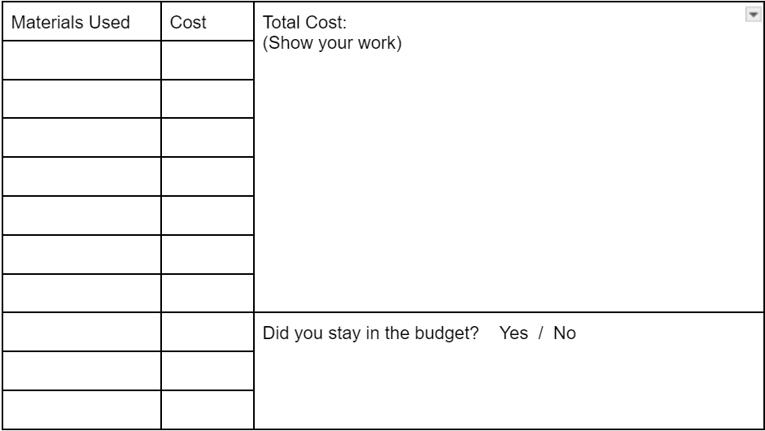
Image Resolution (Focus) Test | 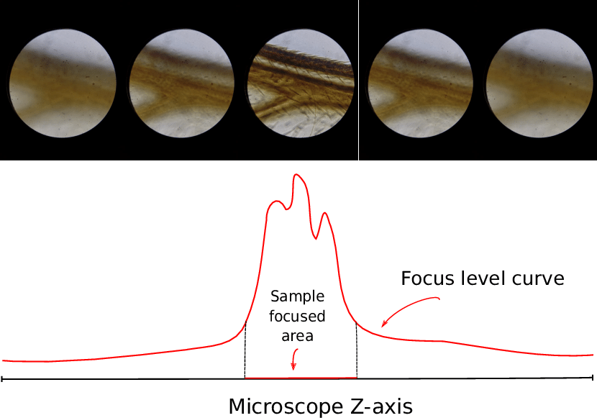 Image appears very blurry.  Image appears somewhat blurry.  Image appears focused.
Durability Test | Using the scale of 1-5 below, rate the other group’s microscope based on durability. Focus on whether the microscope was able to stay together when used or whether parts fell off, whether parts moved like they were supposed to, and whether it felt flimsy while operating it.  1 2 3 4 5  Broke apart Stayed together & felt strong while using it

Step #7: IMPROVE
Based on your testing data, work with your group to decide 1-2 design features you would like to change or improve about your current microscope model.
Feature #1 | Final Model:
Feature #2

Reflection

- Describe a challenge you and your group faced at any time during the engineering design process. How did your team overcome the challenge?

____________________________________________________________________________________________________________________________________________________________________________________________________________________________________________________________________________________________________________________________________________________________________________________________________________________________________________________________________________________________________________________________________________________________________________________________________________________________________________________________________________________________________________

- Glows: Below, provide two examples from the project that YOU are proud of. Explain.
____________________________________________________________________________________________________________________________________________________________________________________________________________________________________________________________________________________________________________________________________________________________________________________________

- Grow: Below, provide one or two examples of an area YOU would like to improve while working on this project with your team. Explain.
____________________________________________________________________________________________________________________________________________________________________________________________________________________________________________________________________________________________________________________________________________________________________________________________

