Pre/Post Assessment Answer Key

1. In the diagram below, draw the path of three light rays as they travel and hit the lens.
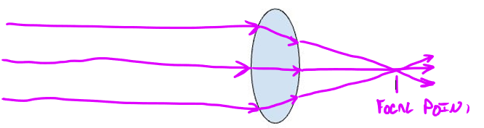

2. In the space provided, write three or more sentences explaining how the light is traveling before and after it hits the lens.

(Answers will vary) In the picture, the light is traveling in a straight line until it hits the lens. When the light hits the lens, it is being refracted because the light is going from one medium (air) to another medium (glass/plastic), which causes the ray of light to bend. The light then passes from the glass/plastic back into the air and is bent again. In the picture, the ’bending’ of the light rays from the lens causes the light rays to cross paths. When the light ray crosses paths, this is the focal point, but after the focal point the light rays will continue to move in a straight line until it hits something else.

3. Describe in three or more sentences how light travels through a microscope using the terms refraction, reflection, and absorption in the space provided.

(Answers will vary) Light from the room will travel in a straight line until it hits the mirror, where it will be reflected up into the microscope. As the light travels, it will hit the sample on the microscope stage and the sample will absorb the light and transmit what is not absorbed into the lenses of the microscope. The light is then refracted by the lenses of the microscope, which will magnify the image of the sample where the person can see the sample image from the light that has been transmitted. If the sample looks green, it’s because all other light except for green has been absorbed.

