Calculus Worksheet: Bounce Test Documentation Answer Key

Instructions: Choose AT LEAST THREE different surface and ball combinations. Bounce the ball from the same height each time, and record the bounce using a slow-motion camera or a motion detector.

Test #1
Surface:___Whiteboard_____ Ball:____Tennis Ball_________
Plot at least 5 points on the graph.
X (t in sec) Y (h in meter)  0 0.996  .05 0  .75 0.434  .92 0  1.05 0.183  1.2 0 | 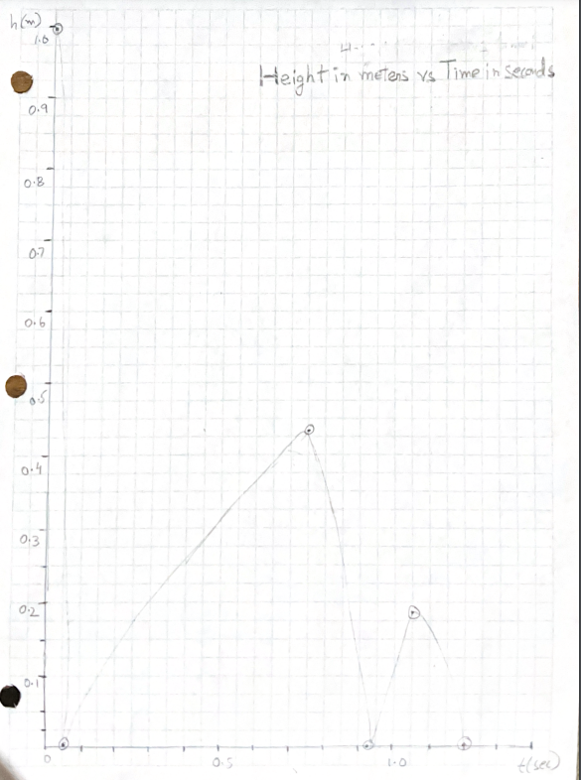

- General observations about the bounce:
To plot all three bounces together, we could use parabolas. Also, each consecutive bounce is lower than the last.

- Label the axis of the graph. What are your units for x and y?
x - seconds (time)
y - inches (height)

- Use quadratic regression on your calculator to get an equation that fits the points. Sketch the graph of the equation on the graph above.

Equations:
$y_{1} =-.996x+.996$[Drop to first bounce. Answer to this question.]

$y_{2} = -.434x^{2}+.869x-(3.05 * 10^{-34})$ [1st bounce to 2nd bounce. Answer to the 1st repeat.]

$y_{3}=-9.38x^{2}+19.9x-10.4$ [2nd bounce to 3rd bounce. Answer to the 2nd repeat.]

- Plot the velocity graph if it can be obtained from motion detectors; otherwise, skip to Question 5.
If you have motion detectors, they should be able to create a graph for you! Otherwise skip.

- Take the 1st derivative of your position equation. Plot this function as a velocity/time graph.
$y_{1}'=-.996$ [Drop to first bounce. Answer to this question.]
$y_{2}'=-.868x+.869$ [1st bounce to 2nd bounce. Answer to the 1st repeat.]
$y_{3}'=-18.76x+19.9$ [2nd bounce to 3rd bounce. Answer to the 2nd repeat.]

- What do you notice?
The quadratics became linear. This means velocity changes at a constant rate.

- What does the first derivative tell us?

The first derivative gives us the velocity of the ball with respect to time.

- If you were to plot the acceleration, what do you think it might look like? Take a guess! (Think about the forces acting on the ball. How many are there?)
It would most likely be constant! The only force on the ball is gravity, so that would be the only thing driving the acceleration, leading to a constant acceleration. (There would be some air resistance as well, but we are treating it as negligible for this activity.)
- Take the second derivative of your position equation. Plot this function as an acceleration/time graph.
$y_{1}''=0$ [Drop to first bounce. Answer to this question.]
$y_{2}''=-.868$ [1st bounce to 2nd bounce. Answer to the 1st repeat.]
$y_{3}'''=$-18.76 [2nd bounce to 3rd bounce. Answer to the 2nd repeat.]

- What does the second derivative tell you about the graph in motion problems?
The second derivative gives the acceleration.

- What does the acceleration graph look like? Why does it look the way it does? Was your guess in question 8 correct?
The acceleration graphs look like a straight line (constant). This makes sense, because the ball is accelerating at a constant rate.

- Would this surface/ball combination be a good fit for your game? Why or why not?
Yes, because it bounced at the height needed to go through the hoop in our game design. (Answers will vary, but should incorporate some specific aspect of their game that relates to the bounce.)

Repeat for the next 2 bounces

