Calculus Worksheet: Bounce Test Documentation

Instructions: Choose AT LEAST THREE different surface and ball combinations. Bounce the ball from the same height each time, and record the bounce using a slow-motion camera or a motion detector.

Test #1
Surface:_________________ Ball:________________________
Plot at least 5 points on the graph.
X Y | 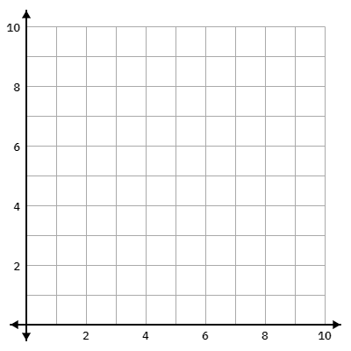

- General observations about the bounce:

- Label the axis of the graph. What are your units for x and y?

- Use quadratic regression on your calculator to get an equation that fits the points. Sketch the graph of the equation on the graph above.

Equations:

- Plot the velocity graph if the data can be obtained from motion detectors; otherwise, skip to Question 5.

- Take the 1st derivative of your position equation. Plot this function as a velocity/time graph.

- What do you notice?

- What does the first derivative tell us?

- If you were to plot the acceleration, what do you think it might look like? Take a guess! (Think about the forces acting on the ball. How many are there?)

- Take the second derivative of your position equation. Plot this function as an acceleration/time graph.

- What does the second derivative tell you about the graph in motion problems?

- What does the acceleration graph look like? Why does it look the way it does? Was your guess in Question 8 correct?

- Would this surface/ball combination be a good fit for your game? Why or why not?

Repeat for the next 2 bounces

