Research Activity Worksheet
Objective:
To test the strength of different building materials by measuring how much weight they can hold before bending or breaking.

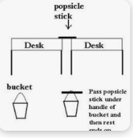
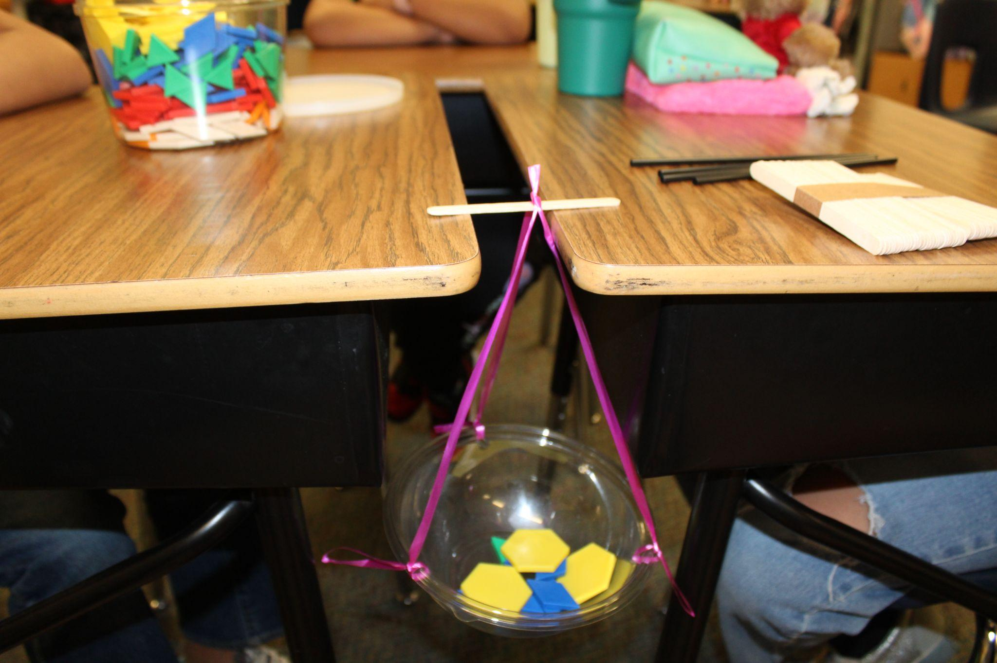

Step 1: Test the Straw (Single Straw)
- Place one straw horizontally between two desks or tables.
- Create a “holding device” by attaching a plastic cup to a piece of string.
- Hang the cup from the center of the straw.
- Carefully add one counting block at a time into the cup.
- Continue adding blocks until the straw bends or breaks.
- Record the total number of blocks in a data chart.

Step 2: Test the Straws (Triple Straws)
- Tape or bundle three straws together and repeat the same process.
- Hang the cup, add blocks one at a time, and record when the straws can no longer hold the weight.
- Record your results on the same data chart for comparison.

Step 3: Test the Popsicle Sticks
- Place one popsicle stick between two desks.
- Repeat the same procedure: Hang the cup, add blocks, and record how many blocks it takes before the stick bends or breaks.
- Repeat with three popsicle sticks bundled together, and record your results.

Step 4: Test the LEGO Brick
- Place a 12x2 LEGO brick between two desks.
- Attach the hanging cup and begin adding counting blocks.
- Stop adding once the number of blocks is three more than the amount needed to break the popsicle sticks.
- Record your results and note that LEGO bricks are much stronger and less likely to bend or break under small loads.

Conclusion:
Compare the strength of each material by reviewing the number of blocks each one held. Use this data to decide which material is strongest and how this information can be used in your house-building challenge.

Data Chart
Material | Number of blocks
Single Straw
Triple Straws
Popsicle Stick
Triple Popsicle Sticks
LEGO Brick

