Aqueous Solutions Research - Data Sheets Answer Key

Station 1: Concentration (Amount of Solute)
Aqueous Solutions Research Data Sheet

Concentration is the amount of a substance that is dissolved in a given amount of liquid. The more solute in a solution, the more concentrated the solution is. The less solute in a solution, the less concentrated the solution is.

Directions: Read the station directions carefully before beginning the experiment. Pay attention to lab safety and cleanup procedures.
How well does the SALT dissolve?
Explain How the Solute Dissolves | Solubility Observations
As the amount of SALT increased …  some will not dissolve, only a certain amount will dissolve in a given volume of water | 0.1 grams should see all salt dissolve
 | 7 grams should see some if not all salt dissolve, may need to stir more
 | 25 grams should see some salt dissolve, and should see some still floating around in the cup
How well does the SUGAR dissolve?
Explain How the Solute Dissolves | Solubility Observations
As the amount of SUGAR increased … it is harder to dissolve but it will still go into solution | 0.1 grams should see all sugar dissolve
 | 7 grams should see all sugar dissolve with enough stirring
 | 25 grams should see most if not all sugar dissolve with enough stirring
How well does the PEPPER dissolve?
Explain How the Solute Dissolves | Solubility Observations
As the amount of PEPPER increased … it still would not dissolve | 0.1 grams should not dissolve, may turn the water brown
 | 7 grams should not dissolve, may turn the water brown
 | 25 grams should not dissolve, may turn the water brown

Conclusions:
When you have lots of solute in a small amount of solvent, we say that solution is very concentrated. However, if you still see some solute particles floating around, those are still not dissolved. What amount of solute is easiest to dissolve in 10mL of water?

The 0.1 grams of salt and sugar were very easy to dissolve because there was much more water (space) for the particles to mix into.

What could you do to a solution that had too many solutes in it (meaning it was too concentrated)? How could you get the solutes to dissolve?

When there are too many solutes in a given area, they cannot mix in evenly with the solvent. You will need to add more water to help the sugar and salt particles dissolve.

Station 2: Surface Area (Size of Solute)
Aqueous Solutions Research Data Sheet

Surface area is the total area of the surface compared to the volume of an object. Smaller objects have more surface area compared to their total volume. Large objects have less surface area compared to their total volume.

Directions: Read the station directions carefully before beginning the experiment. Pay attention to lab safety and cleanup procedures.
How well does the SALT dissolve?
Explain How the Solute Dissolves | Solubility Observations
As the size of the SALT decreased … it was easier to dissolve | Low SA (larger chunks) should be hard to dissolve
 | High SA (smaller chunks) should be easier to dissolve
How well does the SUGAR dissolve?
Explain How the Solute Dissolves | Solubility Observations
As the size of the SUGAR decreased … it was easier to dissolve | Low SA (larger chunks) should be hard to dissolve
 | High SA (smaller chunks) should be easier to dissolve
How well does the PEPPER dissolve?
Explain How the Solute Dissolves | Solubility Observations
As the size of the PEPPER decreased … it still did not dissolve | Low SA (larger chunks) should not dissolve at all
 | High SA (smaller chunks) should not dissolve at all
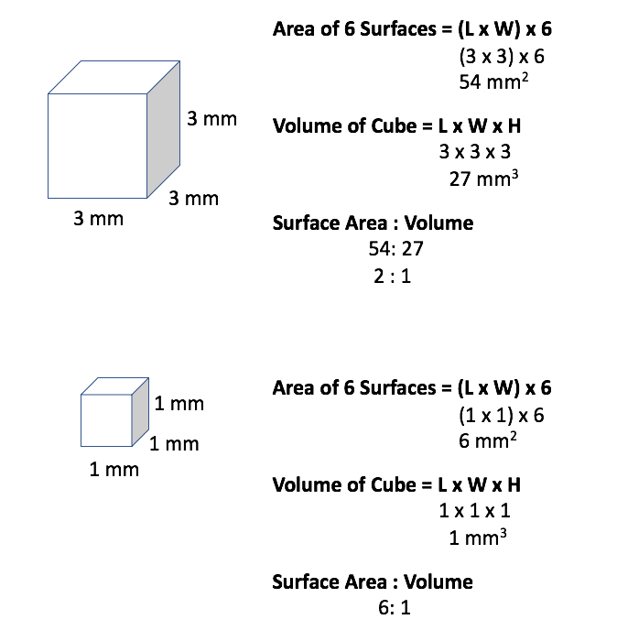
Conclusions:
When you have a large object, your volume is similar to the area of your surface. When you have a small object, your surface area is much larger than your volume. Why does having a lot of surface area help with dissolving solutes into a solvent?

More of the solute is exposed to the water at once. This allows it to mix in faster with the solvent and therefore dissolve. Larger objects have a lot of particles on the inside that are not exposed to water, and until they are broken down into smaller chunks, they will not dissolve until they touch the solvent.

Station 3: Temperature of the Solvent (Water)
Aqueous Solutions Research Data Sheet

Temperature is the amount of hotness or coldness an object has. In this case we are analyzing the temperature of the solvent (water). Solutes can dissolve differently when the solvent temperature changes.

Directions: Read the station directions carefully before beginning the experiment. Pay attention to lab safety and cleanup procedures.
How well does the SALT dissolve?
Explain How the Solute Dissolves | Solubility Observations
As the temperature of the water increased, the SALT … dissolved a little faster | Cold H₂O still dissolved, needed to stir a little
 | Mild H₂O still dissolved with some stirring
 | Hot H₂O helped the salt dissolve faster but needed stir a little
How well does the SUGAR dissolve?
Explain How the Solute Dissolves | Solubility Observations
As the temperature of the water increased, the SUGAR … dissolved a lot faster | Cold H₂O made it very hard for the sugar to dissolve, and had to stir a lot
 | Mild H₂O dissolved completely with stirring
 | Hot H₂O dissolved almost immediately; very little stirring needed
How well does the PEPPER dissolve?
Explain How the Solute Dissolves | Solubility Observations
As the temperature of the water increased, the PEPPER … never dissolved | Cold H₂O did not dissolve
 | Mild H₂O did not dissolve
 | Hot H₂O did not dissolve

Conclusions:
When you have a hot solvent, it sometimes helps the solutes dissolve faster. Why do you think that is?

You are adding kinetic energy to the solvent. Kinetic energy is the energy of motion. The faster the solvent and solutes are moving, the faster they will homogeneously mix and form a solution.

Sometimes, it does not matter how hot or cold a solvent is. Some solutes simply do not dissolve in water. Why do you think that is?

Not all particles dissolve in water specifically. Although water can dissolve many solutes, some particles need something stronger (like acid) to help mix them together.

Station 4: Agitation (Amount of Stirring)
Aqueous Solutions Research Data Sheet

In this case, agitation is the amount of stirring you do to a solvent. You are trying to encourage the solutes to spread out across the container to interact at a faster rate with the solvent.

Directions: Read the station directions carefully before beginning the experiment. Pay attention to lab safety and cleanup procedures.
How well does the SALT dissolve?
Explain How the Solute Dissolves | Solubility Observations
If you increased the agitation for SALT solutions … most if not all of your salt will dissolve | No Stir some salt dissolved, but some is still floating
 | 45s Stir most salt is dissolved, but a few particles still floating
 | 120s Stir all salt is dissolved
How well does the SUGAR dissolve?
Explain How the Solute Dissolves | Solubility Observations
If you increased the agitation for SUGAR solutions … all of your sugar will dissolve | No Stir some sugar dissolved, but some is still floating
 | 45s Stir most sugar is dissolved, but a few particles still floating
 | 120s Stir all sugar is dissolved
How well does the PEPPER dissolve?
Explain How the Solute Dissolves | Solubility Observations
If you increased the agitation for PEPPER solutions … your pepper will not dissolve | No Stir none dissolved
 | 45s Stir none dissolved
 | 120s Stir none dissolved

Conclusions:
Some solutes can immediately dissolve in a solvent, meaning the second you add them together the solvents disappear. Did this happen in our case?

No, we still needed to stir a little.

Why does stirring (or agitating) help a solute dissolve faster?

You are adding kinetic energy to the solvent. Kinetic energy is the energy of motion. The faster the solvent and solutes are moving, the faster they will homogeneously mix and form a solution.

