Aqueous Solutions Research - Data Sheets

Station 1: Concentration (Amount of Solute)
Aqueous Solutions Research Data Sheet

Concentration is the amount of a substance that is dissolved in a given amount of liquid. The more solute in a solution, the more concentrated the solution is. The less solute in a solution, the less concentrated the solution is.

Directions: Read the station directions carefully before beginning the experiment. Pay attention to lab safety and cleanup procedures.
How well does the SALT dissolve?
Explain How the Solute Dissolves | Solubility Observations
As the amount of SALT increased … | 0.1 grams
 | 7 grams
 | 25 grams
How well does the SUGAR dissolve?
Explain How the Solute Dissolves | Solubility Observations
As the amount of SUGAR increased … | 0.1 grams
 | 7 grams
 | 25 grams
How well does the PEPPER dissolve?
Explain How the Solute Dissolves | Solubility Observations
As the amount of PEPPER increased … | 0.1 grams
 | 7 grams
 | 25 grams

Conclusions:
When you have lots of solute in a small amount of solvent, we say that solution is very concentrated. However, if you still see some solute particles floating around, those are still not dissolved. What amount of solute is easiest to dissolve in 10 mL of water?

What could you do to a solution that had too many solutes in it (meaning it was too concentrated)? How could you get the solutes to dissolve?

Station 2: Surface Area (Size of Solute)
Aqueous Solutions Research Data Sheet

Surface area is the total area of the surface compared to the volume of an object. Smaller objects have more surface area compared to their total volume. Large objects have less surface area compared to their total volume.

Directions: Read the station directions carefully before beginning the experiment. Pay attention to lab safety and cleanup procedures.
How well does the SALT dissolve?
Explain How the Solute Dissolves | Solubility Observations
As the size of the SALT decreased … | Low SA (larger chunks)
 | High SA (smaller chunks)
How well does the SUGAR dissolve?
Explain How the Solute Dissolves | Solubility Observations
As the size of the SUGAR decreased … | Low SA (larger chunks)
 | High SA (smaller chunks)
How well does the PEPPER dissolve?
Explain How the Solute Dissolves | Solubility Observations
As the size of the PEPPER decreased … | Low SA (larger chunks)
 | High SA (smaller chunks)
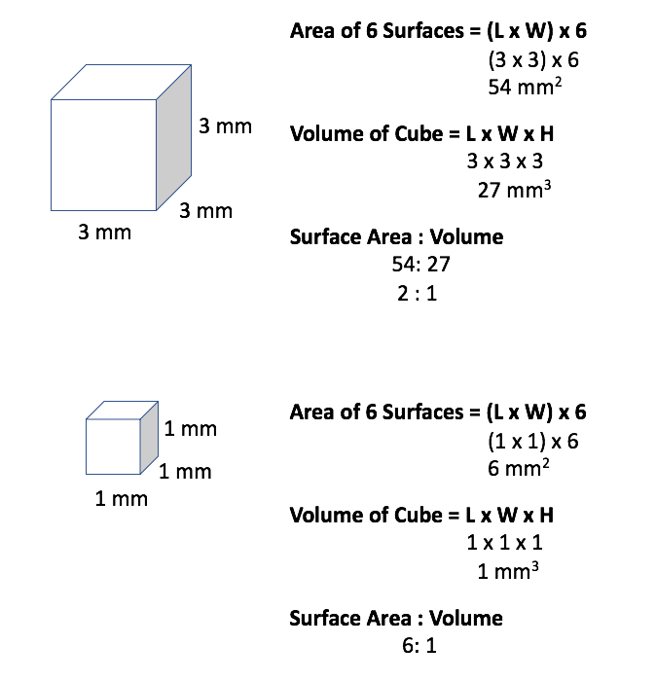
Conclusions:
When you have a large object, your volume is similar to the area of your surface. When you have a small object, your surface area is much larger than your volume. Why does having a lot of surface area help with dissolving solutes into a solvent?

Station 3: Temperature of the Solvent (Water)
Aqueous Solutions Research Data Sheet

Temperature is the amount of hotness or coldness an object has. In this case we are analyzing the temperature of the solvent (water). Solutes can dissolve differently when the solvent temperature changes.

Directions: Read the station directions carefully before beginning the experiment. Pay attention to lab safety and cleanup procedures.
How well does the SALT dissolve?
Explain How the Solute Dissolves | Solubility Observations
As the temperature of the water increased, the SALT … | Cold H₂O
 | Mild H₂O
 | Hot H₂O
How well does the SUGAR dissolve?
Explain How the Solute Dissolves | Solubility Observations
As the temperature of the water increased, the SUGAR … | Cold H₂O
 | Mild H₂O
 | Hot H₂O
How well does the PEPPER dissolve?
Explain How the Solute Dissolves | Solubility Observations
As the temperature of the water increased, the PEPPER … | Cold H₂O
 | Mild H₂O
 | Hot H₂O

Conclusions:
When you have a hot solvent, it sometimes helps the solutes dissolve faster. Why do you think that is?

Sometimes, it does not matter how hot or cold a solvent is. Some solutes simply do not dissolve in water. Why do you think that is?

Station 4: Agitation (Amount of Stirring)
Aqueous Solutions Research Data Sheet

In this case, agitation is the amount of stirring you do to a solvent. You are trying to encourage the solutes to spread out across the container to interact with the solvent at a faster rate.

Directions: Read the station directions carefully before beginning the experiment. Pay attention to lab safety and cleanup procedures.
How well does the SALT dissolve?
Explain How the Solute Dissolves | Solubility Observations
If you increased the agitation for SALT solutions … | No Stir
 | 45s Stir
 | 120s Stir
How well does the SUGAR dissolve?
Explain How the Solute Dissolves | Solubility Observations
If you increased the agitation for SUGAR solutions … | No Stir
 | 45s Stir
 | 120s Stir
How well does the PEPPER dissolve?
Explain How the Solute Dissolves | Solubility Observations
If you increased the agitation for PEPPER solutions … | No Stir
 | 45s Stir
 | 120s Stir

Conclusions:
Some solutes can immediately dissolve in a solvent, meaning the second you add them together the solvents disappear. Did this happen in our case?

Why does stirring (or agitating) help a solute dissolve faster?

