Budget Form Sample Answers

Directions: In the space below, write down your step-by-step method, including all necessary materials and exact liquid quantities, based on the changes you discussed with your lab group. Then, calculate your total cost to conduct this in lab. Show this to your teacher before you head back to lab so they can record your total cost.

Remember, accidents happen, and you may need to purchase more things in the middle of conducting your experiment. Be sure to add this to your total cost to account for your expenses.

List lab group member names here: __Jana, Jason, Jackson, Joelle_____

Which metals shipment did your group get assigned, and what is the major solute in it? Shipment A- Sugar__

Write your Pepper “Acid Wash” Step-By-Step Method in as much detail as possible below. You may want to add more steps if 5 is not enough

- Get the shipment of 6 grams sugar, 1 gram salt, and 3 grams pepper from your teacher.
- Add 50 mL of kettle water to the Shipment A cup and stir with a straw for 60 seconds.
- Check to see all salt and sugar has dissolved. If not dissolved all the way, add another 25 mL of kettle water and stir for another 60 seconds.
- Hold the coffee filter over a 250 mL beaker firmly. Pour the dissolved solution through the coffee filter, making sure not to spill and go slow if needed.
- Once only the pepper is resting on the top of the filter, and the aqueous solution is in the 250 mL beaker, properly label the coffee filter with the wet pepper with group names and set where teacher designates to dry for 24 hours.
- Clean up any mess made with the paper towels and dump the “acid” water down the drain and clean the glass beaker. Throw all other materials away. Wait 24 hours and weigh the pepper once it is completely dry.

Calculate your total cost by circling the items you have selected in the table below. Write your total cost in the space provided below.

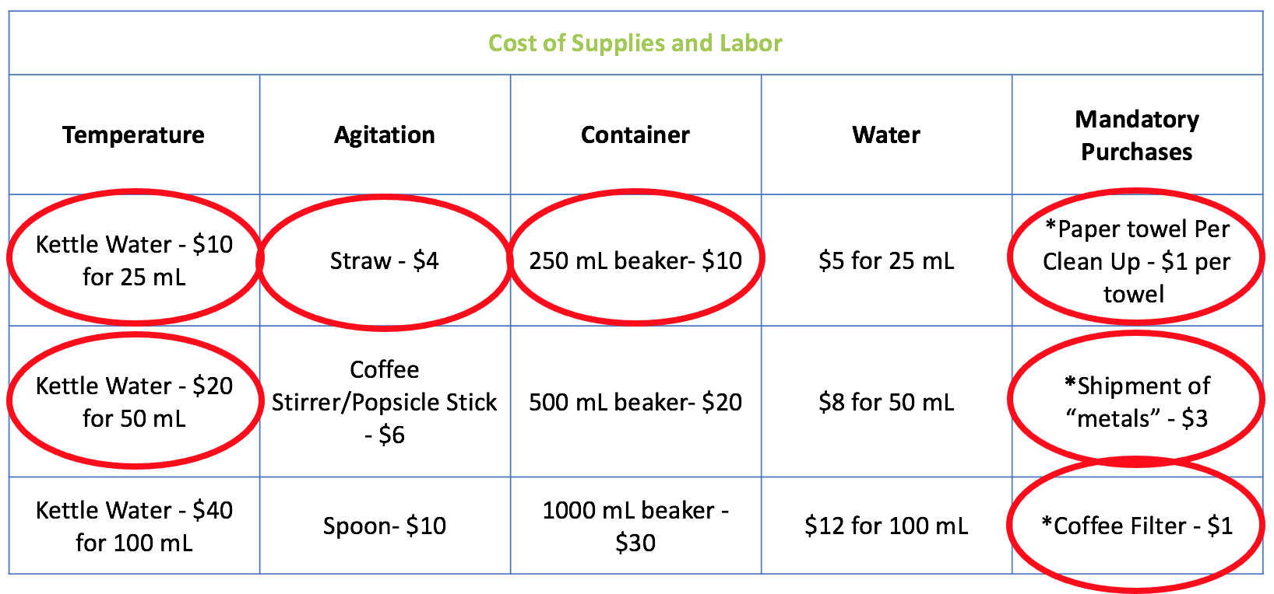
Remember, you are required to purchase at least 1 paper towel, your “shipment of metals,” and your filter. If you spill any of these items, you will have to purchase more.

Total Cost of Pepper Purification BEFORE LAB: __________________________$39_______

List any additional purchases you made during lab here: _____25 mL Kettle Water - $10___________

__2 Additional Paper Towels - $2__________

____________________________________

FINAL COST: __________________________$51_______

TOTAL GRAMS OF PEPPER AFTER DRYING OVERNIGHT: _____________________2.76 grams______

