Budget Form

Directions: In the space below, write down your step-by-step method, including all necessary materials and exact liquid quantities, based on the changes you discussed with your lab group. Then, calculate your total cost to conduct this in lab. Show this to your teacher before you head back to lab so they can record your total cost.

Remember, accidents happen, and you may need to purchase more things in the middle of conducting your experiment. Be sure to add this to your total cost to account for your expenses.

List lab group member names here: __________________________________________________________

Which metals shipment did your group get assigned, and what is the major solute in it? __________________

Write your Pepper “Acid Wash” Step-By-Step Method in as much detail as possible below. You may want to add more steps if 5 is not enough.

- T

- Type

E

e

- T

Calculate your total cost by circling the items you have selected in the table below. Write your total cost in the space provided below.

Remember, you are required to purchase at least 1 paper towel, your “shipment of metals,” and your filter. If you spill any of these items, you will have to purchase more.
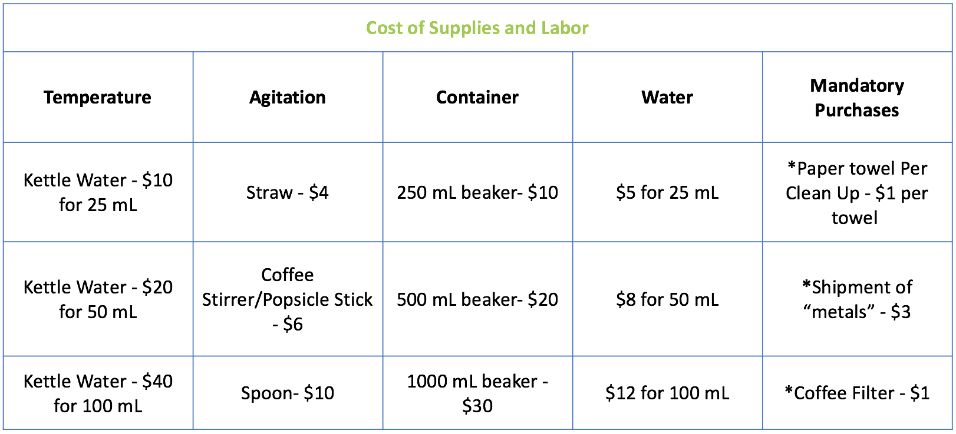

Total Cost of Pepper Purification BEFORE LAB: ___________________________________________

List any additional purchases you made during lab here: ____________________________________

____________________________________

____________________________________

FINAL COST: ______________________________

TOTAL GRAMS OF PEPPER AFTER DRYING OVERNIGHT: _______________________________

