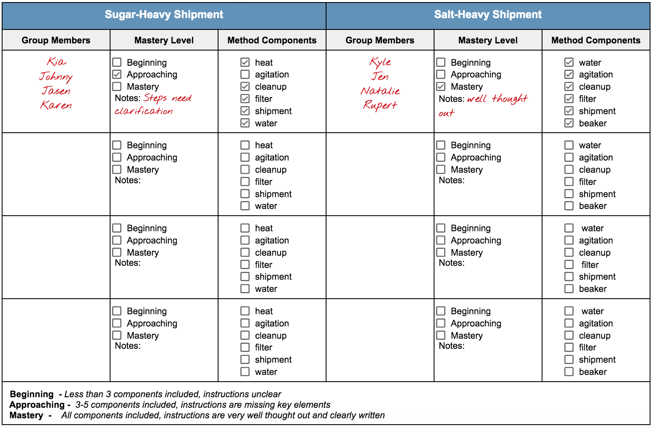**Pepper Extraction Method Rubric Example**