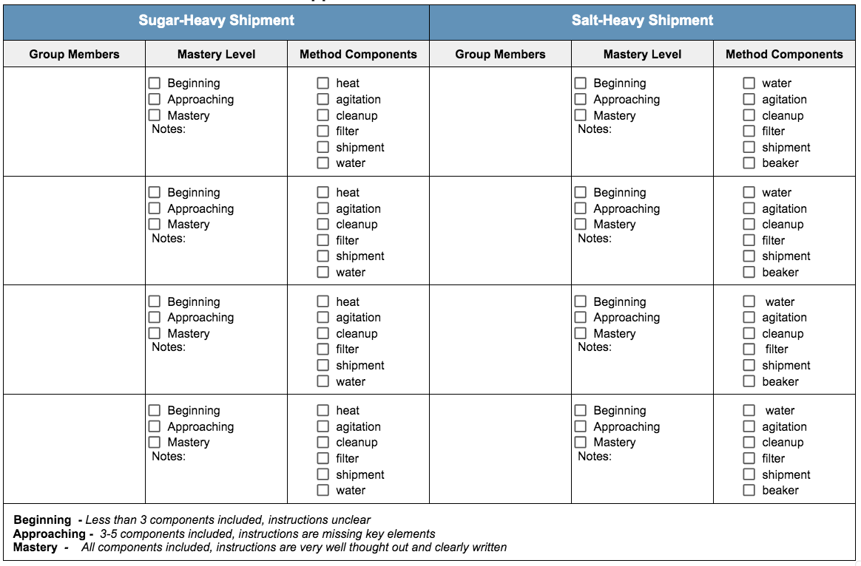
Pepper Extraction Method Rubric

