**Research Stations Preparation**

**Bulk Weighing Station**

*Note: You may need to teach students how to TARE the scale before using.*

* 1-4 scales (4 scales is great, but whatever you have available will also do)
* bulk containers of salt, sugar, pepper, Himalayan salt, sugar crystals, and peppercorn
* spoons to scoop spices into disposable cups

**Station 1: Concentration**

***Station Materials***

* 1-3 graduated cylinders (1 is necessary, 3 is ideal)
* 1,000 mL beaker filled ¾ with water (be prepared to periodically refill if not near a sink)
* something to pipet the water out with; a disposable pipet is ideal, but a straw will work by putting your finger over it and transferring water
* 3 markers
* 9 plastic spoons that will be reused
* 9 small disposable cups (cups will be reused and should be labeled by both gram amount and type of spice)
  + 3 small disposable cups filled with 0.1 grams of granulated salt, sugar, and pepper (respectively)
  + 3 small disposable cups filled with 7 grams of granulated salt, sugar, and pepper (respectively)
  + 3 small disposable cups filled with 25 grams of granulated salt, sugar, and pepper (respectively)
* 9 small beakers or 9 clear plastic cups to mix solutions
* solution disposal (sink or large bucket to take to the sink later)
* paper towels for spills
* 3 copies of the *Station 1 Directions* (located in the Research Station Table Directions sheet; in protective plastic, if possible)
* 10 or more copies of the *Aqueous Solutions Research Station 1: Concentration (Amount of Solute) Data Sheet* (located in the Research Data Sheet)

***Station Arrangement***

1. Arrange 3 separate areas on the research station: salt, sugar, and pepper.
   1. Label each area with sticky notes or tape, but students should see that at least one person needs to be at the salt, the sugar, and the pepper.
   2. Arrange Table Directions and Aqueous Solutions Research Station 4 copies at the station.

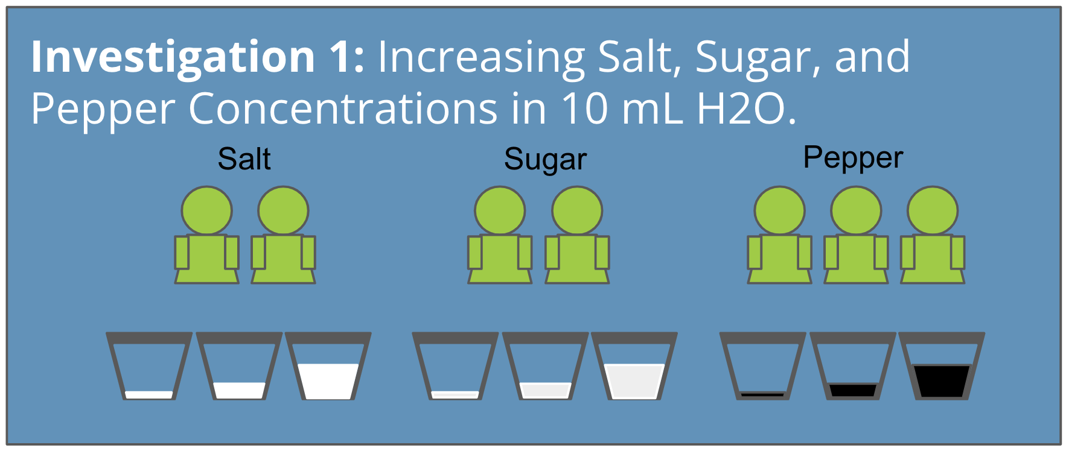

**Station 2: Surface Area**

***Station Materials***

* 1-3 graduated cylinders (1 is necessary, 3 is ideal)
* 1,000 mL beaker filled ¾ with water if not by a sink (if you have many classes, be prepared to periodically refill this if you do not have a sink nearby)
  + Something to pipet the water out with (disposable pipet is ideal but straw will work by putting your finger over it and transferring water)
* 3 markers
* 9 plastic spoons
* 9 small beakers or 9 plastic cups to mix solutions with
* solution disposal (sink or large bucket to take to the sink later)
* 3 small disposable cups filled with 4 grams of Himalayan salt, sugar crystals, and peppercorn, respectively (cups will be reused and should be labeled by both gram amount and type of spice)
* 3 small disposable cups filled with 4 grams of granulated salt, granulated sugar, and granulated peppercorn, respectively (cups will be reused and should be labeled by both gram amount and type of spice)
* paper towels for spills
* 3 copies of the Table Directions
* 10 or more copies per class period of Aqueous Solutions Research Station 2 handout

***Station Arrangement***

1. Arrange 3 separate areas on the research station: salt, sugar, and pepper.
   1. You can label this with sticky notes or tape, but students should see that at least one person needs to be at the salt, the sugar, and the pepper.
   2. Arrange Table Directions and Aqueous Solutions Research Station 4 copies at the station.

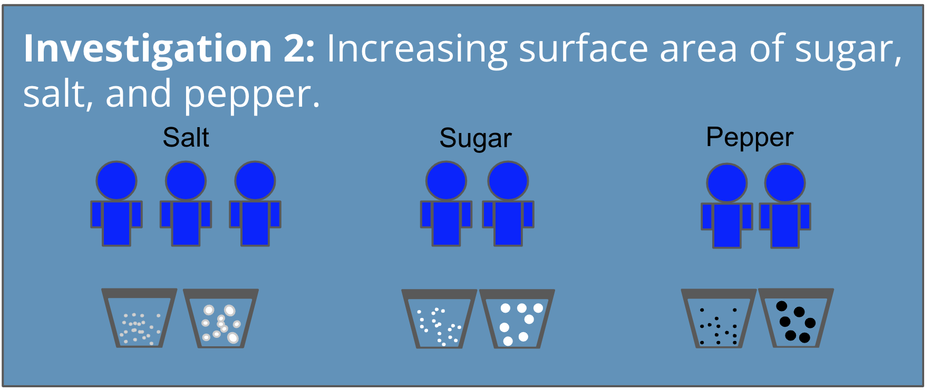

**Station 3: Temperature**

*Note: Do not allow students to touch hot water to minimize the risk of burns. You are advised to distribute all water to students once it is an acceptable warm temperature, but not so hot that it could cause a burn.*

***Station Materials***

* 1-3 graduated cylinders (1 is necessary, 3 is ideal)
* 1,000 mL beaker filled ¾ with water if not by a sink (if you have many classes, be prepared to periodically refill this if you do not have a sink nearby)
* something to pipet the water out with; a disposable pipet is ideal, but a straw will work by putting your finger over it and transferring water
* 3 markers
* 9 plastic spoons
* 9 Styrofoam cups
* solution disposal (sink or large bucket to take to the sink later
* 3 small disposable cups filled with 20 grams granulated salt (cups will be reused and should be labeled by both gram amount and type of spice)
* 3 small disposable cups filled with 20 grams granulated sugar (cups will be reused and should be labeled by both gram amount and type of spice)
* 3 small disposable cups filled with 20 grams granulated pepper (cups will be reused and should be labeled by both gram amount and type of spice)
* kettle/hot plate and pot/ microwave to heat up 500 mL of water above room temperature
* 500 mL of cold water (either in the refrigerator or sitting in an ice bath)
* paper towels for spills
* 3 copies of the Table Directions
* 10 or more copies per class period of Aqueous Solutions Research Station 3

***Station Arrangement***

1. Arrange 3 separate areas on the research station: salt, sugar, and pepper.
   1. You can label this with sticky notes or tape, but students should see that at least one person needs to be at the salt, the sugar, and the pepper areas.
2. Arrange Table Directions and Aqueous Solutions Research Station 3 copies at the station.

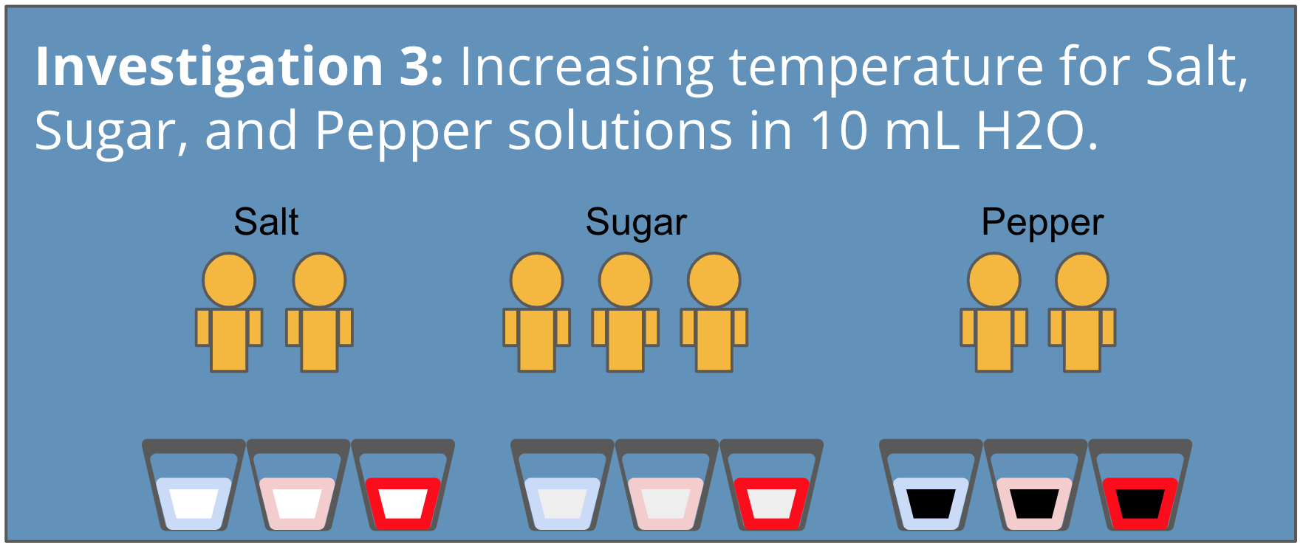

**Station 4: Agitation**

***Station Materials***

* 1-3 graduated cylinders (1 is necessary, 3 is ideal)
* 1,000 mL beaker filled ¾ with water if not by a sink (if you have many classes, be prepared to periodically refill this if you do not have a sink nearby)
* something to pipet the water out with; a disposable pipet is ideal, but a straw will work by putting your finger over it and transferring water
* 3 markers
* 9 plastic spoons
* 9 small beakers or 9 plastic cups to mix solutions with
* solution disposal (sink or large bucket to take to the sink later)
* paper towels for spills
* 3 small disposable cups filled with 10 grams granulated salt (cups will be reused and should be labeled by both gram amount and type of spice)
* 3 small disposable cups filled with 10 grams granulated sugar (cups will be reused and should be labeled by both gram amount and type of spice)
* 3 small disposable cups filled with 10 grams granulated pepper (cups will be reused and should be labeled by both gram amount and type of spice)
* stopwatches or timers to time stirring
* 3 copies of the Table Directions
* 10 or more copies per class period of Aqueous Solutions Research Station 4

***Station Arrangement***

1. Arrange 3 separate areas on the research station: salt, sugar, and pepper.
   1. You can label this with sticky notes or tape, but students should see that at least one person needs to be at the salt, the sugar, and the pepper.
   2. Arrange Table Directions and Aqueous Solutions Research Station 4 copies at the station.

