**Research Station Table Directions**

**Station 1 Directions: Concentration**

*Concentration is the amount of a substance (solute) that is dissolved in a given amount of liquid (solvent). In this case, we are analyzing how the amount of solute (salt, sugar, or pepper) affects how it dissolves in the solvent (water).*

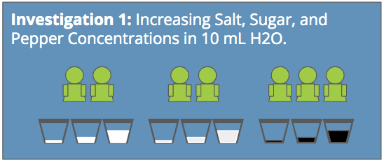

There should be 6–8 people at this station. Split into 3 subgroups as shown above. Each subgroup will test concentration using only one solute: salt, sugar, or pepper (see directions below). All groups will work at the same time. When everyone is finished, share your results with each other to complete your data tables. This way, you will all understand how concentration affects salt, sugar, and pepper in solutions and be ready to share with your peers.

**SALT CONCENTRATION RESEARCH**

1. Before you start, think about what you know about salt. What do you think will happen if we keep adding more salt to the water? Record your predictions in your data table.
2. Using a graduated cylinder, measure 10 mL of water, making sure the bottom of the meniscus is on the 10 mL line.
3. Take one cup and label it *Salt Concentration Low*. Pour 10 mL of water into the cup.
4. Add 0.10 g (100 mg) of salt to the cup of water. Gently stir the solution for 3 minutes.
5. Observe: What do the salt particles do? Record your observations in the data table.
6. Repeat Steps 2-5 with a cup labeled *Salt Concentration Medium* and add 7 g of salt.
7. Repeat Steps 2-5 with a cup labeled *Salt Concentration High* and add 25 g of salt.
8. Compare: Review your three tests. As the salt increased, what happened? Why do you think that happened? Record your observations and answers in the data table.
9. Pour the saltwater down the drain with running water, rinse cups, and set them aside to dry.

**SUGAR CONCENTRATION RESEARCH**

1. Before you start, think about what you know about sugar. What do you think will happen if we keep adding more sugar to the water? Record your predictions in your data table.
2. Using a graduated cylinder, measure 10 mL of water, making sure the bottom of the meniscus is on the 10 mL line.
3. Take one cup and label it *Sugar Concentration Low*. Pour 10 mL of water into the cup.
4. Add 0.10 g (100 mg) of sugar to the cup of water. Gently stir the solution for 3 minutes.
5. Observe: What do the sugar particles do? Record your observations in the data table.
6. Repeat Steps 2-5 with a cup labeled *Sugar Concentration Medium* and add 7 g of sugar.
7. Repeat Steps 2-5 with a cup labeled *Sugar Concentration High* and add 25 g of sugar.
8. Compare: Review your three tests. As the sugar increased, what happened? Why do you think that happened? Record your observations and answers in the data table.
9. Pour the sugar water down the drain with running water, rinse cups, and set them aside to dry.

**PEPPER CONCENTRATION RESEARCH**

1. Before you start, think about what you know about pepper. What do you think will happen if we keep adding more pepper to the water? Record your predictions in your data table.
2. Using a graduated cylinder, measure 10 mL of water, making sure the bottom of the meniscus is on the 10 mL line.
3. Take one cup and label it *Pepper Concentration Low*. Pour 10 mL of water into the cup.
4. Add 0.10 g (100 mg) of pepper to the cup of water. Gently stir the solution for 3 minutes.
5. Observe: What do the pepper particles do? Record your observations in the data table.
6. Repeat Steps 2-5 with a cup labeled *Pepper Concentration Medium* and add 7 g of pepper.
7. Repeat Steps 2-5 with a cup labeled *Pepper Concentration High* and add 25 g of pepper.
8. Compare: Review your three tests. As the pepper increased, what happened? Why do you think that happened? Record your observations and answers in the data table.
9. Pour the pepper water down the drain with running water, rinse cups, and set them aside to dry.

**Station 2 Directions: Surface Area**

*Surface area is the total outside area of an object. When a substance is broken into smaller pieces, the total surface area increases compared to its volume. In this case, we are analyzing whether higher or lower surface area makes dissolving easier.*

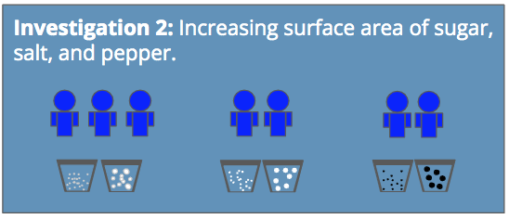

There should be 6–8 people at this station. Split into 3 subgroups as shown above. Each subgroup will test surface area using only one solute: salt, sugar, or pepper (see directions below). All groups will work at the same time. When everyone is finished, share your results with each other to complete your data tables. This way, you will all understand how surface area affects salt, sugar, and pepper in solutions and be ready to share with your peers.

**SALT SURFACE AREA RESEARCH**

1. Before you start, think about what you know about surface area. How do you think increasing the surface area of salt will affect how it dissolves? Will larger salt crystals dissolve faster or slower than smaller ones? Write your predictions in your data table.
2. Using a graduated cylinder, measure 10 mL of water, making sure the bottom of the meniscus is on the 10 mL line.
3. Take one cup and label it *Salt Low Surface Area*. Pour 10 mL of water into the cup.
4. Add 4 g of large salt crystals to the cup of water. Start your timer and gently stir with a spoon until the salt completely dissolves. Stop the timer when it is fully dissolved. If the salt has not dissolved after 5 minutes, stop stirring.
5. Record how long it took for the salt to dissolve in your data table.
6. Repeat Steps 2-5 with a cup labeled *Salt Large Surface Area* and add 4 g of small salt crystals.
7. Compare: How did the two sizes of salt compare when trying to dissolve them? Why do you think that happened? Record your observations in the data table.
8. Pour the saltwater down the drain with running water, rinse cups, and set them aside to dry.

**SUGAR SURFACE AREA RESEARCH**

1. Before you start, think about what you know about surface area. How do you think increasing the surface area of sugar will affect how it dissolves? Will larger sugar crystals dissolve faster or slower than smaller ones? Write your predictions in your data table.
2. Using a graduated cylinder, measure 10 mL of water, making sure the bottom of the meniscus is on the 10 mL line.
3. Take one cup and label it *Sugar Low Surface Area*. Pour 10 mL of water into the cup.
4. Add 4 g of large sugar crystals to the cup of water. Start your timer and gently stir with a spoon until the sugar completely dissolves. Stop the timer when it is fully dissolved. If the sugar has not dissolved after 5 minutes, stop stirring.
5. Record how long it took for the sugar to dissolve in your data table.
6. Repeat Steps 2-5 with a cup labeled *Sugar Large Surface Area* and add 4 g of small sugar crystals.
7. Compare: How did the two sizes of sugar compare when trying to dissolve them? Why do you think that happened? Record your observations in the data table.
8. Pour the sugar water down the drain with running water, rinse cups, and set them aside to dry.

**PEPPER SURFACE AREA RESEARCH**

1. Before you start, think about what you know about surface area. How do you think increasing the surface area of pepper will affect how it dissolves? Will larger pepper crystals dissolve faster or slower than smaller ones? Write your predictions in your data table.
2. Using a graduated cylinder, measure 10 mL of water, making sure the bottom of the meniscus is on the 10 mL line.
3. Take one cup and label it *Pepper Low Surface Area*. Pour 10 mL of water into the cup.
4. Add 4 g of large pepper crystals to the cup of water. Start your timer and gently stir with a spoon until the pepper completely dissolves. Stop the timer when it is fully dissolved. If the pepper has not dissolved after 5 minutes, stop stirring.
5. Record how long it took for the pepper to dissolve in your data table.
6. Repeat Steps 2-5 with a cup labeled *Pepper Large Surface Area* and add 4 g of small pepper crystals.
7. Compare: How did the two sizes of pepper compare when trying to dissolve them? Why do you think that happened? Record your observations in the data table.
8. Pour the pepper water down the drain with running water, rinse cups, and set them aside to dry.

**Station 3 Directions: Temperature**

*Temperature is the amount of “hotness” or coldness an object has. In this case, we are analyzing how the temperature of the solvent (water) affects how the solutes dissolve.*

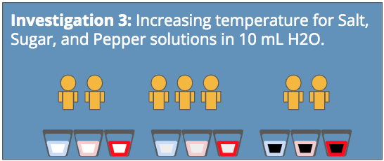

There should be 6–8 people at this station. Split into 3 subgroups as shown above. Each subgroup will test temperature only one solute: salt, sugar, or pepper (see directions below). All groups will work at the same time. When everyone is finished, share your results with each other to complete your data tables. This way, you will all understand how temperature affects salt, sugar, and pepper in solutions and be ready to share with your peers.

**SALT AND WATER TEMPERATURES RESEARCH**

1. Before you start, think about temperature. What do you think will happen if the water gets hotter? Write your predictions in your data table.
2. Using a graduated cylinder, measure 10 mL of **cold water**, making sure the bottom of the meniscus is on the 10 mL line.
3. Take one **Styrofoam** cup and label it *Salt Cold H2O*. Pour 10 mL of cold water into the cup.
4. Add 20 g of salt to the cup of water. Gently stir the solution for 3 minutes with a spoon. **Be careful not to spill or splash the water.**
5. Observe:What do the salt particles do? Record your observations in the data table.
6. Repeat Steps 2-5 with a cup labeled *Salt Room-Temp H2O* and 10 mL of room temperature water.
7. Repeat Steps 2-5 with a cup labeled *Salt Hot H2O*. Get 10 mL of hot water from your teacher in a Styrofoam cup**. Make sure that the teacher is the one to pour the hot water and that you do not touch the hot water. Be very careful not to spill.**
8. Compare: As the temperature increased, what happened to the salt? Why do you think that happened? Record your observations in the data table.
9. **Carefully and gently** dump the saltwater solutions down the drain with running water, rinse cups, and set them aside to dry.

**SUGAR AND WATER TEMPERATURES RESEARCH**

1. Before you start, think about temperature. What do you think will happen if the water gets hotter? Write your predictions in your data table.
2. Using a graduated cylinder, measure 10 mL of **cold water**, making sure the bottom of the meniscus is on the 10 mL line.
3. Take one **Styrofoam** cup and label it *Sugar Cold H2O*. Pour 10 mL of cold water into the cup.
4. Add 20 g of sugar to the cup of water. Gently stir the solution for 3 minutes with a spoon. **Be careful not to spill or splash the water.**
5. Observe:What do the sugar particles do? Record your observations in the data table.
6. Repeat Steps 2-5 with a cup labeled *Sugar Room-Temp H2O* and 10 mL of room temperature water.
7. Repeat Steps 2-5 with a cup labeled *Sugar Hot H2O*. Get 10 mL of hot water from your teacher in a Styrofoam cup**. Make sure that the teacher is the one to pour the hot water and that you do not touch the hot water. Be very careful not to spill.**
8. Compare: As the temperature increased, what happened to the sugar? Why do you think that happened? Record your observations in the data table.
9. **Carefully and gently** dump the sugar water solutions down the drain with running water, rinse cups, and set them aside to dry.

**PEPPER AND WATER TEMPERATURES RESEARCH**

1. Before you start, think about temperature. What do you think will happen if the water gets hotter? Write your predictions in your data table.
2. Using a graduated cylinder, measure 10 mL of **cold water**, making sure the bottom of the meniscus is on the 10 mL line.
3. Take one **Styrofoam** cup and label it *Pepper Cold H2O*. Pour 10 mL of cold water into the cup.
4. Add 20 g of pepper to the cup of water. Gently stir the solution for 3 minutes with a spoon. **Be careful not to spill or splash the water.**
5. Observe:What do the pepper particles do? Record your observations in the data table.
6. Repeat Steps 2-5 with a cup labeled *Pepper Room-Temp H2O* and 10 mL of room temperature water.
7. Repeat Steps 2-5 with a cup labeled *Pepper Hot H2O*. Get 10 mL of hot water from your teacher in a Styrofoam cup**. Make sure that the teacher is the one to pour the hot water and that you do not touch the hot water. Be very careful not to spill.**
8. Compare: As the temperature increased, what happened to the pepper? Why do you think that happened? Record your observations in the data table.
9. **Carefully and gently** dump the pepper water solutions down the drain with running water, rinse cups, and set them aside to dry.

**Station 4 Directions: Agitation**

*Agitation is the movement or stirring of a liquid. In this case, we are analyzing how stirring (or not stirring) the water affects how the solute dissolves.*

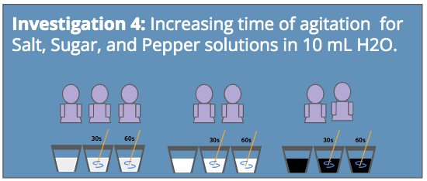

There should be 6–8 people at this station. Split into 3 subgroups as shown above. Each subgroup will test agitation using only one solute: salt, sugar, or pepper (see directions below). All groups will work at the same time. When everyone is finished, share your results with each other to complete your data tables. This way, you will all understand how agitation affects salt, sugar, and pepper in solutions and be ready to share with your peers.

**SALT AGITATION RESEARCH**

1. Before you start, think about agitation. What do you think will happen if we keep agitating our solution? Write your predictions in your data table.
2. Using a graduated cylinder, measure 10 mL of water, making sure the bottom of the meniscus is on the 10 mL line.
3. Take one cup and label it *Salt No Stir*. Pour 10 mL of water into the cup.
4. Add 10 g of salt to the cup of water. **Do not stir the water in any way**.
5. Observe: What do the salt particles do? Record your observations in the data table.
6. Repeat Steps 2-5 with a cup labeled *Salt Stir 45 sec* and gently stir the water for 45 seconds.
7. Repeat Steps 2-5 with a cup labeled *Salt Stir 120 sec* and gently stir the water for 120 seconds.
8. Compare: As the amount of stirring increased, what happened to the salt? Why do you think that happened? Record your observations in the data table.
9. Pour the saltwater down the drain with running water, rinse cups, and set them aside to dry.

**SUGAR AGITATION RESEARCH**

1. Before you start, think about agitation. What do you think will happen if we keep agitating our solution? Write your predictions in your data table.
2. Using a graduated cylinder, measure 10 mL of water, making sure the bottom of the meniscus is on the 10 mL line.
3. Take one cup and label it *Sugar No Stir*. Pour 10 mL of water into the cup.
4. Add 10 g of sugar to the cup of water. **Do not stir the water in any way**.
5. Observe: What do the sugar particles do? Record your observations in the data table.
6. Repeat Steps 2-5 with a cup labeled *Sugar Stir 45 sec* and gently stir the water for 45 seconds.
7. Repeat Steps 2-5 with a cup labeled *Sugar Stir 120 sec* and gently stir the water for 120 seconds.
8. Compare: As the amount of stirring increased, what happened to the sugar? Why do you think that happened? Record your observations in the data table.
9. Pour the sugar water down the drain with running water, rinse cups, and set them aside to dry.

**PEPPER AGITATION RESEARCH**

1. Before you start, think about agitation. What do you think will happen if we keep agitating our solution? Write your predictions in your data table.
2. Using a graduated cylinder, measure 10 mL of water, making sure the bottom of the meniscus is on the 10 mL line.
3. Take one cup and label it *Pepper No Stir*. Pour 10 mL of water into the cup.
4. Add 10 g of pepper to the cup of water. **Do not stir the water in any way**.
5. Observe: What do the pepper particles do? Record your observations in the data table.
6. Repeat Steps 2-5 with a cup labeled *Pepper Stir 45 sec* and gently stir the water for 45 seconds.
7. Repeat Steps 2-5 with a cup labeled *Pepper Stir 120 sec* and gently stir the water for 120 seconds.
8. Compare: As the amount of stirring increased, what happened to the pepper? Why do you think that happened? Record your observations in the data table.
9. Pour the pepper water down the drain with running water, rinse cups, and set them aside to dry.