Appendix B Answer Key

Calculating number of bricks and fence posts:
Note: distances are found using the ruler tool in Google Earth.

For calculating the area of the path on the field, find the length and width (as shown in the attached diagram) using the ruler tool in Google Earth. Note that only the width of the pathway is to scale, the lengths of the paths are NOT to scale. The path is 2 meters in real life, so the scale on the sketch is 1cm=2m, but again only the width of the path follows this scale.

Pathway divided into sections:
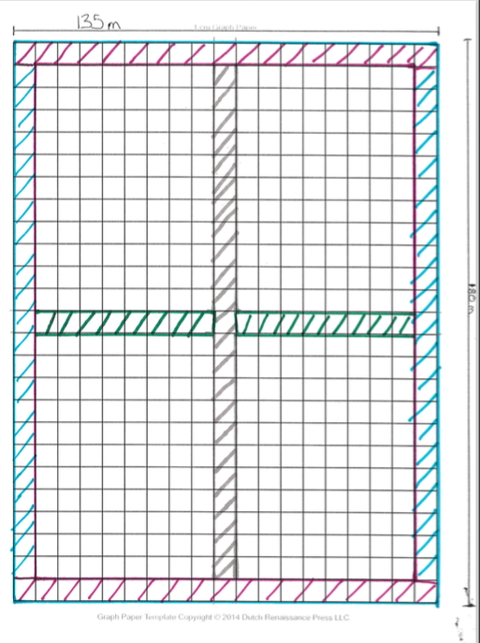

Purple Sections:
2 x 135m x 2m = 540 square meters

Green Sections
[135m-(2m x 3]) x 2m = 129m x 2m = 258 square meters
***Note***
There are 3 sections of sidewalk that must be removed from the whole width of the field (2 blue sections and the grey section) hence subtracting 2 x 3m or 6m from the total of 135m.

Grey Section:
[180 m-(2 x 2m)] x 2m = 176m x 2m = 352 square meters
***Note***
The grey section is only 2 path widths shorter than the whole length of the field (the two purple sections).

Blue Sections:
[180m-(2 x 2m)] x 2m x 2 = 176m x 2m x 2 = 704 square meters
***Note*** The blue sections are each the same size as the grey section, but there are two of them.

Total Area of the Path:
540 square meters
+ 258 square meters
+ 352 square meters
+ 704 square meters
1854 square meters

As each brick occupies only 1/9 of a square meter, we need to divide our total area by 1/9. Dividing by a fraction is the same as multiplying by its reciprocal, so we can actually multiply:
1854 square meters x 9 bricks per square meter = 16,686 bricks.

Fence posts for fencing:
Using the ruler tool, we find that the perimeter of the polygon is approximately 480 meters.
To find out how many fence posts we need, divide the perimeter by $1\frac{5}{6}$ fence posts per meter.
480m ÷$1\frac{5}{6}$ posts per meter = 480m ÷ $\frac{11}{6}$ posts per meter = 2280/11 posts = 261$\frac{9}{11}$ posts.
Since you can’t buy less than one post, we would need 262 posts and have a shorter section or 261 posts and have a longer section.

