Student Activity Sheet- Denali Topo Map Answer Key

***NOTE: The calculations for the scales will depend on how big the screen of the students’ device is, which dictates how long the scale bar is.***

Directions: Follow the steps in order and answer the associated questions as you proceed through the activity. The first part of the activity will be guided by your teacher and may vary depending on the electronic device that your class uses and your familiarity with the Google Earth software.

Part 1: Setup and Introduction to Google Earth

- If Google Earth is not already installed on the computers, have students navigate to the following address to do so: https://www.google.com/earth/download/gep/agree.html. On tablet devices, the software can be downloaded as an app.
- All students should download the KMZ file NGS Topo 2d from http://services.arcgisonline.com/arcgis/rest/services/NGS_Topo_US_2D/MapServer. Once at the above website, click Google Earth under the heading “View In” at the very top of the page.
- Once the KMZ file is downloaded, it should load in Google Earth. If not, there is a pane on the left-hand side of the software called “Places” that allows you to toggle on/off the new file with a checkmark to the left of the file. When your file initially downloads, it may be located under the tab “Temporary Places.” See Figure 2.
- Students should set Google Earth to display information in metric units (kilometers) and show the scale bar. To set this preference, click on the Google Earth heading (shown as Google Earth Pro in the image below) and then click on “Preferences.” From within the preferences dialogue box, students can set the units to kilometers. To show the scale bar, click on “View” the top pane and make sure there is a checkmark by “Scale Legend.”
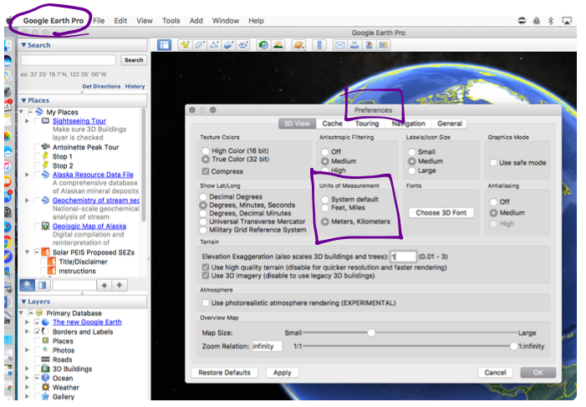

- We will be looking at a mountain in Alaska known as Denali. To zoom to Denali, place your curser in the “Search” pane in the top left of the program, type in “Denali, AK” and hit enter. It may take a while for the USGS map overlay to load again.
- Take some time to familiarize yourself with the navigation in Google Earth. Try the following:

  - Zoom in/out—either use your electronic device’s scroll function with the cursor over the map, or manually click on the plus and minus tabs on the right-hand side of the screen.
  - Move map—click and drag the screen in any direction, or click on the directional arrows above the zoom functions on the right of the screen.
  - Change viewpoint—hold shift or control on the keyboard and click and drag the screen.
  - Toggle USGS Topo Maps on/off—In the left-hand window you will see a tab called “Places.” Find “NGS_Topo_US_2D” and toggle the checkmark on and off to see what the map looks like.
  - Vary the transparency of the USGS Topo Maps—You can make the USGS topography maps more or less visible (transparent) by selecting the gradient tool (next to the magnifying glass) at the bottom of the “Places” pane on the left-hand side of the screen. Slide the white button left and right to see the USGS maps move in and out of view.
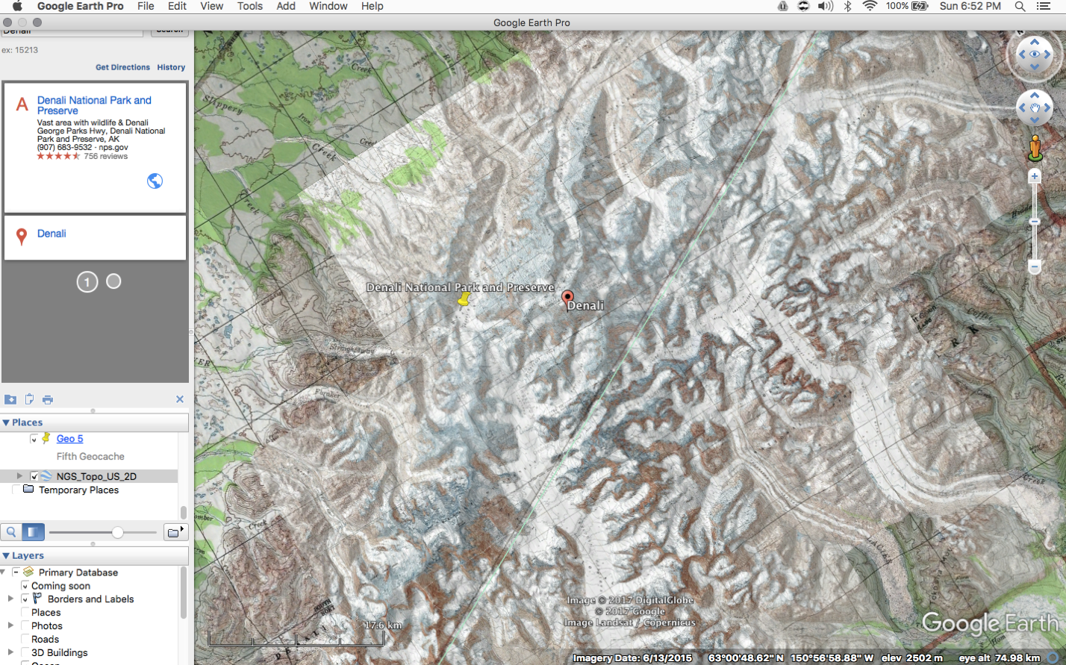

Part 2: Determining Scale

Google Earth, like all maps, uses scale to represent distances in real life as distances on the map. Different maps have different scales. Google Earth gives its scale in the form of a bar on the lower left of the screen (make sure you have selected to show the bar—see Step 4 above). Notice how the scale changes when you move the screen around.

Scale can be written as a ratio comparing the distance on the map to the distance represented in real life, like this:

Distance on map : distance in real life

Scale does not typically have units because the units cancel out when written as a fraction. Scale works when the same units are used on the map as in real life. So, if the scale was 1:4, then one inch on the map would equal four inches in real life and one centimeter on the map would equal four centimeters in real life.

In this section, you will determine the scale of the map in Google Earth for two different zoom positions.

- Position the map so that the scale bar reads 5 km. This means that for every length of the scale bar, the distance on the earth is 5 km. We want to show this scale as a ratio: km on map : km in real life. To do this we must know the length of the scale bar. Using your ruler and the following conversion, measure the length of the scale bar in millimeters and convert 5 km to millimeters. We always convert map scales to have a one in the numerator, or a when written as a:b. (Note that this is not technically a unit rate, but the inverse or reciprocal of a unit rate.)

Conversion: 1 km = 1,000,000 mm

- Length of scale bar in millimeters.

48 mm

- Convert 5 km to millimeters.

5 km x 1,000,000 mm/ 1 km = 5,000,000 mm

- Ratio: mm on map : mm in real life.

48:5,000,000

d: Convert ratio to have a one in the numerator (hint: use division to create an equivalent ratio).

5,000,000÷48=104,166
So, the scale is 1:104,166 which we could round to 1:100,000

e: Based on your ratio above, how many centimeters on earth would be represented by 10 centimeters on the map?

10x104,166= 1,041,660 cm or about 10.4 km

f: What would your ratio look like as a decimal?

1÷104,166=.0000096 or approximately .00001

- Position your scale bar so that the scale reads 2500 m (equivalent to 2.5 km). Note that it may be difficult to get the reading exact, but if you are within 10 m of that number the effect on the scale will be negligible.

a: Length of scale bar in millimeters.

48 mm

b: Convert 2500m to millimeters.

2.5 km x 1,000,000 mm/ 1 km= 2,500,000 mm

c: Ratio: mm on map : mm in real life

48:2,500,000

d: Convert ratio to have a one in the numerator.

2,500,000÷48= 52,083

1:52,083 or about 1:50,000

e: Based on your ratio above, how many centimeters on earth would be represented by 10 centimeters on the map?

10x52,083= 520,830 cm or about 5.2 km.

f: What would your ratio look like as a decimal?

1÷52,083= .0000192 or approximately .00002

- Analysis of scale

a: Which scale (from 1 or 2 above) allowed you to see more detail on the map? Why?

You can see more detail from part 2 above, because you are more zoomed in on the map. The length of the scale bar is not changing, however the map is showing smaller distances. So, the same distance on the map shows a smaller distance in real life, resulting in a more zoomed in (or “blown up”) map.

b: When we use maps in STEM and the social sciences, we refer to large- and small-scale maps. Which map had a larger scale (ratio), and which map had a smaller scale (ratio)? How does this compare to your answer in Question A above? In other words, do large-scale or small-scale maps provide more detail?

The scale for part A was about .00001 while in part B it was twice that large, or .00002. Therefore, the larger the scale of the map the more detail the map will provide and the smaller the scale of the map the less detail provided.

b: Do maps that have ratios closer to one or closer to zero show more detail?

Because numbers closer to one are larger and those closer to zero are smaller, ratios or scales closer to 1 (or a 1:1 ratio) show more detail. If a map was drawn at a scale of 1:1, the map would actually be the exact same size as the piece of land it was representing! A number greater than 1 for the scale would provide even more detail, and the map would be bigger than the land it was representing. We see these types of scales often, for example when we draw things like bacteria.

d: Imagine that you were given the following two map scale ratios: 24,000 and 120,000.

Which map would provide more detail? Why?

If you reduce the second scale by dividing both sides by 5, you get a new, equivalent ratio of 1:24,000. So effectively these scales are the same, and both would provide the same amount of detail.

Part 3: Contour Lines and Gradient (Slope)

Topography maps allow us to determine elevation on the map. Elevation simply means the vertical distance a point is above sea level, and is represented by the small numbers on lines in a map. As you see them in the topography map overlay, these lines are called contour lines. To use contour lines, it is helpful to know the elevation change between each line; otherwise known as a unit rate. Unit rates are determined by division. The small numbers represent elevation in feet above sea level.

- You will notice that not every contour line is labeled. The bold lines, which occur every fifth contour line, are the only labeled contours.

a: Complete the table below, which compares the number of contour lines to the elevation change between the lines.

Contour Lines | 0 | 5 | 10 | 15
Elevation Change (ft) | 0 | 500 | 1000 | 1500

b: Determine how many feet are represented between each line. Express the ratio as two unit rates in the following forms:

Feet/Contour Line

100 ft/contour line

Meters/Contour Line (note that 1 ft = .3048 meters)

100x.3048= 30.48 m/contour line

c: If the change in elevation for each contour line is constant, the relationship is considered proportional. Is the relationship between the number of contour lines and elevation change above proportional? Explain.

Yes, because every contour line represents 100 feet relative to the closest line. Another way to think about this is that 5/500, 10/1000 and 15/1500 all have the same value, 1/100 or .01.

- We can use the unit rate you established above to help us determine gradient, or slope, which is another ratio. Again, this ratio has no unit because we use the same units in the numerator and denominator of the ratio, and they cancel each other out. Typically, slope is given as a fraction while gradient is given as an equivalent percent. For example, a slope of ½ is equivalent to a gradient of 50%. The ratio for slope is defined as the change in vertical distance to the change in horizontal distance. Therefore, the larger the ratio is, the steeper the slope is. A slope of ½ would mean that for every meter of elevation you gain, you are moving horizontally two meters.

a: Based on what you know about slope and gradients, would you expect the terrain to be steeper if the contour lines were spaced more closely together or further apart? Why? How is this helpful to you as an engineer?

The terrain is steeper if the lines are more closely spaced than if they are further apart. The closer they are to each other, the more elevation is being gained or lost with less change in horizontal distance and the further spaced out they are the more horizontal distance you can travel before changing any given amount of vertical distance, so the slope is less steep.

b: It is very hard to show large, vertical cliffs on a topography map. Why do you think that would the case?

In the case of vertical cliffs, the horizontal change would be zero. Therefore, if the elevation change is great, you would have several contour lines stacked up one on top of the other and it would appear to be one contour line.

- Two groups are climbing Denali, one located at point “A” and one located at point “B” in the image below. For reference, Group A is located at the upper reaches of the Northeast Fork while Group B is on the Harper Glacier. Both groups are located exactly 3 km horizontally from the summit of Denali, which is located at 6,190 m (20,310 ft). Note the slight discrepancy in Google Earth’s elevation of the mountain as opposed to the USGS listed elevation of 6193 m (20,320 ft).
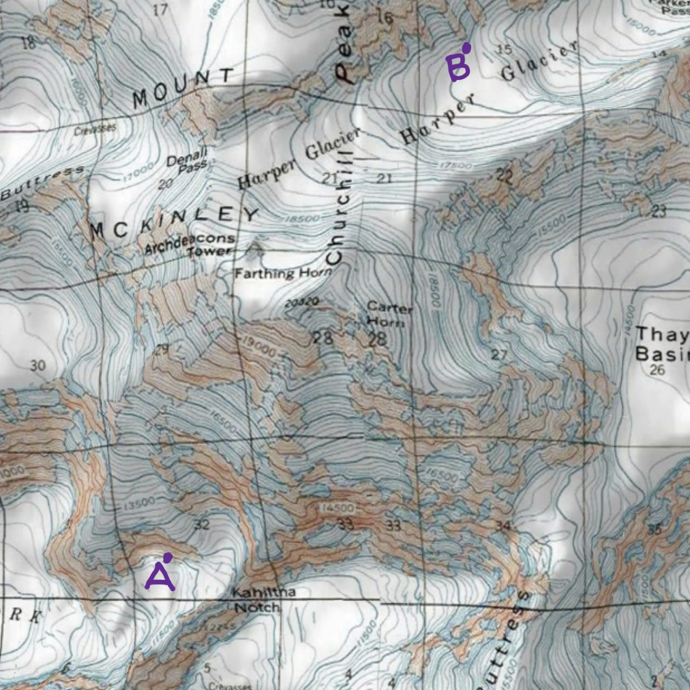

a: Based on the locations of each group and the spacing of contour lines, which group appears to have the easier path to the summit? Why?

Group B’s path seems much easier because the contour lines between them and the summit are much more spaced out than for group A, who seems to have to climb some very steep terrain to summit the mountain.

b: Calculate the slope and gradient that each group must climb now to reach the summit. You will need to determine each group’s elevation based on your contour line unit rate and their locations on the map. Assume both groups lie directly on a contour line. You will need to use meters or kilometers for both the elevation and horizontal distances.

Group A:

Group A is located at 11,500 feet. 11,500 x .3048 is 3,505.2 m.
The summit is located at 6190 m, so they need to go 6190-3,505.2= 2,684.8 m in elevation.
They have 3 km, or 3000 m, to go horizontally, so the slope is:
2,684.8/3000 or approximately .895.
Written as a gradient or percent, this is:
.895x100= 89.5%

Group B:

Group B is located at 16,500 feet. 16,500 x .3048 is 5,092.2 m.
The summit is located at 6190 m, so they need to go 6190-5,092.2=1097.8 m in elevation.
They have 3km, or 3000 m, to go horizontally, so the slope is:
1097.8/3000 or approximately .366
Written as a gradient or percent, this is:
.366x100= 36.6%

c: How is this situation with the climbers similar to your goal as the engineer? How are the situations different?

If I were climbing Denali, I would prefer to approach like Group B because they have a less steep climb to get to the summit. At those elevations, there isn’t much oxygen so the less grueling the slope the easier it would be for me to get to the top. Similarly to the climbers, the tram needs to make it to the summit. However, trams can climb very steep inclines like the one seen for the path of Group A. As an engineer, I could easily consider both routes because the power for the tram isn’t coming from a person, so other factors may come into play.

Part 4: Mountain Growth

a: Denali is still growing at an average rate of 5 meters per 5000 years. Express this rate as a unit rate in mm/year

5 m x 1000 mm/ 1m = 5000 mm
5000 mm ÷ 5000 yr = 1 mm per yr

b: Assume that the number you found in part A above does not include the rate at which Denali is eroding, or shrinking. To understand how the mountain can grow and shrink in the same year, think about your hair. It grows at a certain rate each year, but most of us also cut our hair periodically. A mountain can grow during an earthquake, and shrink during rock slides and other events. Assume that on average, Denali grows and shrinks by the amounts given above and below. If your calculations are correct, you will see that on average, Denali grows each year more than it shrinks.

If Denali also shrinks on average at a rate of 1/2 mm per year, how many years will it take for Denali to grow 1 m?

If Denali grows by 1 mm per yr and also shrinks at .5 mm per yr, then the net result is a growth of .5 mm per yr.

1 m = 1000 mm

1000 mm ÷ .5 mm/ yr = 2000 yr
So, it would take 2000 years to grow 1 meter on average.

Part 5: Engineering

a: As an engineer tasked with building a tram to the top of Denali, why might you want to use a tool like Google Earth, and how would knowledge of topography maps be used in your work?

An engineer would want to know how steep the different parts of the mountain might be and also whether the mountain is all cliff or maybe covered in snow. Google Earth’s satellites provides some of that information, however this is obviously changing daily and with the seasons. The topographic map overlay shows how steep the different parts of the mountain are and for how long, as well as just showing the elevations. Knowing that you are working above 5000 m is important for considering how you will get materials and people to the site. Engineers need to find areas for the towers and summit and base infrastructure, and could identify places to visit in person from the maps and images. They can also communicate to other workers about which areas they are referring to, using latitude and longitude and elevation, also provided by Google Earth. They can instantly calculate distances using the ruler to see how spread out potential tower placements would be and get other crucial data from the images and maps.

b: Choose a path up Denali (starting no higher than 2133 m, or 7000 ft.) that you would recommend using for your tram. You will need to print the part of the screen that shows this path, then draw it in with marker. Alternatively, you can use the path tool under the “Add” tab at the top of Google Earth. Explain below why you chose your path for the construction of the tram.

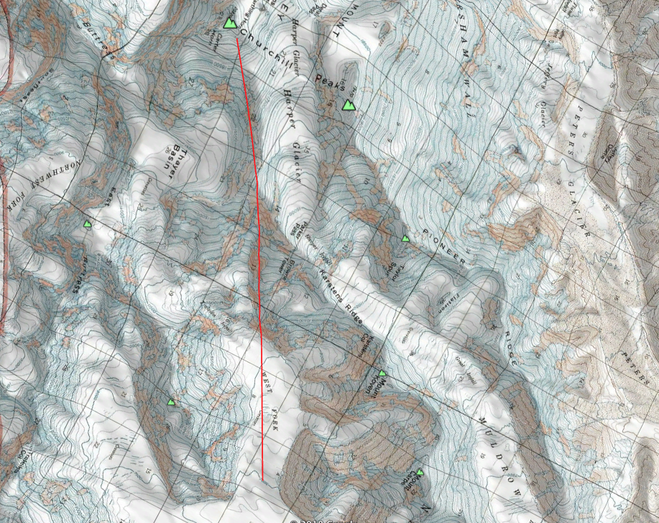

The reason I chose this path up Denali is that it starts on a nice flat spot that is easy to build on. As the tram follows the West Fork glacier, it has an easy path until it has to climb very steeply. The middle section would be the hardest to build because it is so steep. However, the path ends up on a nice ridge that would make it easy to put in towers and has more a feasible slope to the summit. All ascent paths have their challenges, and some would be easier if the path the tram takes is able to move from a straight line.

