Dome It Challenge Worksheet
space exploration
Your scenario: ____________________________
Example Solution

Introduction
- What is the background story of your scenario?
Why are you there? How did you get there?
My group is on a 10-year mission in space to find Earth-like planets where humans can live.

- What are some limitations of your scenario or what aspects make it difficult to survive?
The spaceship has limited space available. We must bring everything we need with us, but still fit it on the ship. We will have limited supplies of air and water.
Solution
- How did you get your energy using biorecycling?
We used algae photobioreactors to make biofuel from the sun. The biofuel runs the spaceship.
We used organic (human) waste on the ship in an anaerobic digester to create biogas for cooking and electricity.

- How did you get your food using biorecycling?
The anaerobic digester gave us fertilizers that we used to grow food. We also used the remaining food and plant waste as compost to make new soil/fertilizer for food growth.

- How did you deal with your waste?
We had to recycle all of our waste. Our wastewater and human waste was used in the anaerobic digester. Food and plant waste was composted. Fertilizer/nutrients from the anaerobic digester and compost were used to grow food.

- Draw a sustainable (circular) connection you made as part of your solution.
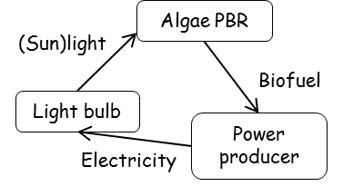
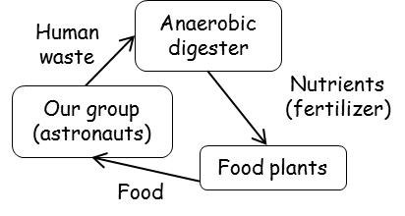

- Do you think you will survive your scenario? Why or why not?
We will survive because we used closed loops to recycle waste as resources. Waste is not piling up in our spaceship, and we have food, water and energy to survive. We are sustainable.

