Just Breathe Green Worksheet Example Answers
10:30am 74° 75% 65°
Time of Day ______________ Temperature ______________ Humidity ______________ Dew point ______________
Clear skies
Weather conditions _______________________________________________________________________________
Condensed water
What do you predict that you will see accumulate on the bottle/bag? _______________________________________
Clear
Predict the color of water as it evaporates from the plant. ________________________________________________
1
Plant ID # ________
Common name: Horsetail Scientific name: Equisetum hyemale
Time (minutes) | Weight (g) | Observations (What do you see?)
0 min | 20.0 g | The bottle is clean, clear and dry.
5 min | 21.5 g | You can begin to see water condensing on the bottle surface.
10 min | 23.2 g | The bottle is no longer transparent.
15 min | 24.0 g | Drops of water can be seen collecting on the sides of the bottle.
Determine the amount of transpiration:
Trial 1 weight | 21.5 g | Trial 2 weight | 23.2 g | Trial 3 weight | 24.0 g
minus |  | minus |  | minus
Initial weight | 20.0 g | Initial weight | 20.0 g | Initial weight | 20.0 g
equals |  | equals |  | equals
Trial 1 transpiration mass (g) | 1.5 g | Trial 2 transpiration mass (g) | 3.2 g | Trial 3 transpiration mass (g) | 4.0 g
Trial 1  transpiration rate | 0.30 g/min | Trial 2  transpiration rate | 0.32 g/min | Trial 3  transpiration rate | 0.27 g/min
Average transpiration rate (1 g=1 ml) |  |  |  |  | 0.296 ml/min
Draw and describe this plant species:
Plant species
Common name: Horsetail Scientific name: Equisetum hyemale
Light requirements | Full sun to partial shade | 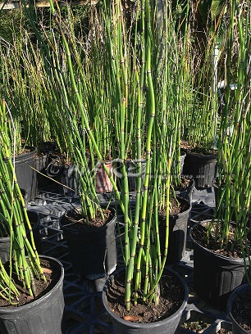  Sketch with details:
Height | 1-4 ft
Soil conditions | Wet
Transpiration rate (ml/min) | 296

Draw and describe plant species selected by two other classmates and record the transpiration rate below:
Plant species
Common name: Tickseed Scientific name: Coreopsis leavenworthii
Light requirements | Full sun | 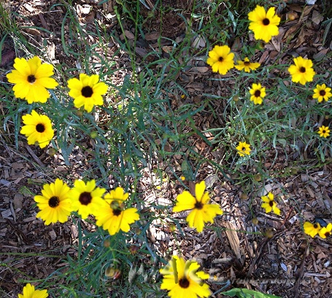  Sketch with details:
Height | 1-3 ft
Soil conditions | Average to moist
Transpiration rate (ml/min) | 150

Plant species
Common name: Tropical Sage Scientific name: Salvia coccinea
Light requirements | Full sun to partial shade | 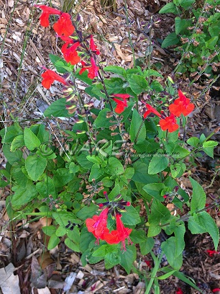  Sketch with details:
Height | 2-3 ft
Soil conditions | Well drained
Transpiration rate (m/min) | 406

Plant species common name: Tickseed
Trial 1 transpiration mass (g) | 0.7 g | Trial 2 transpiration mass (g) | 1.7 g | Trial 3 transpiration mass (g) | 2.2 g
Trial 1  transpiration rate | 0.14 g/min | Trial 2  transpiration rate | 0.17 g/min | Trial 3  transpiration rate | 0.15 g/min
Average transpiration rate (1 g=1 ml): |  |  |  |  | 0.152 ml/min
Plant species common name: Tropical Sage
Trial 1 transpiration mass (g) | 1.9 g | Trial 2 transpiration mass (g) | 4.1 g | Trial 3 transpiration mass (g) | 6.5 g
Trial 1  transpiration rate | 0.38 g/min | Trial 2  transpiration rate | 0.41 g/min | Trial 3  transpiration rate | 0.43 g/min
Average transpiration rate (1 g=1 ml)” |  |  |  |  | 0.407 ml/min

Graphing
In one graph, plot the transpiration rate data as volume over time for each plant species. Use different colors
and/or line styles for each plant species and create a key. The slope of the line is the transpiration rate.
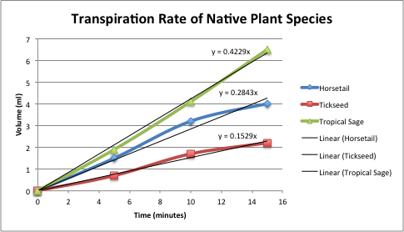

Analysis Questions
Did one plant species have a higher rate of transpiration than the other? If so, what were the physical differences in the plants? Why might this make a difference? Refer to your drawings and observations of the plants and the data you collected.
Tropical sage had the highest transpiration rate. Its physical characteristics include a high leaf surface area to overall plant ratio compared to tickseed, and its leaves have a rough textured surface compared to the horsetail. The increase in leaf surface area provides more area for transpiration to occur.

What was the color of the condensed water? Why?
The condensed water was clear. Only pure water can evaporate. Any pollutants in the water are adsorbed by soil or remain in the plants’ organic biomass.

