Personal Rain Garden Worksheet Answer Key
Time of day ____________ Temperature ___________ Humidity ___________ Dew point ___________
Weather _____________________________________________________________________________
Personal Rain Garden Properties
- From the Does Media Matter? Worksheet, list the media mix combination materials and ratio, and its average infiltration rate.
Material 1  sand | Material 2  soil | Material 3  gravel | Material 4  mulch
Volume/ratio of material 1  2 parts | Volume/ratio of material 2  2 parts | Volume/ratio of material 3  0 parts | Volume/ratio of material 4  1 part
 | Average infiltration rate |  | 32.6 ml/sec
- From the Magic Sidewalk Worksheet, list the types of materials used to create the concrete mix combination, and the ratio.
Material 1  limestone | Material 2  cement | Material 3  water
Amount (volume/ratio) of material 1  2 parts | Amount (volume/ratio) of material 2  1 part | Amount (volume/ratio) of material 3  1 part
- From the Magic Sidewalk Worksheet, list the infiltration rates.
 | Volume of water (ml) | Time (sec) | Infiltration rate (ml/sec)
Trial 1 | 1000 ml | 8.5 sec | 117 ml/sec
Trial 2 | 1000 ml | 13.5 sec | 74 ml/sec
Trial 3 | 1000 ml | 10 sec | 100 ml/sec
 | Calculated average infiltration rate |  | 97 ml/sec
- From top to bottom, what are the four zones that make up a typical rain garden?
Zone 1 | Ponding Zone (rainfall runoff collection area)
Zone 2 | Mulch Zone (a carbon source for biological processes and maintains soil moisture)
Zone 3 | Vegetative/Primary Media Zone (native plant species and media mix)
Zone 4 | Secondary Media Zone (engineered media layer)
- Select an appropriate location on the school campus to construct a rain garden and describe characteristics of the runoff area in terms civil engineers would use (infiltration, percolation, permeability, bioretention, green infrastructure, low-impact development, transpiration rate, etc.).
The location selected on the school campus does not allow for stormwater runoff to infiltrate adequately during storm events, frequently causing flooding conditions. Stormwater leaves the school campus and enters into the sewer system, which drains directly to McKacy Bay. McKay Bay is an impaired watershed that makes up one of four segments of the Tampa Bay Estuary. The proposed green infrastructure/low-impact development improvement will limit the negative effects associated with nutrient over-enrichment to McKay Bay.
Measure the rainfall runoff area: _______________________ft².
168 420
8,399.5
Determine the rain garden area, usually 2% to 5% of the runoff area: ________ft² and _________ ft².
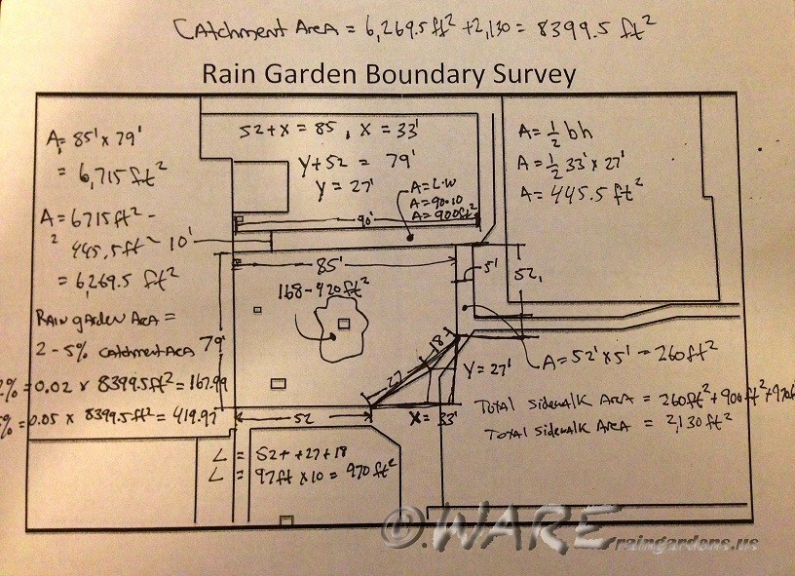
- Make a sketch of the rainfall runoff area. Include labels, measurements and rain garden location.

- From the Just Breathe Green Worksheet, select native plants to grow in your personal rain garden.
Plant species
Common name: Tickseed Scientific name: Coreopsis leavenworthii
Light requirements | Full sun | 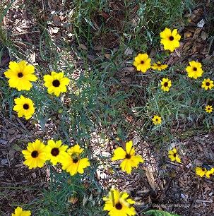
Height | 1-3 ft
Soil conditions | Average to moist
Transpiration rate (ml/min) | 0.150 ml/min

Plant Species
Common name: Tropical Sage Scientific name: Salvia coccinea
Light requirements | Full sun to partial shade | 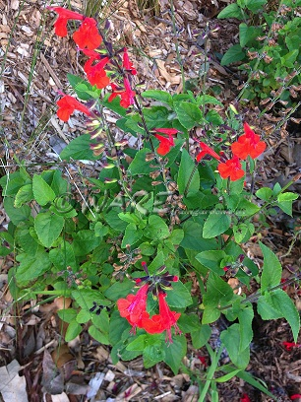
Height | 2-3 ft
Soil conditions | Well drained
Transpiration rate (ml/min) | 0.406 ml/min

Plant Species
Common name: Horsetail Scientific name: Equisetum hyemale
Light requirements | Full sun to partial shade | 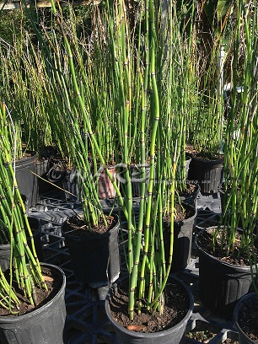
Height | 1-4 ft
Soil conditions | Wet
Transpiration rate (ml/min) | 0.296 ml/min

- Plant, mulch and water.
- Mark and label on the sketch (#6) the location of your team’s personal rain garden, as well as the locations of other groups’ personal rain gardens.

