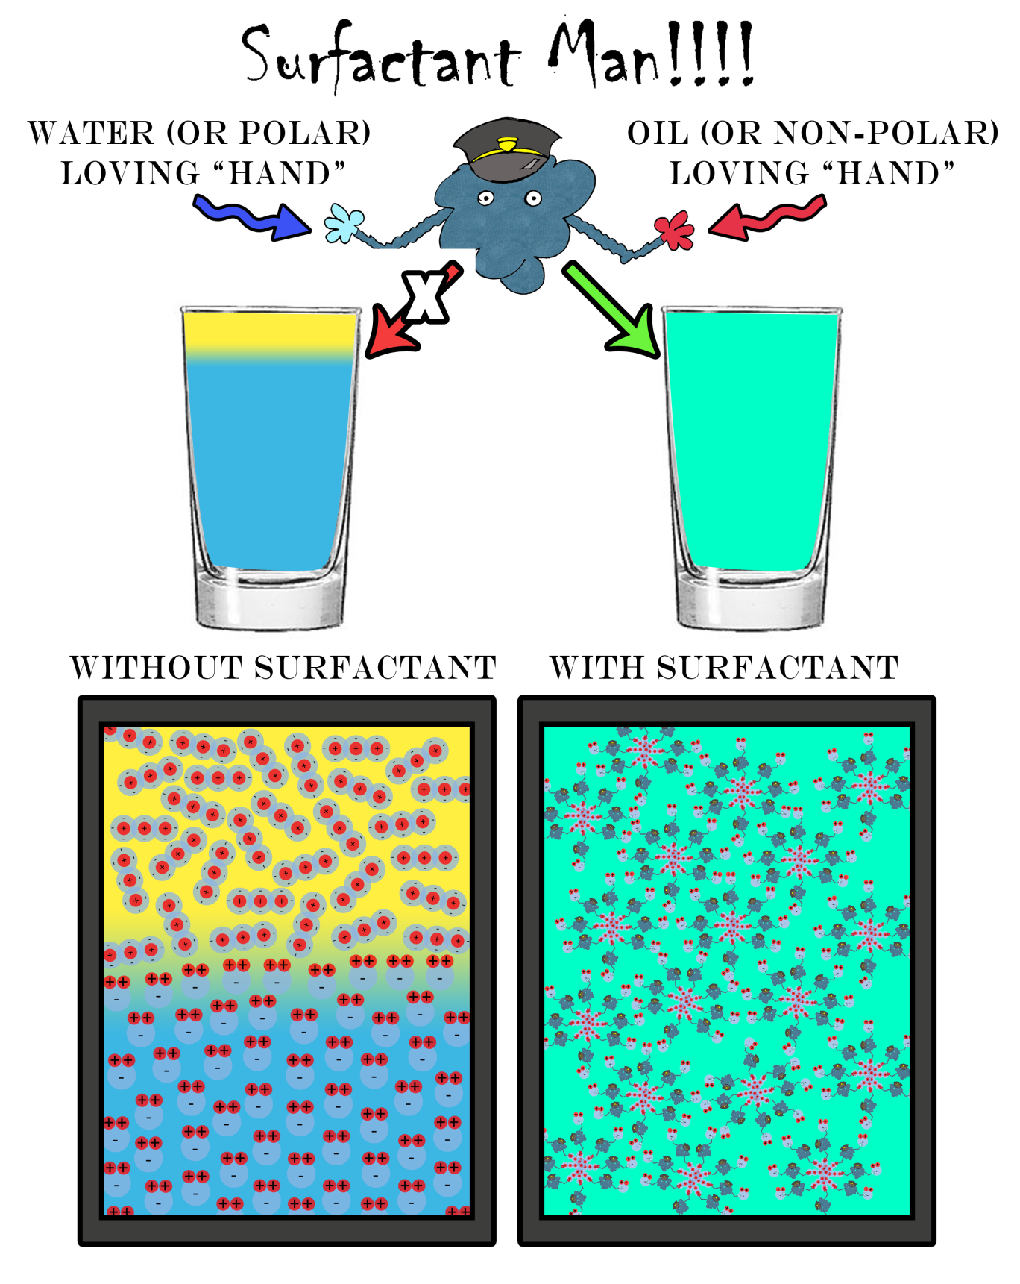

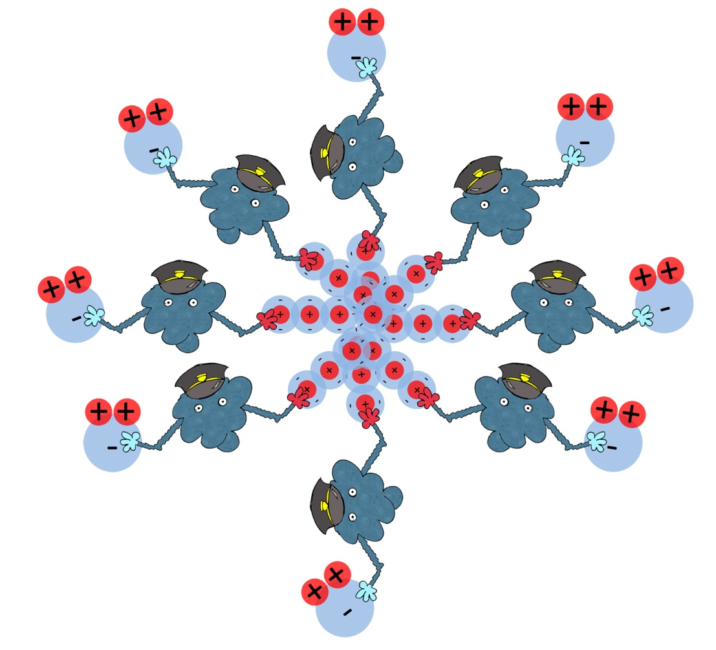

Surfactant man in action, illustrating how a surfactant is an amphiphilic molecule that interacts with both polar and non-polar molecules, essentially “bringing them together.”

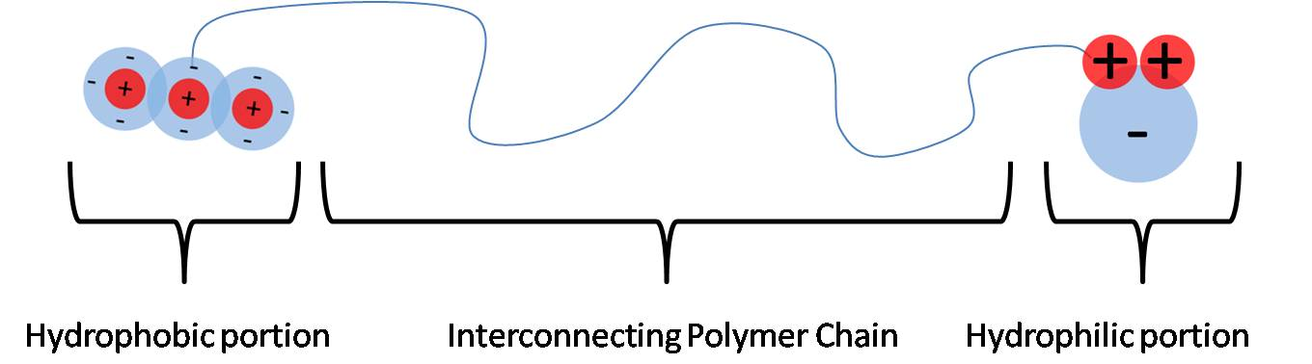

A surfactant molecule with non-polar appendage (left) and polar appendage (right), connected by a polymer chain.

