GRADING CONGESTION WORKSHEET ANSWER KEY

Part 1 – Data Collection

- Form your track using the ropes, cones, or other materials so 2 to 3 individuals can walk beside one another, see figure 1

- Measure the length of your track from the middle of the lane

Length = Answer: 62 ft (approx. 62 ft)

- Have a person walk leisurely through the track and time how long it takes him/her to complete 8 laps

Time = Answer: approximately 152 sec

- Have the same person walk leisurely through the track again, but with an additional 7 persons on the track walking in the same direction. Now time how long it takes him/her to complete 8 laps

Time = Answer: approximately 183 sec

Part 2 – Calculations based on 1 person on the track

- Calculate the individual’s speed in feet per second and mph

Distance Traveled = (# laps)*(Length)

Length = Answer: 62 ft (From step 2)
# of Laps = 8 laps

Distance Traveled = ( Answer: 8 laps)*(Answer: 62 ft) = Answer: 496 ft

Time = Answer: 152 sec (From step 3)

Speed = Distance / Time
Speed = (Answer: 496 ft) / (Answer: 152 sec) = Answer: 3.26 ft/sec

Converting to mph
Speed = (15/22)*(Answer: 3.26 ft/sec) = Answer: 2.22 mph

- Let us see how fast that would be if you were a car

Speed = (25)*( Answer: 2.22 mph) = Answer: 55.5 mph

- Calculate density of the roadway assuming only 1 lane

# of Persons on the Track = Answer: 1 persons

Density = (# of Persons) / [(Distance)*(# of lanes)]
Density = (Answer: 1 persons) / [(Answer: 496 ft)*( 1 ln)]
Density = Answer: 0.002 persons/ft/ln

- Let us see the density if you were a car

Density = (2500)*(Answer: 0.002 persons/ft/ln) = Answer: 5 veh/mi/ln

- Use the density from step 8 and the Table 1 to find level of service (LOS)
Table 1: LOS Density Levels with
LOS A outlined in red.

Finding LOS
LOS | Max Density | Range
A | 11 | 0 - 11
B | 18 | 11 - 18
C | 26 | 18 -26
D | 35 | 26 -35
E | 45 | 35 -45
F | >45 | >45
Density = Answer: 5 veh/mi/ln

Which range does the density
fall within? Answer: 0 - 11

LOS = Answer: A

- Let us try finding LOS through flow and speed

Flow = Density*Speed

Density = Answer: 5 veh/mi/ln (Find from step 8)
Speed = Answer: 55.5 mph (Find from step 6)

Flow = (Answer: 5 veh/mi/ln)*(Answer: 55.5 mph)
Flow = Answer: 277.5 veh/hr/ln

- Using the Figure 2, determine LOS

Flow = Answer: 277.5 veh/hr/ln (Find from step 10)
Speed = Answer: 55.5 mph (Find from step 6)

LOS = Answer: A

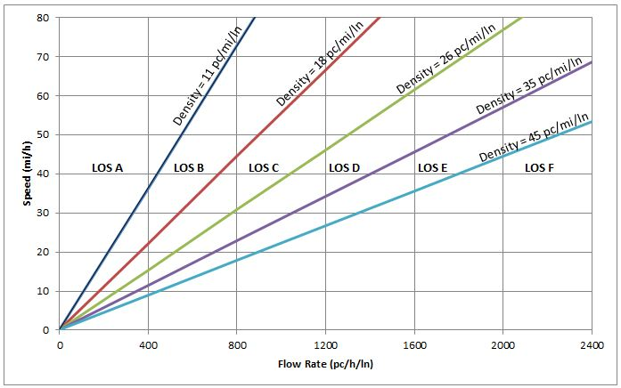
55.5
277.5

Figure 2: LOS for Freeway Segments with point (412.5,75) identified with its corresponding LOS A outlined in red.

- Are the LOSs from steps 9 and 11 the same? Answer: Yes

LOS = Answer: A (From step 9)
LOS = Answer: A (From step 11)

Part 3 – Calculations based on 8 people on the track

- Calculate the individual’s speed in feet per second and mph

Distance Traveled = (# laps)*(Length)
Distance Traveled = (Answer: 8 laps)*(Answer: 62 ft) = Answer: 496 ft

Time = Answer: 183 sec (From Step 4)

Speed = Distance / Time
Speed = (Answer: 496 ft) / (Answer: 183 sec) = Answer: 2.71 ft/sec

Converting to mph
Speed = (15/22)*(Answer: 2.71 ft/sec) = Answer: 1.85 mph

- Calculate how fast that would be if you were a car

Speed = (25)*(Answer: 1.85 mph) = Answer: 46.25 mph

- Calculate density of the roadway assuming only 1 lane

# of Persons on the Track = Answer: 8 persons

Density = (# of Persons) / [(Distance)*(# of lanes)]
Density = (Answer: 8 persons) / [(Answer: 496 ft)*( 1 ln)]
Density = Answer: 0.016 persons/ft/ln

- Calculate density if you were a car

Density = (2500)*( Answer: 0.016 persons/ft/ln) = Answer: 40 veh/mi/ln

- Use the density from step 16 and the Table 2 to find level of service (LOS)
Table 2: LOS Density Levels with
LOS A outlined in red.

Finding LOS
LOS | Max Density | Range
A | 11 | 0 - 11
B | 18 | 11 - 18
C | 26 | 18 -26
D | 35 | 26 -35
E | 45 | 35 -45
F | >45 | >45
Density = Answer: 40 veh/mi/ln

Which range does the density
fall within? Answer: 35 - 45

LOS = Answer: E

- Let us try finding LOS through flow and speed

Flow = Density*Speed

Density = Answer: 40 veh/mi/ln (Find from step 16)
Speed = Answer: 46.25 mph (Find from step 14)

Flow = (Answer: 40 veh/mi/ln)*(Answer: 46.25 mph)
Flow = Answer: 1850 veh/hr/ln

- Using the Figure 2, determine LOS

Flow = Answer: 1850 veh/hr/ln (Find from step 18)
Speed = Answer: 46.25 mph (Find from step 14)

LOS = Answer: E

1850
46.25

Figure 2: LOS for Freeway Segments with point (412.5,75) identified with its corresponding LOS A outlined in red.

- Are the LOSs from steps 17 and 19 the same? Answer: Yes

LOS = Answer: E (From step 17)
LOS = Answer: E (From step 19)

- Are the LOSs from Part 2 and Part 3 Different? Answer: Yes

LOS = Answer: A (From part 2)
LOS = Answer: E (From part 3)

- If they are different, why? Incorporate discussion on times, speeds, and densities.
- Answer: The values from parts 2 and 3 are different: LOS A and LOS E. The reason for this difference is that part 3 had more traffic than part 2 and hence more congestion. The one car on the track had a density of 5 veh/mi/ln, while the eight cars on the track had 40 veh/mi/ln. This increase in density results in the vehicle from part 3 to have a higher time of 183 sec and lower speed of 46.25 mph, where part 2 had a time of 152 sec and speed of 55.5 mph.

- What have you learned from this activity and how can it be useful?
- Answer: I learned from this activity the way engineers measure the amount of congestion on our roads by using two different methods: densities, and flows and speeds. This is useful to be able to identify roads that need improvement in terms of capacity, adding more lanes to improve flow.

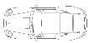

- Draw a picture of your congested roadway (track and students on the track).

- Engineering Design Problem: Currently there is a 2 mile segment of a 6 lane divided highway (3 lanes in each direction) where the posted speed limit is 55 mph. Local residents are complaining about a proposed new residential development off the highway will increase congestion. They have asked you, the county engineer, to stop the project by analyzing the situation and recommend the development not to be constructed. You have performed a site visit and recorded the number of vehicles in the busiest direction during a 60 minute period, 66 vehicles, and you noted the vehicles were traveling at the speed limit, 55 mph. Through analysis, the combined existing and new traffic levels will produce a flow of 800 pc/h/ln with an average speed of 50 mph. Use the knowledge you obtained through this activity and lesson to solve the problem. (Hint: Determine the current LOS and how it will change with the new development.)

Finding LOS
LOS | Max Density | Range
A | 11 | 0 - 11
B | 18 | 11 - 18
C | 26 | 18 -26
D | 35 | 26 -35
E | 45 | 35 -45
F | >45 | >45

Existing Conditions:
$Speed=55$ mph
$Density=\frac{\# of vehicles}{\left(lane\right)(mile)}=\frac{66}{3(2)}=11$ pc/mi/ln
$LOS=A$

Finding LOS
LOS | Max Density | Range
A | 11 | 0 - 11
B | 18 | 11 - 18
C | 26 | 18 -26
D | 35 | 26 -35
E | 45 | 35 -45
F | >45 | >45

Proposed Conditions:
$Speed=50$ mph
$Flow=800$ pc/h/ln
$Density=\frac{Flow}{Speed}=\frac{800}{50}=16$pc/mi/ln
$LOS=B$

From your calculations, the current level of service of the roadway is A and the proposed development would drop that to a B. It is your recommendation to allow the development to proceed because the impact is minor and the roadways will continue to have stable traffic flow.

