Energy from Algae?! Worksheet
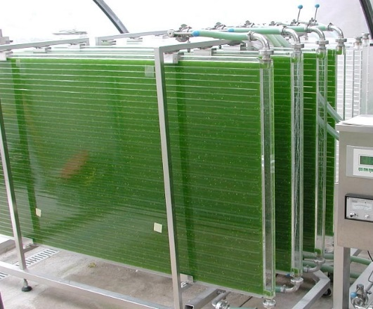
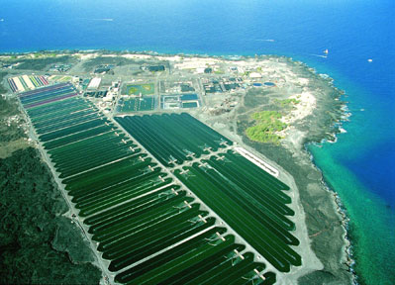
Microalgae grown in a photobioreactor (left) and raceways at an algae farm in Hawaii (right).

A photobioreactor is a container in which algae or other plants are grown. “Photo” comes from photosynthesis (what plants do to make energy), “bio” comes from biological (something is alive in there!), and reactor is just another word for the container where it all happens.
Algae can be grown in photobioreactors by using recycled water and nutrients from waste. The algae are harvested and converted into biofuel (even jet fuel!). Because algae grow so fast and naturally produce oil, we can make earth-friendly biofuel with a small ecological footprint!
If not converted to biofuel, algae can also be harvested and made into other products, such as human and animal food, fertilizers, and ingredients in makeup, vitamins and medicine.
Show Your Smarts!
- Why are algae (or other plant-based biofuels) important?
During photosynthesis plants take in _____________________, which is a greenhouse gas. Because plants use this gas, plant-based biofuels do not pollute the Earth’s atmosphere.
- What main things do algae (and plants) need to grow?
___________________________________________________________________________
- Where might we find “waste” sources of these important items?
___________________________________________________________________________
___________________________________________________________________________
___________________________________________________________________________
- Plants (and algae!) use the sun’s energy to grow in a process called ________________.
- Besides biofuel, for what else can algae be used?
Image sources: 2003 IGV Biotech via Wikimedia Commons: http://commons.wikimedia.org/wiki/File:Photobioreactor_PBR_500_P_IGV_Biotech.jpg
Cyanotech Corp. via Commerce.gov: http://www.commerce.gov/blog/2011/06/13/manufacturers-receive-presidential-award-their-export-efforts

