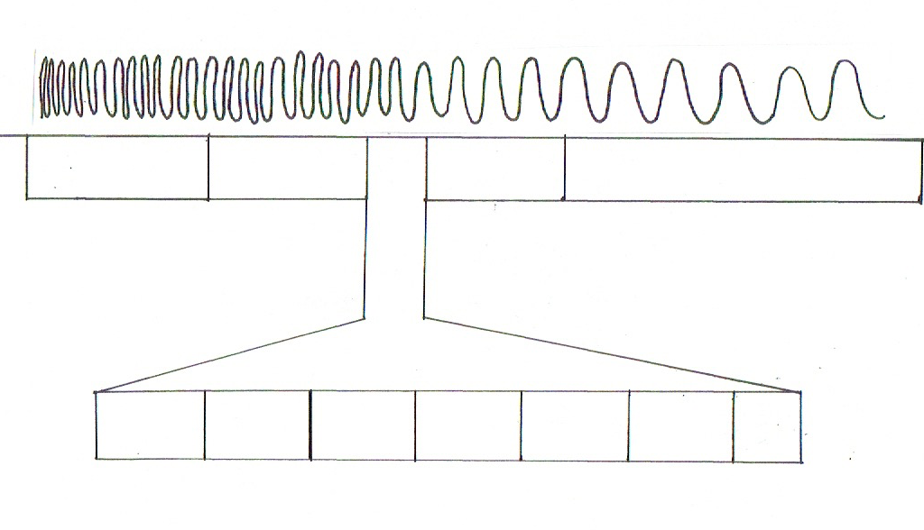
Electromagnetic Spectrum Handout

