Name: ______________________________________ Date: _______________________________ Class: ________________________

Google Sheets Example Directions
Data Sheet
Marbles | Bag of 10 | Bag of 20 | Bag of 30 | Bag of 40
Mass (g) | g | g | g | g

Slime Stretch Data Table
Time (sec) | Distance (cm)  No added stress | Distance (cm)  Added stress of  40.2 g | Distance (cm)  Added stress of  80.4 g | Distance (cm)  Added stress of  120.6 g | Distance (cm)  Added stress of  160.8 g
0 | 0 | 0 | 0 | 0 | 0
5 | 2 | 2 | 3 | 5 | 2
10 | 3 | 3 | 9 | 17 | 9
15 | 4 | 4 | 15 | 44 | 20
20 | 5 | 5 | 28
25 | 7 | 9 | 50
30 | 10 | 13 | 95
35 | 17 | 20
40 | 30 | 35
45 | 46 | 60
50 | 93 | 100
55
60
65
70
Snapped?  Yes or No | Yes at 150 cm | Yes at 140 cm | Yes at 180 cm | Yes at 70 cm | Yes at 25 cm
Average Speed | 1.86 cm/sec | 2.00 cm/sec | 3.166 cm/sec | 2.933 cm/sec | 1.33 cm/sec
Instantaneous Speed at 15 cm | 0.94 cm/sec | 0.47 cm/sec | 1.00 cm/sec | 1.88 cm/sec | 1.25 cm/sec

- Enter Title and Data into Google Sheets Grid

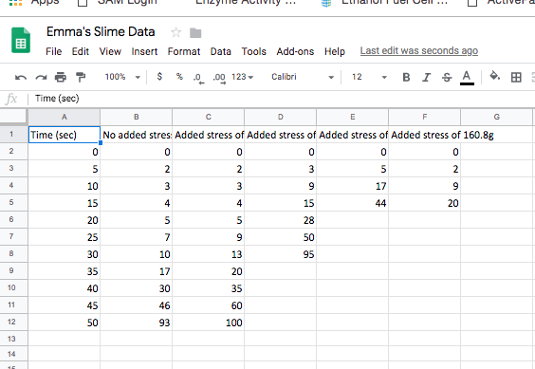

- Highlight Data and Click Chart under Insert Tab

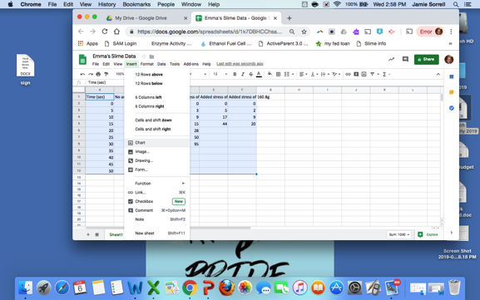

- Make sure your chart editor has the following information to make a line graph

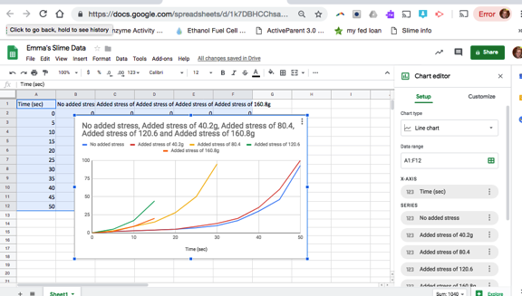

- Click the Customize tab in the Chart Editor to fix and/or add titles

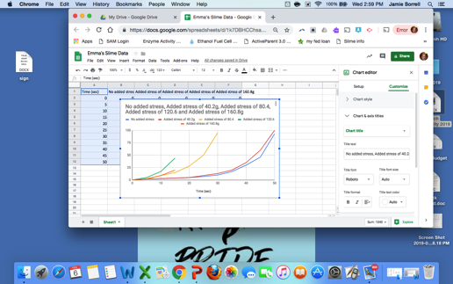

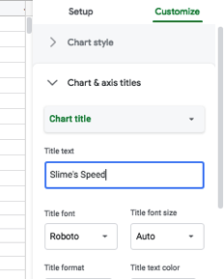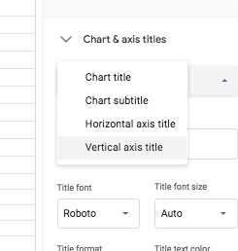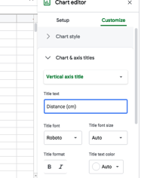

- Students can copy and paste graph into a power-point or word document for presentation

