Tensile Tool Instructions

1. Cut a ~60 cm piece of twine and thread it through the metal loop.

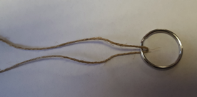

2. Tie a knot in the string to secure the loop.

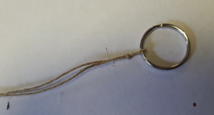

3. Cut a 14 cm strip of duct tape. 4. Cut a slit on either side of the tape.

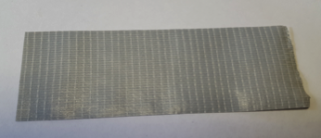
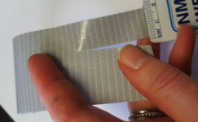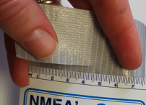

5. Thread the string through the slit. 6. Tie a knot in the string. 7. Cut the excess string.
8. Secure string with square pieces of tape.

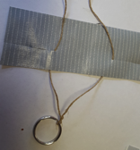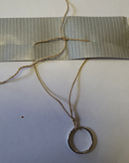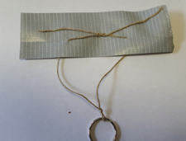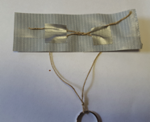
9. Fold the bottom and then top of the tape over.

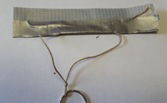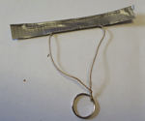

10 Cut a 14 cm piece of sticky-sided Velcro. Stick one piece of Velcro on one side of the tape, and other piece of Velcro on the other side of the tape.

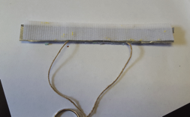

11. Punch two holes at the top of a 1 L Ziploc bag. 12. Bend a paper clip.
13. Thread through the holes of the zipper bag.

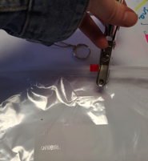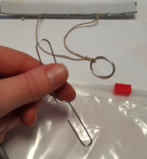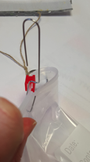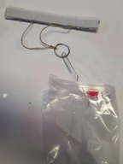

Loading weight

1. Put 10 marbles in a snack-size bag. 2. Obtain the mass of the marbles.
3. Write the mass on the bag and data sheet. 4. Add the bag of marbles to larger bag.
5. Hook the marbles in the larger bag to the metal loop using the bent paper clip

