Yellow Biotechnology

Did you know that yeast is a domesticated living organism? We use yeast’s ability to perform alcoholic fermentation to produce food and drinks daily. Using microorganisms like yeast to engineer and manufacture edible products is known as Yellow Biotechnology.

Facts from “Here’s Everything You Need to Know about Yeast.”

When manufacturing our products with yeast (which are living organisms/cells) it is essential that we engineer the best working conditions for the yeast but get the best yield of products from the yeast.
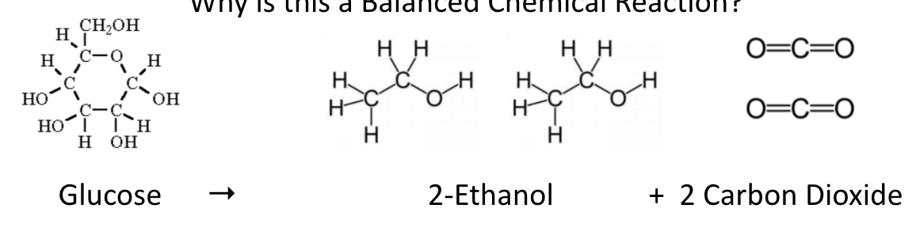 Reactants Products
What do you think would happen if we increased the amount of glucose reactant we give the yeast?
What do you think could happen to the yeast cells if we expose them to too much glucose reactant?

Engineering the Efficiency of Alcoholic Fermentation
Problem: How can we produce the MAX amount of CO₂?
REACTANTS PRODUCTS

Other Reactants:
Glucose | Fructose | Starch
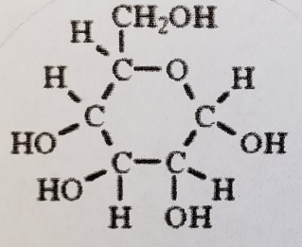 | 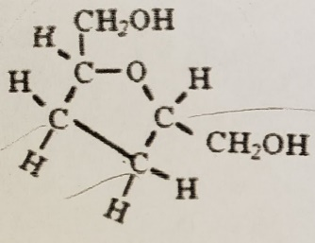 | 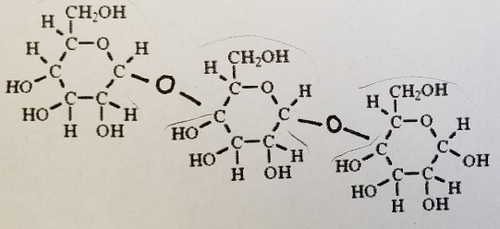

Lactose | Sucrose
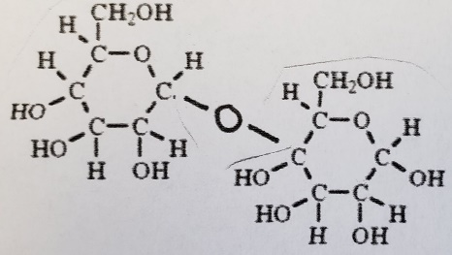 | 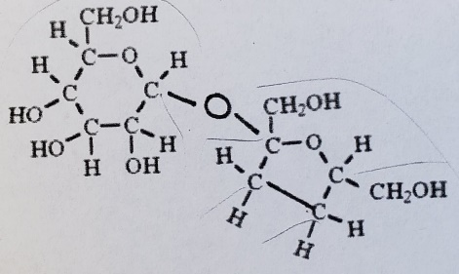

If we changed the reactant from glucose to fructose, what do you think would happen to the amount of CO₂ produced? Why?
If we changed the reactant from glucose to lactose, what do you think would happen to the amount of CO₂ produced? Why?
If we increased the amount of glucose reactant, what do you think would happen to the amount of CO₂ produced? Why?
Hypothesis 1 (Reactant Hypothesis) How will different reactants affect product production of CO₂?
Hypothesis 2 (Reactant Concentration Hypothesis) How will reactant concentration affect product production of CO₂?

The Closed System Set-up and Water Displacement Apparatus
Group Assigned Reactant __________________________

Sample 1 | Sample 2 | Sample 3 | Sample 4
Balloon color | Balloon color | Balloon color | Balloon color
2g of yeast  2g of reactant  30mL of water | 2g of yeast  3g of reactant  30mL of water | 2g of yeast  4g of reactant  30mL of water | 2g of yeast  5g of reactant  30mL of water
Student name | Student name | Student name | Student name

Procedure
- Place balloon on a funnel **Make sure when loading your balloon that you hold both the neck of the
balloon and funnel to prevent the balloon from falling off of the funnel.
- Into the balloon add 2.0g of yeast
- In the same balloon add your assigned amount of reactant
- Assemble the water displacement apparatus according to teacher instructions
- In the same balloon add 30mL of 40C water
- Carefully remove the funnel from the balloon
- With the help of a partner, stretch the neck of the balloon and seal the opening with a string tied in a
knot.
- Cut the excess string and be careful to not pierce the balloon!
- Shake the balloon 10 times **Optional: Take a before picture of your balloon.
- Place the balloon in the water displacement apparatus
- Place the foam plate on top of the balloon in the apparatus, and a bag of rice on top of the plate.
This will hold the balloon under the water as it expands with CO2.
- Record the balloon’s start volume. Set a timer set for 2 minutes
- Record the balloon’s volume every 2 minutes for 40 minutes
- After 40mins, remove the balloon from the water displacement apparatus.
- Take a final picture of your sample.

Time (min) | 2g of Reactant | 3g of Reactant | 4g of Reactant | 5g of Reactant
0 START
2
4
6
8
10
12
14
16
18
20
22
24
26
28
30
32
34
36
38
40

Graphing Using Excel
- Click on the tab that is labeled with your reactant name:
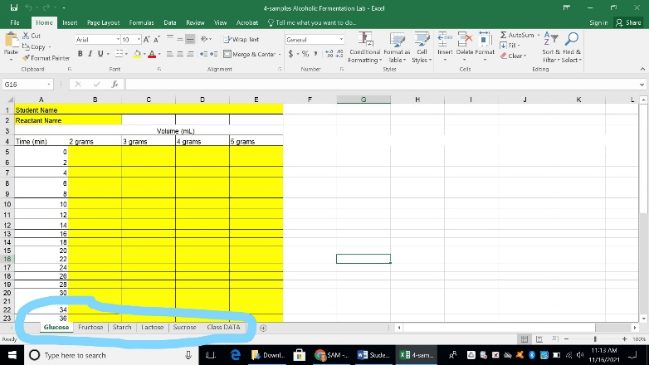
ONLY TYPE IN THE YELLOW PORTIONS
- Type in you and your classmates names
- Type in your reactant name
- Type in your collected data from your Data Table Handout under the designated grams of reactant.
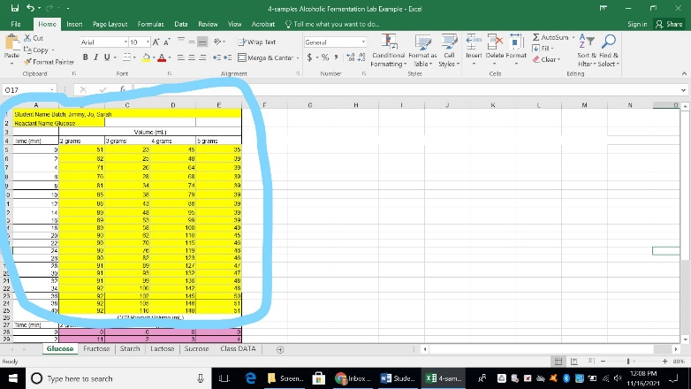
- Scroll down and select the data below in the 2nd color (NOT YELLOW), Click on the Insert Tab, Click
On the Line Graph Icon, Click on More Line Charts.
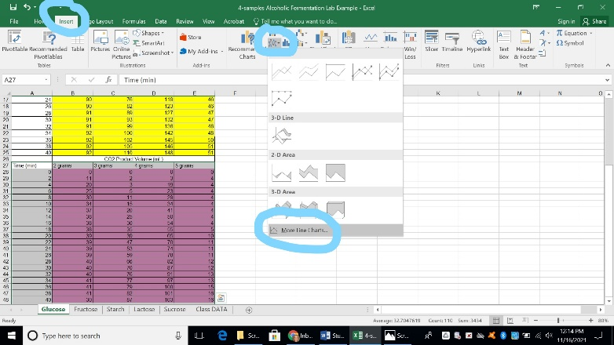
- Make sure to select the line graph option that does not chart Time on a line
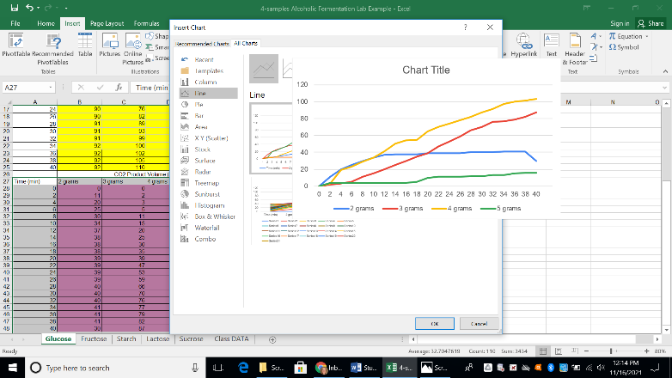
- Click on the X. Make sure the following is selected: Axes, Axis Titles, Chart Title, Gridlines, Legend
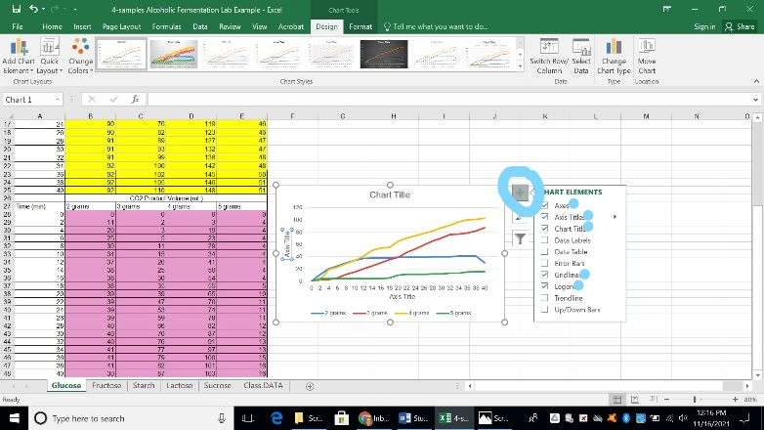
- Select where it says, “Chart Title” and two “Axis Titles,” and give them proper names.
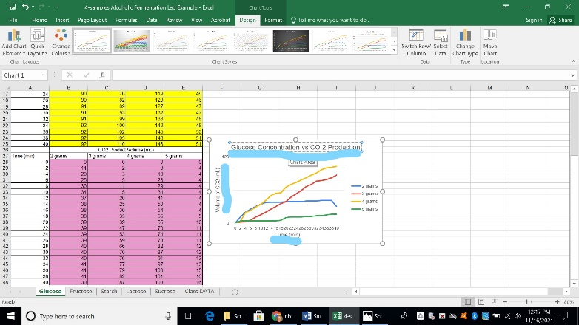

Poster Presentation Requirements (Poster MUST include the following)
- Title
- The reaction scheme with your specific reactant and products
- Drawing of the reactant
- Hypotheses
- Table of how the samples were different
- Visual of testing apparatus
- Before and after pictures of all 4 samples
- Group graph and class graph

Verbal Presentation Requirements
(Verbal presentation MUST cover the following AND all students MUST participate in the presentation)
- What is the purpose of the experiment?
- What were your hypotheses and your reasoning behind your hypotheses?
- How were your samples different?
- How were your samples tested?
- What were you testing/ What were you measuring and why?
- Using your group graph, what were the results of your group’s samples?
- Using your class graph, how did your results compare with the entire class?
- Using both graphs, were your hypotheses correct? Explain.
- If you were given an opportunity to move forward with the experiment, what would you do next and
why? Explain.

