Marisol Case Study
Everyday Engineering: Using the Engineering Design Cycle to Organize a Locker
Please read to each stop sign and wait for your group leader to ask questions about what you just read. As you read and discuss each section, annotate the text by underlining important information and identifying the steps in the engineering design process.
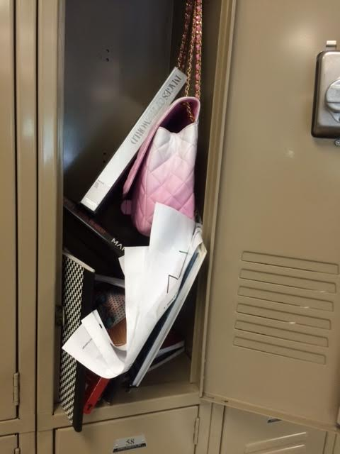
Marisol started her first day of school at Valley High as a ninth-grader. At the beginning of the school year, she was assigned a locker to store her personal belongings and school supplies. The first time she turned the combination lock to the numbers on her very own secret code, she beamed with pride—her very own locker! Sure, it was just a half locker, but it was hers alone, and she didn’t need to share with anyone! On that first day, she couldn’t imagine ever needing all of the space inside. After all, in middle school, she had simply carried her things with her from class to class.
By November, everything had changed. In middle school, each classroom had its own class set of textbooks that students never removed from the room. But in high school, students checked out textbooks and needed to take them home and then bring them back to class. Furthermore, teachers didn’t allow backpacks in the classrooms, so she had to leave all of her supplies in her locker. Finally, Marisol wasn’t the most organized student. Since she only had five minutes between classes, she usually threw books in and snatched books out without much care. Since her teachers encouraged students to save their graded work, she did so, but without much organization. Hence, the locker was crammed not only with books but with loads of crumpled sheets of paper. Not to mention the makeup, hair ties, perfume and other random stuff.
Figure 1. Marisol's messy locker.
One day in November, Marisol opened her locker and had to quickly jump back to avoid the cascade of her belongings falling to the floor. “Oh no,” she yelled. “This isn’t cool!” Marisol quickly began to scoop her things back into her locker, but after putting everything away, she was late to her next class. Unfortunately, this wasn’t the first time the locker avalanche had happened. “I’ve got to find a way to organize my locker,” she said to herself.

1

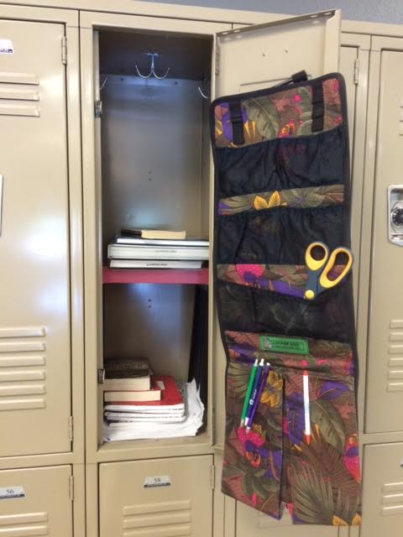
In order to generate possible ideas for her own locker, Marisol used her smartphone to take photographs of her friends’ lockers—or at least photographs of those that were organized. (Let’s be honest—many of Marisol’s friends’ lockers were as disorganized as hers.)
One friend had a brightly colored shelf and a cloth hanging that she had purchased at a department store. Another friend had a magnetic container that she placed on her locker door. These shelves, cloth hangings and containers made it possible to store books, papers, pens and other small items in separate areas. One of these would be perfect for solving her problem!
Unfortunately, Marisol found that similar organizers for sale on the Internet were expensive—around $30—and she knew her mom wouldn’t let her use her credit card to buy one! So she would have to make one herself. Since her parents only gave her a few dollars a week for allowance, she’d have to make an organizer for less than $3.
Figure 2. Marisol's friend used a shelf and a hanging organizer to organize her locker.
Figure 3. Another friend used a plastic organizer, stuck to the side of the locker with a magnet, to organize her belongings.
Marisol made a list of all of the available free materials that she might use to organizer her locker. Her list included:
- an old rack in her basement that her mom used to store her CDs several years ago;
- crates that her family used to carry and sell fruit at the local market;
- her mother’s old apron;
- leftover wood from her technology and engineering teacher’s woodshop.
Marisol’s mother taught her to never waste anything, so she wanted to be sure that the materials she chose were the right size for the locker. She borrowed a tape measure from Mrs. Itami, her technology and engineering teacher, and found that her locker was 32 inches tall, 12 inches wide and 9.5 inches deep. She also used the scale in Mrs. Itami’s classroom to measure the weight of the items in her locker. She was surprised to find that her seven textbooks weighed 28 pounds total—no wonder she ached when she carried them home! She also weighed her small personal items, like perfume and hair spray; they weighed 5 pounds total.
2
Figure 4. Old rack for storing CDs.

The next day when Marisol opened her locker, her hairspray fell to the floor just before her friend Samuel walked by, causing him to trip and fall to the floor. She was mortified! It was then that she knew she had to get serious about developing a solution to the problem of her messy locker.
That night, Marisol began to brainstorm ideas for organizing her locker by talking with her mom at home. She showed her mom her list of possible materials and shared photographs of her friends’ lockers that she had taken with her smartphone. As they used these photographs to generate additional ideas, Marisol’s mom suggested that they make a table with possible solutions and identify whether each solution met Marisol’s needs. After discussing possible solutions, Marisol and her mother made the following tables:
Possible Ideas for Shelves
Shelf Materials | Under $3 | Holds 28 Pounds | Fits in Locker
CD rack | yes | no | yes
Plastic crate | yes | yes | no
Wood from Mr. Itami’s shop | yes | yes | yes

Possible Ideas for Locker Door Organizers
Locker Door Organizers | Under $3 | Holds 5 Pounds | Fits on Door
Cloth hanging (apron) | yes | yes | yes
Plastic cups attached with magnets glued to cup | no | yes | yes
Paper cups attached with tape | yes | no | yes
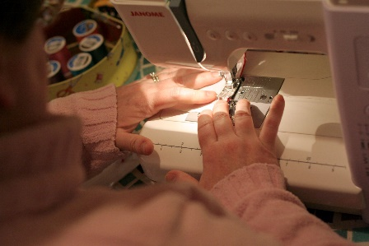
After discussing the ideas in the tables, Marisol and her mother decided to obtain wood from Mr. Itami’s shop because it was the only idea that met all of their shelf requirements.
They also decided to sew a cloth organizer out of the old apron because it was the only idea that met all of their requirements for a door organizer.
That night, they had fun while measuring, cutting and sewing the apron so that it was both stylish and would fit perfectly on the locker door!
Figure 5. Marisol and her mother sewed a hanging organizer out of an old apron.

3

The next day, Marisol went to school early to ask Mrs. Itami for help. She found her sweeping sawdust from yesterday’s classes. “Mrs. Itami? I need a way to organize my locker… I was wondering if I could have some of your wood scraps to make a little shelf? And maybe use your tools?”
Mrs. Itami had seen Marisol struggle with her messy locker and was happy that she was asking for help. “Of course, Marisol,” she said, smiling warmly, “all of the scraps are over here in this bin—let’s see if we have some pieces that will work.”
Together, Marisol and Mrs. Itami found a flat piece of wood, about 12 inches by 12 inches, and a wooden pole about 3-feet long. Since Marisol had not been trained on how to use the power tools, Mrs. Itami cut the board down to 11 inches by 9 inches so it would fit in her locker. Then, she cut the pole down into 4 small pieces about 7 inches tall. She let Marisol use a drill to screw the shorter poles to each of the four corners of the board, making what looked like a small table.
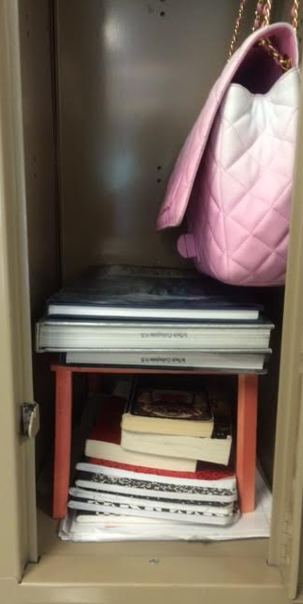
“This should do the trick,” Mrs. Itami said. “You can stack your books on top, and place your papers underneath!”
“Awesome! Thanks so much Mrs. I!” Marisol exclaimed, and hurried back to her locker, anxious to see how her shelf and cloth hanging would work out.
Marisol excitedly emptied her locker and carefully placed the makeshift shelf inside. “Success!” she thought to herself. It fit perfectly! She stacked her books on top of the sturdy shelf, and happily noted that it had no problem holding all of her books.
Next, she carefully hung her cloth hanging on some paperclips that Mrs. Itami had given to her. Marisol had bent these paperclips into small hooks, and when she hung her cloth organizer on these hooks, it looked great! One by one, she filled her hanging organizer with makeup, perfumes, extra pens and pencils, and—oh no! Before the pockets were even filled, the organizer fell to the ground. The paperclips weren’t strong enough to support the weight of all of her belongings. She realized that she would need to find something sturdier. She went to Mrs. Itami for advice.
“What you need are some sturdy S-hooks that are narrow enough to fit through the door slats,” Mrs. Itami advised. “You can find them at most hardware stores for less than a dollar.” Marisol resolved to head to the hardware store on her way home from school.
Figure 6. Marisol built this shelf for her locker.
4

At lunchtime, Marisol showed her locker shelf to her best friend Yaritza. “Neat!” Yaritza declared. “But… don’t you wish it had some nicer colors or something? It’s so plain now.” Marisol frowned—she had been so proud! “I know,” she said “but I can’t afford a fancy organizer.”
Yaritza brightened up. “I think my parents have some cool spray paint lying around—you want me to spray it pink for you?” “That would be great!” Marisol said, brightening up.
“Okay, I’ll check it out—but I would get into trouble bringing spray paint to school. Can I borrow the shelf and paint it tonight?” asked Yaritza. Marisol reluctantly agreed—she had spent so much time on her shelf that she was nervous to see it leaving her locker!
While Yaritza was at her apartment painting the shelf, Marisol went to the hardware store and spent ages looking through all of the tiny bins of hooks. She was amazed at how many different types were sold in this one store! She spent some time choosing between a small steel hook and a slightly larger steel hook. She didn’t want to choose a smaller hook that could not hold a lot of weight, but a large hook might not fit through the slats on her locker door.
She nervously approached a sales associate. “Um… excuse me… how much weight can this small hook hold?”
“I’d say you’d be safe hanging two and a half pounds from just one of those little guys,” he replied. Marisol considered this. “So… two of them together could hold five pounds?”
“You got it,” he smiled. Marisol selected two of the smaller hooks and paid less than a dollar for both of them.
The next day, Marisol user her new hooks to hang her organizer and it held all of her personal items without falling.
Just before first bell, Yaritza ran up to her with the shelf, painted a beautiful shade of hot pink. “Here you go, girl,” she beamed. “It’s the kind that dries quick so you can try it out—go ahead!” Marisol proudly eased the shelf into her locker, excited to have a way to keep her locker organized that was cute and cheap.
Over the next few weeks, many of Marisol’s friends were impressed at her creative and resourceful solutions to organize her locker. Some of them even asked her for help in making their own, but Mrs. Itami soon ran out of suitable wood scraps. Marisol realized that locker organizers were important because they saved time between classes so students did not have to spend extra time looking for assignments, books, pencils or other items. In fact, since building her locker organizer, Marisol had not been late to class once! She reflected back on her experience and realized that she had learned a lot about design.
She began to think that maybe the home economics classes and the technology classes could make their own organizers as a class project. The school bought those materials for those classes anyway, and it would be a good opportunity for students to make something they could use to improve their school. She wrote a letter in which she recommended locker organizers as a class project, and she delivered her letter to the school principal, Mrs. Itami, and the home economics teacher.
5

Images source: 2016 Christina M. Sias, Utah State University

