Top Inventions of the Year

Excerpted from: http://time.com/3594971/the-25-best-inventions-of-2014/

The Real-Life Hoverboard
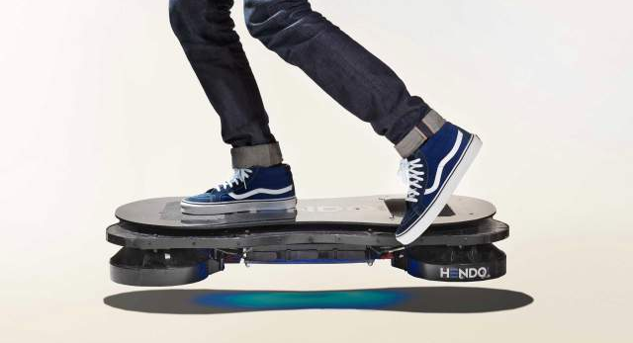
Hendo Hoverboard / $10,000
Preorder at hendohover.com
The hoverboard—a type of skateboard that levitates like a magic carpet—had been a pipe dream since its fictional debut in 1989s Back to the Future Part II. Now California-based tech firm Hendo has built the real thing. Hendo’s hoverboard can float only an inch or so above the ground and even then only over conductive material like copper or aluminum. Just 10 are being made to order (so far), and battery life is 15 minutes—barely enough time to zoom past your enemies à la Marty McFly. But the technology that powers it could be revolutionary. Using the $450,000-plus it raised on Kickstarter, Hendo founders Jill and Greg Henderson plan to develop magnetic “hovering” tech to stabilize buildings during earthquakes, protect valuable works of art and more. “The hoverboard is the first step to bringing this technology to the world,” says Greg.

Wireless Electricity
WiTricity
In development for Toyota cars, Intel PCs and more
We already have wireless Internet and wireless phones. Why, then, are everyday appliances still shackled to the wall? To be sure, a few power-mat chargers exist for small gadgets like phones. But WiTricity, based in Watertown, MA, is thinking big. Its technology—involving a plug-in coil that creates a magnetic field, which in turn powers objects as far away as 8 feet (2.4 m)—has been tested on Toyota electric cars (with charging mats), Intel PCs (with charging pads) and more.
Within 10 years, says CEO Alex Gruzen, rooms could be wired so that all appliances—lamps, TVs, stereos—pull power from a central charging base.

Watches that Redefine Smart
Apple Watch / $349 to $10,000
Available early 2015
Most smart watches have proved to be anything but: they try to shrink down the experience of using a cell phone, with clunky results. Apple’s Watch, by contrast, entirely reimagines the computer for the wrist, using a novel interface that combines a touchscreen and physical buttons.
esides telling time, the Watch can send messages, give directions, track fitness and make wireless payments. It’s also an attractive piece of fashion, with high-end edition models that feature 18-karat gold.
“Apple poured its heart and soul into the design,” says Robert Brunner, founder of San Francisco design studio Ammunition and a former director of industrial design at Apple. “It’s brave because they’re venturing into unknown territory.”

The Smartphone that Puts Privacy First
Blackphone / $629
Available at blackphone.ch
Nearly half of Americans don’t feel safe sharing private information over a cell-phone call, according to research results. So how can phone owners conceal their data? Enter the Blackphone, a smartphone designed to put privacy above all else. The device, developed by the company of the same name and accelerated after the Snowden leaks, runs a customized Android operating system stripped of features that might make data vulnerable, like calendar sync. It also comes with software that encrypts calls, texts and browsing history at levels far beyond normal smartphones (which could make the Blackphone a target of law-enforcement officials, who say encryption technology makes it harder for cops to catch criminals). But even with a Blackphone, users should be careful about what they type or upload. As Blackphone CEO Toby Weir-Jones explains, “It’s dangerous to assume anything is a magic invisibility cloak.”

The Cooler that Powers Your Party
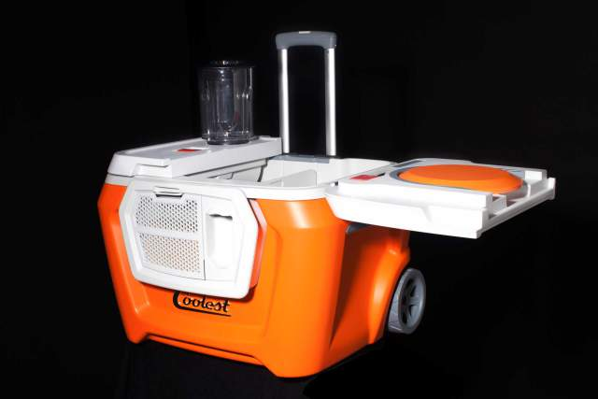
Coolest Cooler / $399
Preorder at coolest.com (to ship in early 2015)
For more than 60 years, coolers have done a fine job putting party refreshments on ice. But that wasn’t good enough for Ryan Grepper. “We wanted the cooler to be a place where people gather—to have all the things that make a space somewhere you’d want to hang out,” says the former medical sales rep. The result is the world’s smartest all-purpose party starter. It stores food and drinks, plus a blender, an LED lid light (“to see if you’re reaching for soda or Clamato juice”), a USB charger (“so nobody’s phone dies”), a Bluetooth speaker (for tunes) and big wheels to navigate many terrains (beach, parking lot). “I just want to make the coolest cooler out there,” says Grepper.
Since the prototype first appeared on Kickstarter earlier this year, ~63,000 backers have contributed $13.3 million to make it a reality.

The Chip that Stops Your Slouching
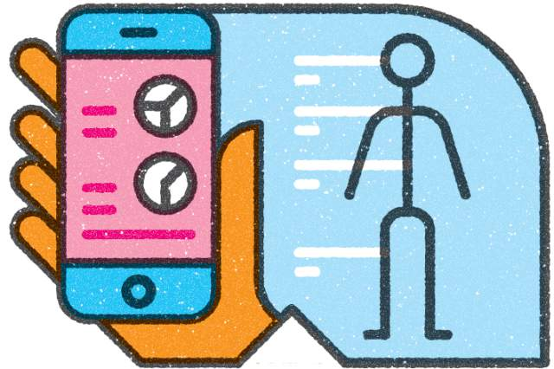
Lumo Lift / $100
Available at lumobodytech.com
You can probably guess why so many people have posture that causes back pain: “We simply forget” to stop slouching, says Monisha Perkash, whose company, Lumo BodyTech, created the ultimate reminder. Once users clip the Lumo Lift, a chiplike gadget about the size of a thumb, onto their shirts, it analyzes neck and spinal positions and vibrates when they’re less than ideal.
Although the system isn’t perfect—it buzzes when you lean for necessary reasons like taking a phone call—it has exceeded sales goals. Half of its users are women, which is impressive given that early adopters for gadgets often tilt male.

The Ring that Alerts You in Style
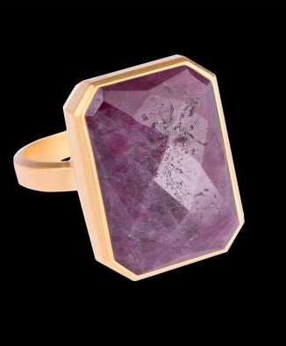
Ringly / $195+
Available at ringly.com
Like many professional women, Christina Mercando keeps her smartphone in her purse, which meant she was constantly digging it out to check for important notifications. But what if she could get that info from something she was already wearing, much as pants-wearing men can feel a phone buzz in their pockets?
That’s the thinking behind Ringly, a line of rings that can be programmed to glow when wearers get an email from their bosses, a text from their Uber drivers or any number of other can’t-miss communications.
Mercando, a former product and design manager at eBay, raised more than $1 million to realize her vision. So far, the concept is working: the first 1,000 Ringly rings, which debuted in June, sold out within 24 hours.

The Pillbox that Gets Personal
Pillpack / prices vary
Available at pillpack.com
“I grew up in a family that owned and operated a pharmacy,” says T. J. Parker, who knows firsthand how confusing it can be for people to track which meds to take when, especially if they fill multiple prescriptions. That’s why the e-pharmacy he runs now, PillPack, doesn’t traffic in bottles. Instead, every two weeks, patients are sent a dispenser that has all of their medication sorted into a ticker tape of tearable packets organized by date and time.
For now, service is limited to patients with multiple prescriptions, but Parker’s ultimate goal is to make the pharmacy experience simpler for everyone, even patients on short-term antibiotics.

Bananas that Prevent Blindness
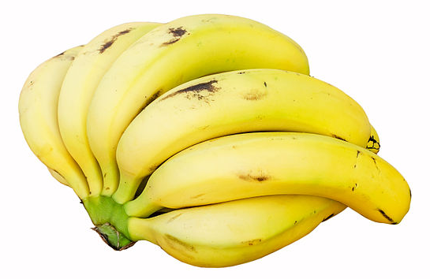

“Superbananas”
Developed by the Queensland University of Technology
In sub-Saharan Africa, up to 30% of kids under age five are at risk of going blind—among other conditions—for one simple reason: they don’t get enough eye-nurturing vitamin A. But what if the bananas that make up a lot of their diet could be re-engineered to deliver it? That’s the idea that struck Australian biogeneticist James Dale when he visited Uganda in the early 2000s.
With backing from the Bill & Melinda Gates Foundation, Dale and his team began developing a vitamin-A-enriched “superbanana.”
Human trials start soon in the U.S. In Africa, they will be introduced using what Dale calls a “reverse Ponzi scheme” to spark adoption. Village leaders will be given 10 free superbanana plants to grow, on the condition that they give at least 20 new shoots to other villagers, who will do the same.
“These bananas could potentially solve” a major health problem, Dale says.

The Wheel that Gives Bikers a Boost
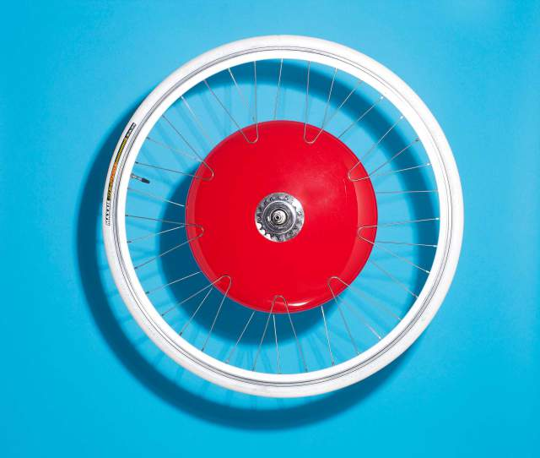
Copenhagen Wheel / $799
Preorder at superpedestrian.com (to ship spring 2015)
We know that biking is good for us and good for the environment, but getting around on a bicycle can seem daunting in hilly terrain and in large cities. To lessen those barriers, Cambridge-based Superpedestrian has developed the Copenhagen Wheel, a standard-size wheel—it can be attached to the back of most bicycles—that boasts a rechargeable, battery-powered motor.
Depending on rider preferences, entered through a smartphone app, the motor can kick in power throughout the ride or just on hills. Sensors also track road conditions, air temperature and potholes, so cyclists can share real-time information about best routes.
“Cities are reaching a limit in terms of how many more cars they can accept,” says Assaf Biderman, founder and CEO of Superpedestrian; indeed, studies like those from the University of Michigan Transportation Research Institute suggest that the U.S. has reached “peak car.” The Copenhagen Wheel, which has raised more than $6 million (partially through crowdfunding), may help make cycling a more viable alternative.

The Filter that Fights Ebola
Hemopurifier
Developed by Aethlon Medical
What makes the Ebola virus so frightening is its speed. In a matter of days, it can pump out enough copies of itself to overtake the immune system.
The Hemopurifier—a specially designed cartridge that attaches to a dialysis machine—can tip the balance back in the body’s favor: its lectin filter attracts Ebola viruses and sucks them from the blood as it flows through.
It’s been used only once, on a patient in Germany, but it did the trick—effectively curing his Ebola infection.
In the future, doctors hope similar technology can be used on viruses like hepatitis.

The Selfie Stick (and Hairbrush)
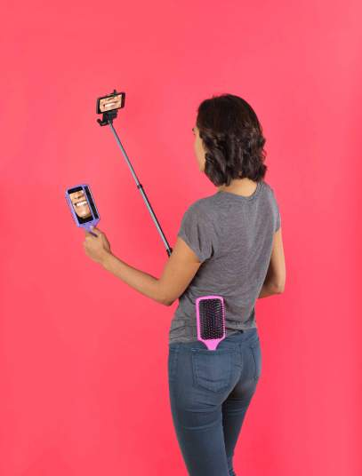
If 2013 was the year in which selfie became a buzzword, then 2014 was the year selfies became a cultural phenomenon. A recent Pew report that found that at least one-quarter of Americans have shared a selfie on a social-networking site.
Sensing a new market, several companies have launched devices designed to streamline the selfie-taking experience.
Many of them, like a hairbrush that holds your smartphone, are more goofy than game changing. But the selfie stick (produced by multiple brands), which enables users to position a smartphone beyond arms’ reach to get better photo angles, “adds genuine value,” says Van Baker, a mobile tech analyst at the research firm Gartner. “I’ve seen a lot of people using it.”

The Prison Room that Helps Inmates Relax
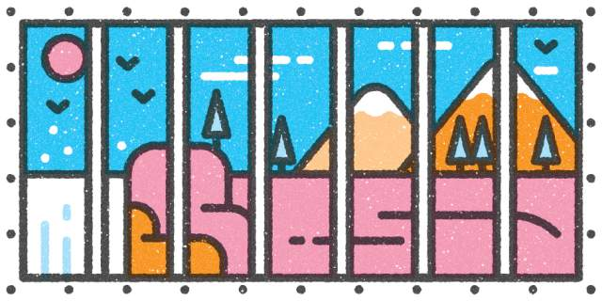
“Blue Room”
Developed by Snake River Correctional Institution in Oregon
For 23 hours a day, the 200 inmates in solitary confinement at Oregon’s largest prison see nothing but a tiny, white-walled cell—an experience some research suggests can heighten mental illness and make prisoners prone to suicide attempts and violence.
Last year, officials began letting some of them spend their free hour in a first-of-its-kind “blue room,” an exercise space where a projector plays video of open deserts, streaming waterfalls and other outdoor scenes.
That imagery, says creator Nalini Nadkarni, who studies how nature affects behavior, is designed to calm prisoners, “much in the way we walk through a park” to relax. Inmates have responded so well that guards now use blue-room time as a way to pre-empt bad behavior.

The Tablet Toy that Gets Physical
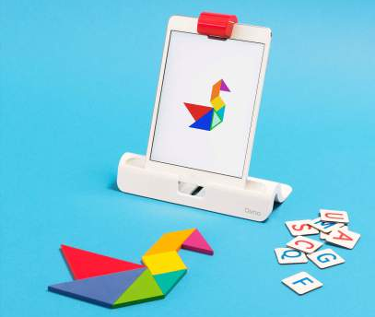
Osmo / $79
Available at playosmo.com
Like many kids, Pramod Sharma’s daughter loves the iPad. But “when her face is glued to the screen, six inches away, all day long—I wasn’t too happy,” he says. (Studies have shown that too much screen time can lead to attention problems and obesity.) So the ex-Google engineer and his former colleague, Jérôme Scholler, devised a way to bring virtual play back into the real world. Osmo’s “reflective AI” attachment enables the iPad camera to interpret physical objects—allowing kids to mimic an onscreen pattern with colored tiles, for example, and get rewarded for doing it correctly (while also refining their motor skills). The toy, which debuted in October, has helped Osmo raise $14.5 million in capital and is now being sold in the Apple Store. “Many kids can play at once,” says Sharma, “so it becomes more interactive and imaginative.”

The Coaching Basketball
94fifty smart sensor / $200
Available at 94fifty.com
In sports training, as in business, there’s no more valuable asset than data. That’s why hoops pros use high-tech equipment to monitor everything from passing patterns to fatigue levels.
This basketball aims to re-create those perks for casual players. It comes embedded with nine sensors and a Bluetooth chip that sends performance data to a mobile app—allowing players to measure, say, the arc of a jumpshot. If something’s off during game play, the voice of a coach (via the app) can even implore you to “go faster” or “snap your wrist.”
“We get excited when we see someone improve,” says Michael Crowley, whose company, InfoMotion Sports Technologies Inc., makes the 94Fifty Smart Sensor. And apparently, that’s happening a lot: InfoMotion has sold 100,000 balls.

Action Figures that Empower Girls
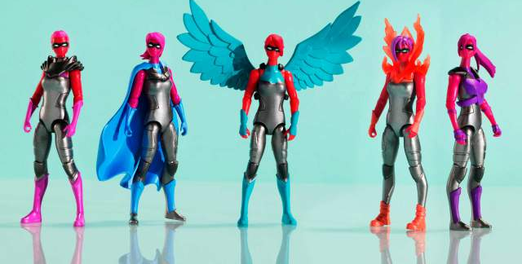j
Amelemental / $65 for a set of 7
Available at iamelemental.com
Studies have shown that girls’ career ambitions can be heavily influenced by their playthings. But when moms Dawn Nadeau and Julie Kerwin started searching for female action figures that were athletic and empowering—as opposed to dolls like Barbie, most of which cannot even bend their limbs—they were dismayed to find… none.
So using funds they raised on Kickstarter—$162,906 to be exact, more than quadruple their goal—they designed and commissioned a firm to build their IAmElemental series of action figures that portray women as heroes with strong personalities. Each figure embodies a different “element” of heroism, like persistence or honesty. “The idea that girls could save the world—that’s a very powerful fantasy,” says Nadeau.

