Worksheet Alternative Design Example Answers
Recap: For this example answer, the “Blue Room” invention—a prison room that helps inmates relax via an exercise space with a projector showing videos of outdoor imagery—was modified into a product called “Vista” to improve hospice care.
Part 5: Make Your Own Alternative Design
Review the Top Inventions of 2014, choose one, and create an alternative design. Make your alternative design more ethical according to the class definition of “ethics.” At the end of the period, you will present your design to the Bill and Melinda Gates Foundation who will decide which design to fund. Be sure to keep in mind the definition of “ethics” agreed upon by the class.
- What ideas do you have for modifying an existing design to make it more ethical?
I would take the “Blue Room” idea and modify it so it could be used for people who are confined to a bed and who cannot get up. I would especially target its use for people who do not have nearby family. The projector would be the same, but hospice workers could upload photographs or compiled images of the confined person’s favorite places. For instance, if the person likes the desert, the projector could show desert images and sounds interspersed with images of the person’s family and favorite celebrities or other interests.
- What problem(s) can your design solve?
People become depressed when they cannot go outside or see people they love. This may help to alleviate people’s depression or sadness by giving them visual reminders of places and people they love.
- Who will benefit from your design?
This design would benefit immobile people in hospice and hospital settings, such as elderly people. I would give this product to high-traffic hospitals around the world, especially in India and sub-Saharan Africa. I would also market this product to insurance companies so that they give them to people under hospice care too.
- On whom will you test your design and why? How will you test your design?
I would first use the prototype with people who are not cognitively impaired, but who are physically impaired and confined to their beds in high-traffic hospitals in the U.S., China, India and Africa. I would try the projector with both elderly males and females and interview them to find out if they liked the projector and how they would improve it.
After further developing the design, I would test it with a population and survey them at the beginning and end to learn their level of happiness before and after using the device.
- To whom will you market your design? How will you market it?
I would market the design to hospice care workers at hospice care conventions. I would market the design to hospital administrators and insurance companies. I would market the design to the WHO.
- What else will you do to ensure your design is ethical?
I will make it accessible to people in multiple countries and sell it for minimal profit. I will test it with males and females in multiple countries, including high-poverty areas.
- In what ways might your design not be ideal?
It requires an electric plug, so people who without electricity in their homes would not have easy access to it. The equipment is not made of biodegradable materials.
- Draw your alternative design below (or on a separate sheet of paper).
Include as many details as possible. Especially indicate modifications from the original design.
In this case, the equipment remains the same. Changes to the original design include the personalization of the photographs, videos, graphics and other imagery that are displayed through the projector, and using it in hospital and hospice environments instead of an exercise space in a prison.
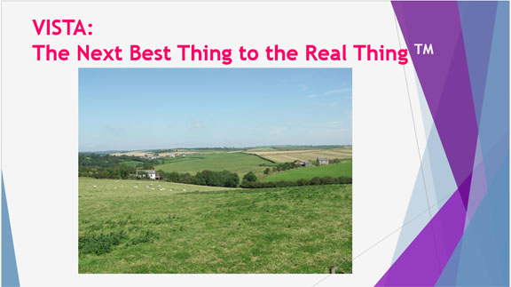

Part 6: Alternative Design Presentation
In the space below, write the words for a presentation that you would make to a charitable foundation that funds humanitarian projects in which you try to persuade them to sponsor your design. Make connections between your design changes and the class definition of “ethics.” Make sure to include the following key terms as they apply to the invention: altruism, production, testing, availability and impact. Be sure to explain why they should fund your design.
Imagine your grandmother, confined to a room, sad and alone. After a lifetime of service to you, doesn’t Granny deserve a little happiness and service to her?
Many elderly people are depressed in their older years, especially if they can no longer move and do the activities they used to do. Many elderly people are confined to their rooms and are unable to leave for months and even years. Though wheelchairs can help elderly people go outside, some may be connected to machines or may be too weak to leave their rooms. What can we do to lift their spirits, especially when family members are unable to visit them?
My proposed solution is the VISTA. It is a projector that brings the beauty of nature and your family into your room. It’s not as good as the real thing, but it’s the next best thing to the real thing. It’s been shown to decrease depression among people confined in prison, and it will probably decrease depression among people confined in their rooms for other reasons as well.
The projector come with a variety of stock images and sounds, ranging from desert to mountainous landscapes to African savannahs. In addition to choosing a preferred template, patients can also provide their own photographs, so they can have large photos of their family projected on the screen as well. If they have an estranged relationship with their son, they don’t need to put him up on the screen; instead they can put images of Brad Pitt, Charlton Heston or whoever else makes them happy.
In conclusion, please make the grandmothers of the world happy: Fund the VISTA!

