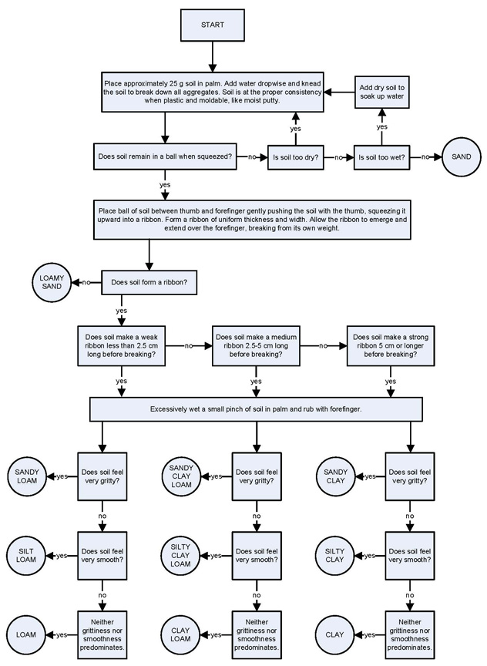

Source: USDA http://soils.usda.gov/education/resources/lessons/texture/

