**Gentle Touch Background Handout Answer Key**

1. **Define curve fitting.**

**Curve fitting is the process of constructing a curve model (or mathematical function) that has the best fit to a series of data points.**

1. **What is the benefit of curve fitting?**

**Curve fitting helps engineers and scientists better understand the behavior and relationship among variables in an integrated circuit or scientific experiment. For production purposes, it is an effective and efficient method for testing and evaluating. It may also be helpful to simulate solutions to real-world problems.**

1. **The most basic units measured and used by electrical engineers are:**

**I: current, R: resistance, V: voltage, G: ground**

1. **Draw the symbols or units used by electrical engineers.**

**I: mA, A, amp, R: Ω, ohms, V: V, volts, G:**

1. **Using an analogy, draw a diagram that explains the   
   relationship between voltage, resistance and current.**
2. **What is the equation for Ohm’s law and how can it be used? Give an example, with real values. Hint: What if you are given two of the three unknown variables?**
$$I=\frac{V}{R} =\frac{9 V}{18 Ω}=0.5 amps$$

$$Assume you are given a 9 volt battery that \\ is connected to a resistor with 18 ohms.$$

$$What is the current?$$

3. **In your own words, summarize Newton’s second law of motion.**

**A force is equal to a mass multiplied by acceleration. For example, a person trying to push a car that is 100 kilograms with an acceleration of.02 m/s² would require 2 Newtons.**

1. 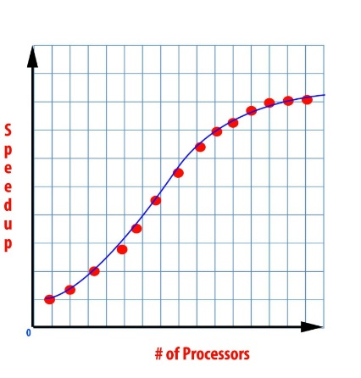**Amdahl’s law gives us the maximum expected improvement to an overall system when only part of the system is improved. For example, we can add more cores to a computer, which would result in a much faster computer. From the curve fitting graphs, intuitively analyze what will happen if we keep on adding cores?**

**From the graph on slide 6 (🡺), it is safe to conclude that the   
maximum overall system reaches a limit. It does not matter how   
many cores you add to a system.**

1. **What is regression?**

**Regression is the study of the relationship between variables.**

1. 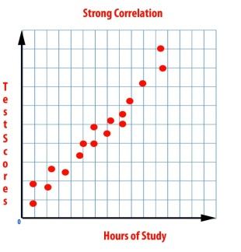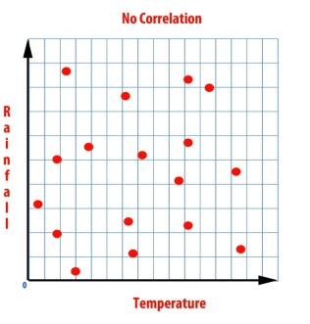**Draw correlation graphs for strong correlation and no correlation.**

1. **Define a line of best fit.**

**A line of best fit is the line that comes closest to all data samples in a regression study.**

1. **In your own words, explain how you can use residuals on a scatter plot to check which line is the best fit.**

**You can find the line of best fit by finding the sum of the squares of the residuals. The sum with a value closets to 1 is the line of best fit.**

1. **List the procedure to calculate the line of best fit using a calculator.**
2. **Press STAT and select EDIT to enter data into L1 and L2 using arrows.**
3. **Press STAT again and choose CALC.**
4. **Choose LinReg(ax+b) and press ENTER twice.**
5. **Discuss with your neighbors the engineering challenge given to you at the end of the presentation. Now that you have a better understanding of it, re-state the challenge in your own words.**

**The Robo-Glove crushes people’s hands when shaking them. We will improve the glove and fix this problem by making Robo-Glove X2 that incorporates FlexiForce sensors, calibrate it using weights, and test it using an egg and by shaking people’s hands.**