Calibrating the Force Sensor: Determining Relationships between Applied Force and Sensor Resistance
DATA COLLECTION SHEET
Answer Key
Use the provided table and graph paper to record your results when calibrating the sensor needed to create your robotic hand. Apply known weight values to the sensor and record the output resistance values. Represent the force as a function of resistance. Verify your resistance output more than once to ensure accurate readings. Readings from sensor to sensor may vary slightly.
Calibration using weights
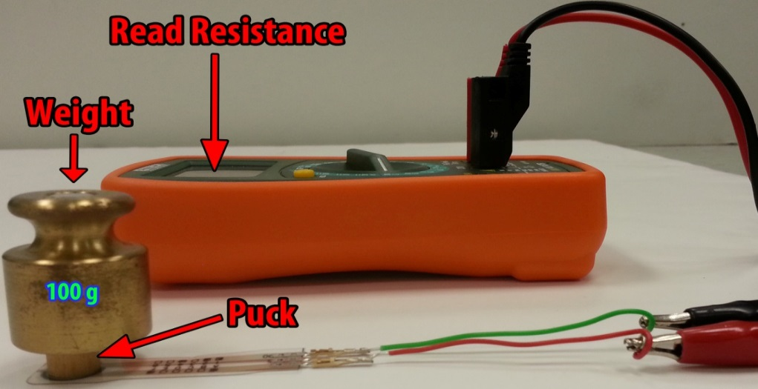

Force  (grams) | Resistance  (mega ohms)
100 | 10.8
200 | 2.11
300 | 1.31
400 | 0.88
500 | 0.66
600 | 0.50
700 | 0.43
800 | 0.42
900 | 0.35
1000 | 0.31
1200 | 0.22
1400 | 0.22
1500 | 0.20
1700 | 0.17
2000 | 0.14
2500 | 0.11

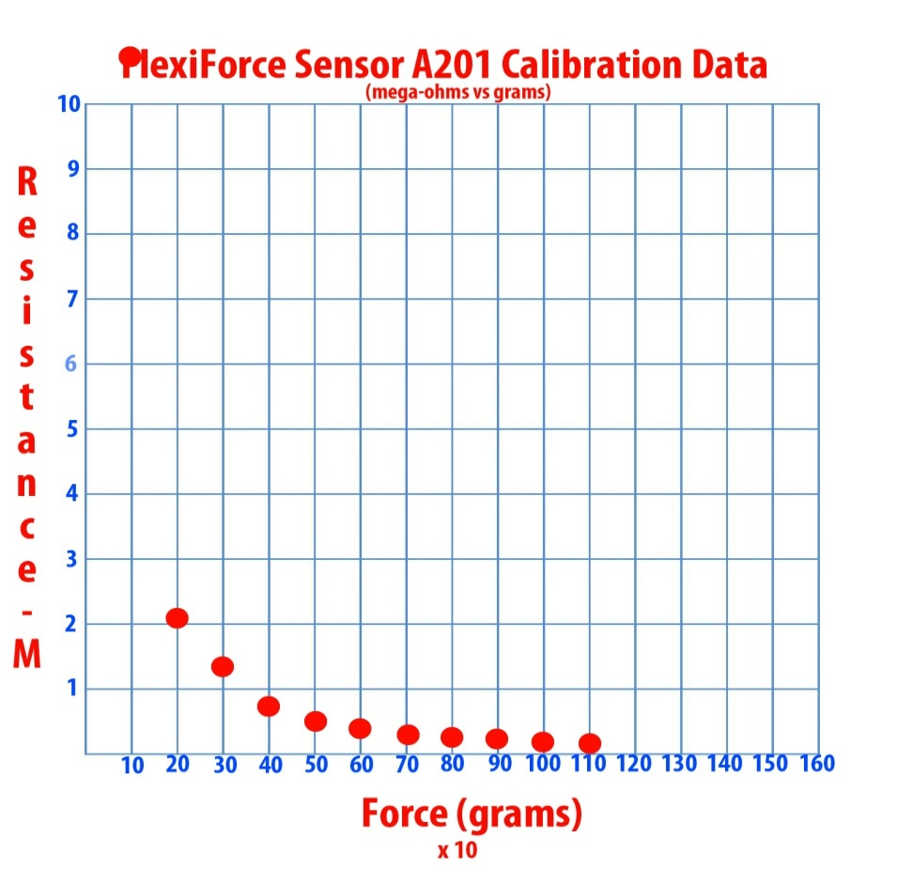

Calibrating the Force Sensor: Determining Relationships between Applied Force and Sensor Conductance
DATA COLLECTION SHEET
Answer Key
Use the resistance data collected in the previous exercise to produce a new table, graph and best fit line. Convert resistance to conductance. Conductance is equal to 1 divided by the resistance (C = 1/R). Use a graphing calculator to produce a linear regression and write your linear equation.
Steps for calculating best fit lines using a TI-8X:
- Press STAT and select EDIT.
- Enter data into L1 and L2 using arrows.
- Press STAT again and choose CALC.
- Choose LinReg(ax+b) and press ENTER.
Conductance = 1/Resistance
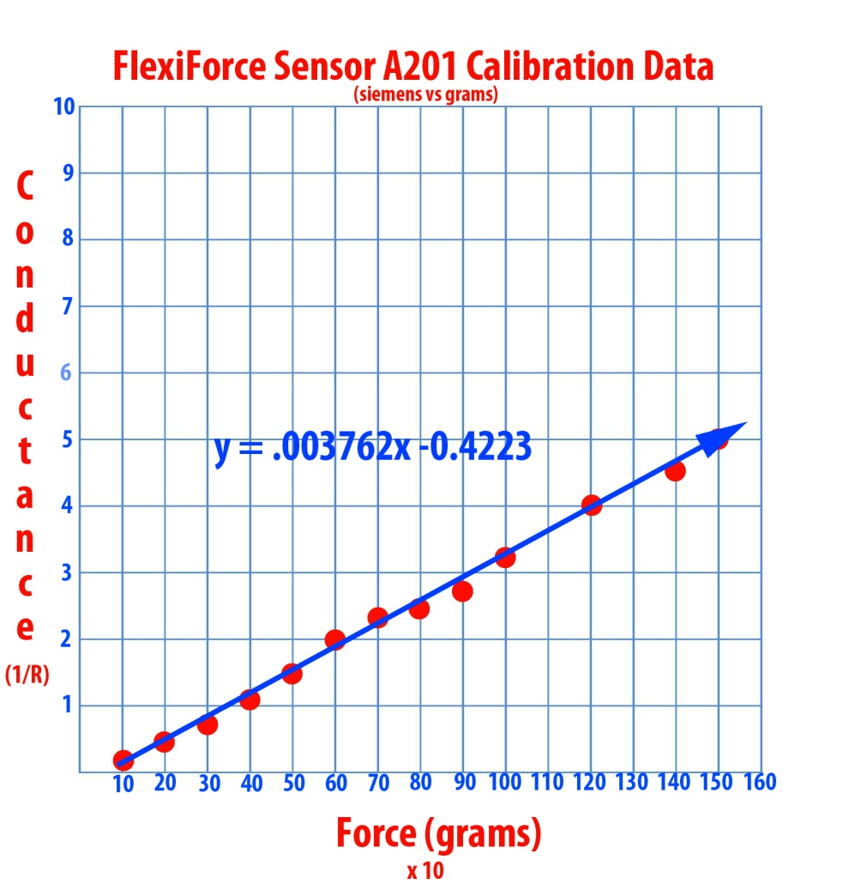

Force  (grams) | Conductance  (siemens)
100 | 0.09
200 | 0.47
300 | 0.76
400 | 1.13
500 | 1.51
600 | 2.00
700 | 2.32
800 | 2.38
900 | 2.85
1000 | 3.22
1200 | 4
1400 | 4.54
1500 | 5.00
1700 | 5.88
2000 | 7.14
2500 | 9.09

