**Building an Electric Circuit to Convert   
the Sensor Resistance into a Usable Voltage  
INSTRUCTIONS**

**Use this instruction manual to help you build an electric circuit to convert the sensor resistance into a usable voltage. The goal is to determine the relationships between applied force and sensor voltage output. Make sure you have the following items:**

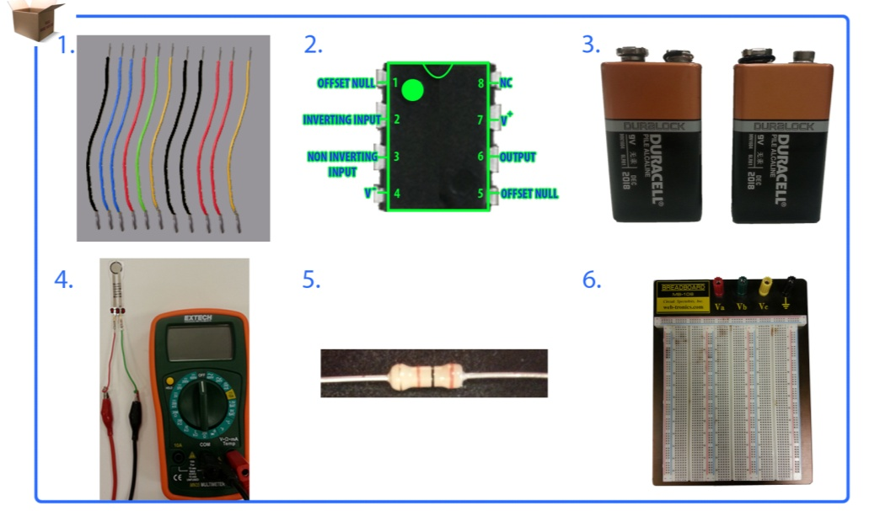

**🡸multimeter with sensor attached**

**11 6-inch wires (22 gauge)**

**breadboard**

**two 9V batteries**

**LM 741 op amp**

**30k Ω resistor**

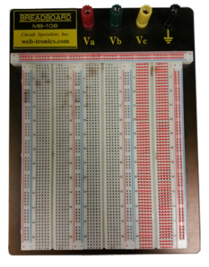

1. **Breadboard Basics**
   1. Letters on the breadboard are used to identify vertical columns.
   2. Numbers on the breadboard are used to identify horizontal rows.

**Figure 2C**

* 1. The red lines in Figure 1 show how vertical columns and horizontal rows are internally connected.
  2. When you connect a power source to a set of vertical columns, you can access voltage (+) and ground (-) from that set of vertically holes.

**Figure 1**

1. **Operational Amplifier (Op Amp) Basics**
   1. The main purpose of this integrated circuit is to amplify a weak signal.
   2. It usually has two inputs (inverting input [2], non-inverting input [3]), and one output (6).
   3. It has a wide range of functions: inverting amplifier, non-inverting amplifier, differential amplifier, voltage follower, summing amplifier, instrumentation amplifier.
   4. In our circuit, we will use it as a non-inverting amplifier. See the Figure 2 schematic.

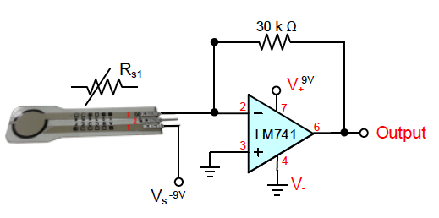

**Figure 2**

1. **Resistor Basics**
   1. As the name implies, a resistor is used in a circuit to create resistance to an electrical current. It limits the current passing through it.
   2. Resistors have variable (Figure 3A) or fixed resistance (Figure 3B). A diagonal line through its symbol denotes that its resistance will vary.
   3. The unit of a resistor is ohms (Ω).



**Figure 3B**

**Figure 3A**

1. **Op Amp 741 Placement**
   1. Locate pin 1, which is identified by a circle.
   2. Place your op amp chip center in-between vertical column “e” and “f.”
   3. Note: Do NOT place your chip in-between “a-e” or “f-j.”

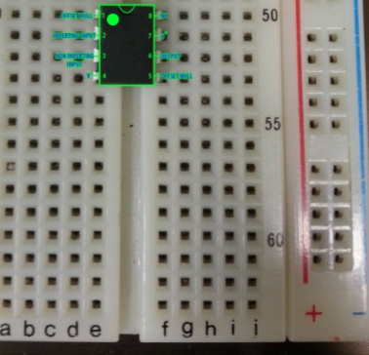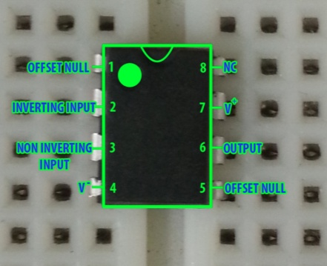

**Figure 4B**

**Figure 4A**

1. **Op Amp 741 – Voltage Connection (V+)**

Connect a wire from pin 7 to your voltage supply (vertical “+” column). See Figures 5A and 5B.

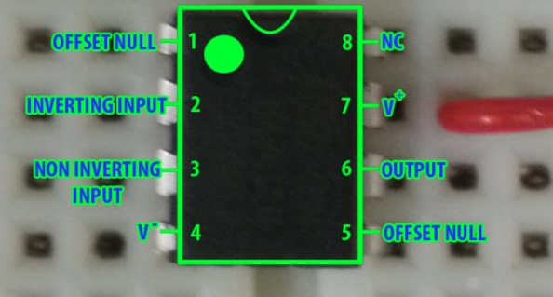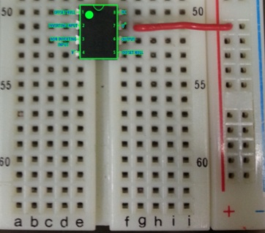

**Figure 5B**

**Figure 5A**

1. **Op Amp 741 – Ground Connection (V+)**

Connect a wire from pin 4 to your ground supply (vertical “-“ column). See Figures 6A and 6B.

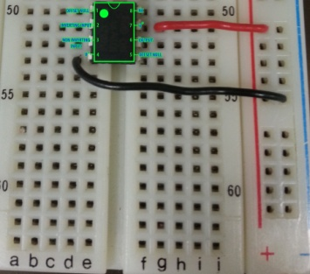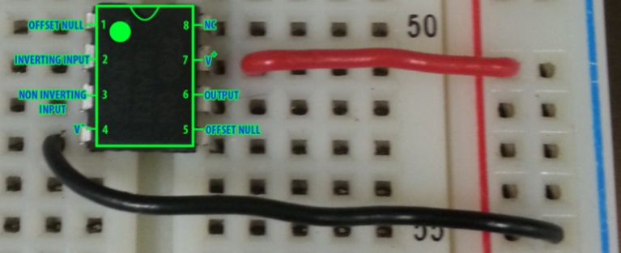

**Figure 6B**

**Figure 6A**

1. **Op Amp 741 – Non-Inverting Input Connection**

Use 2 wires to connect from pin 3 to your ground supply (vertical “-“ column). See Figures 7A and 7B.

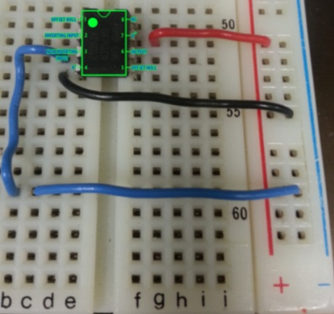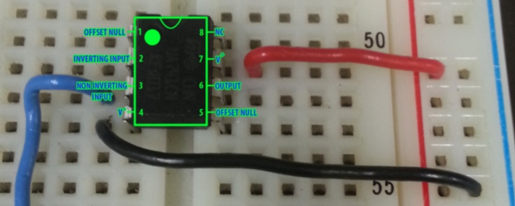

**Figure 7B**

**Figure 7A**

1. **Op Amp 741 – Inverting Input Connection**

Connect a wire from pin 2 to any horizontal row above the op amp chip. See Figures 8A and 8B.

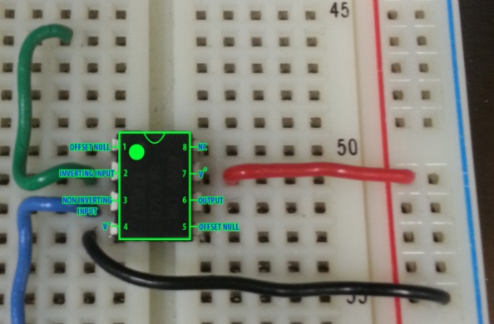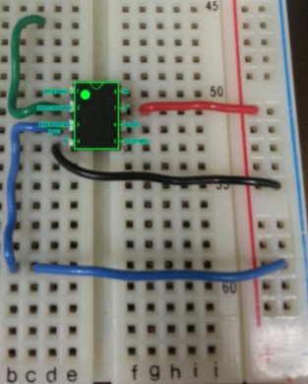

**Figure 8B**

**Figure 8A**

1. **Op Amp 741 – Output Connection**
2. Connect a wire from pin 6 to any horizontal row above the op amp chip.
3. You can choose to horizontally align it to an inverting input row from the previous step.
4. See Figures 9A and 9B.

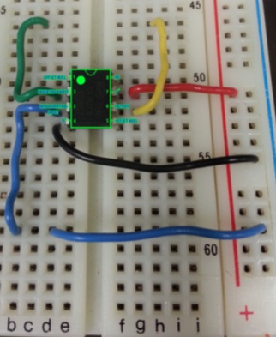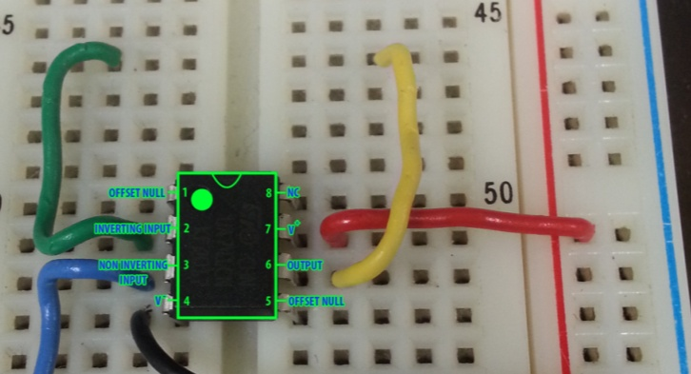

**Figure 9B**

**Figure 9A**

1. **Resistor Connection – 30k Ohms**

Place the 30k ohms resistor in-between your inverting input and output connections.   
See Figures 10A and 10B.

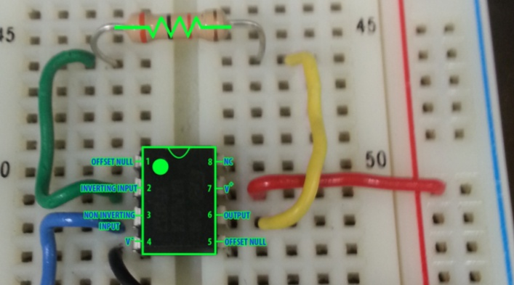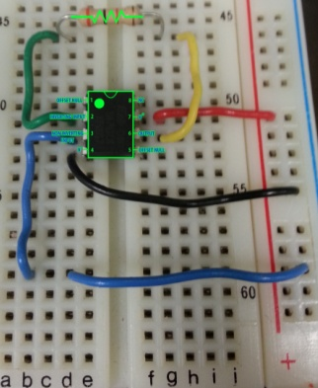

**Figure 10B**

**Figure 10A**

1. **Power Supply – Obtaining +9V and -9V**
2. Place the 9V batteries side by side, as shown in Figure 11A.
3. Connect the two 9V batteries in series. To do this, connect the positive terminal of the left battery to the negative terminal of the right battery.
4. Connect the multimeter to verify the output voltage on each side.
5. Figure 11B shows a reading of a negative voltage.
6. NOTE: REMEMBER WHICH SIDE OUTPUTS NEGATIVE and POSITIVE.
7. NOTE: Connecting batteries incorrectly may cause the batteries to overheat!

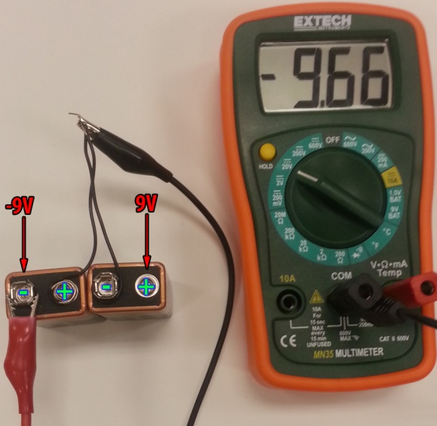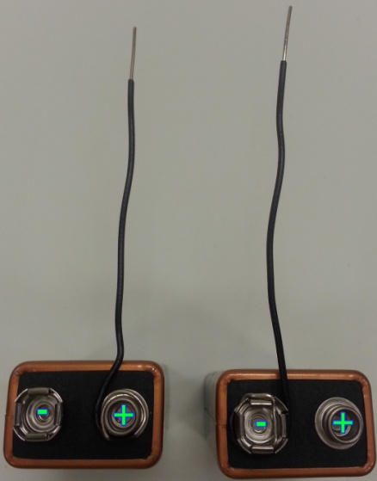

**Figure 11B**

**Figure 11A**

1. **Power Supply – Power Op Amp with +9V**
   1. Disconnect wires in the previous step.
   2. Connect the positive terminal to the positive vertical column on the breadboard.
   3. Connect the negative terminal to the negative vertical column on the breadboard.
   4. NOTE: Connecting batteries incorrectly may cause the batteries to overheat!

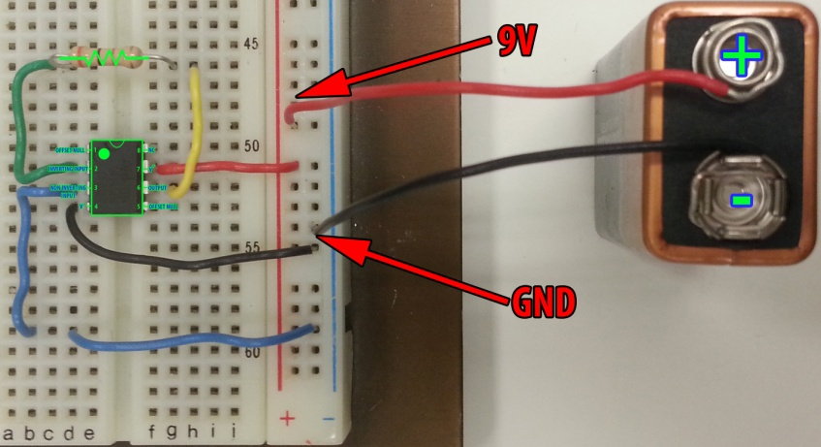

**Figure 12**

1. **Power Supply – Power Sensor with -9V**
   1. Connect the negative terminal to pin 1 of the FlexiForce sensor.
   2. Connect a wire to pin 3 of the FlexiForce sensor
   3. NOTE: PIN 2 DOES NOT GET USED!!
   4. NOTE: Connecting batteries incorrectly may cause the batteries to overheat!

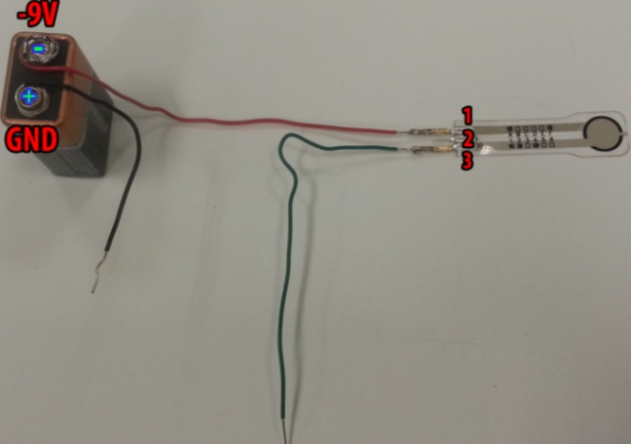

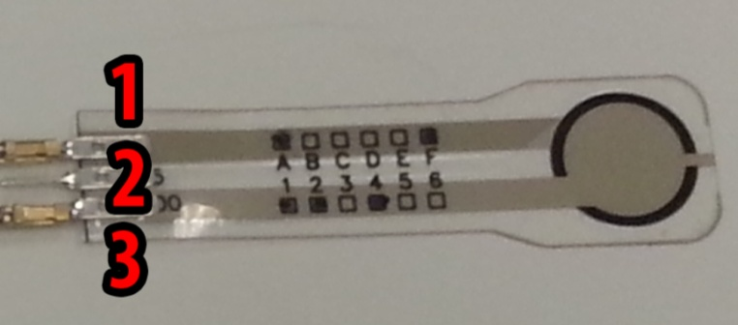

**Figure 13B**

**Figure 13A**

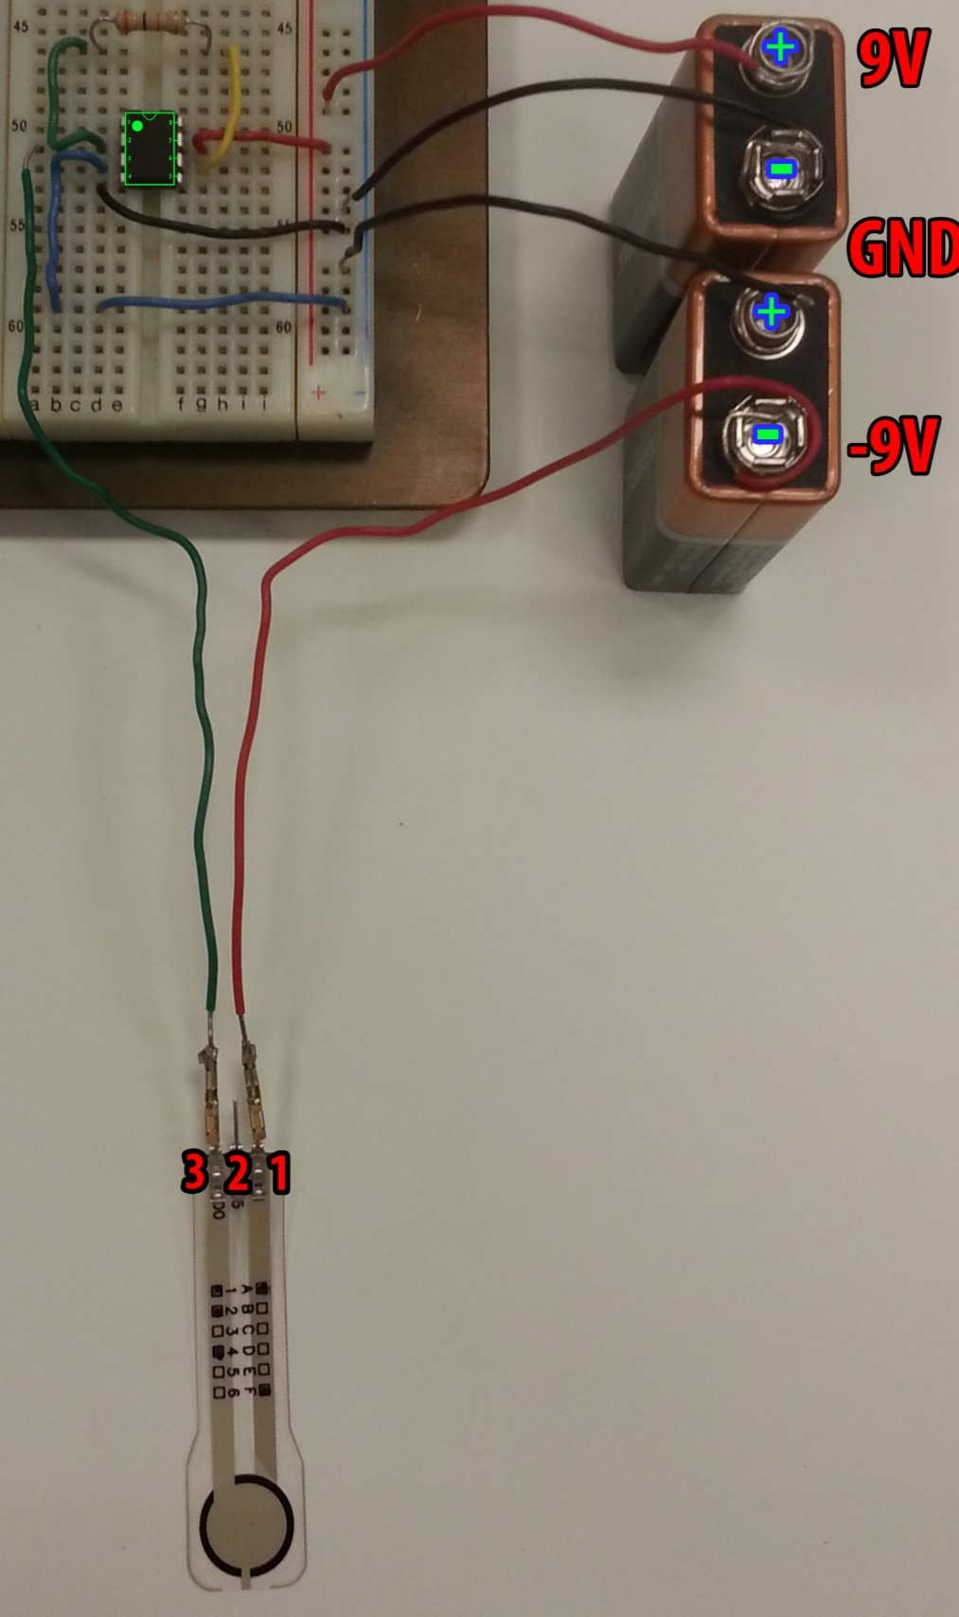

**Figure 14**

1. **Connect Sensor to Breadboard**
   1. Connect the positive terminal of the lower battery to the negative vertical column of the breadboard.
   2. **Connect pin 3 of the FlexiForce sensor to pin 2 of the op amp.**
   3. NOTE: Connecting batteries incorrectly may cause the batteries to overheat!