Designing and Building a Robotic Hand Using
the Force Sensor Circuit GUIDANCE & TIPS

Use this instruction manual to help you design and build a robotic hand. Incorporate the force sensor into the inside of a glove finger. The sensor remains connected to the electric circuit as force is applied to an object. Make sure you have the following items:
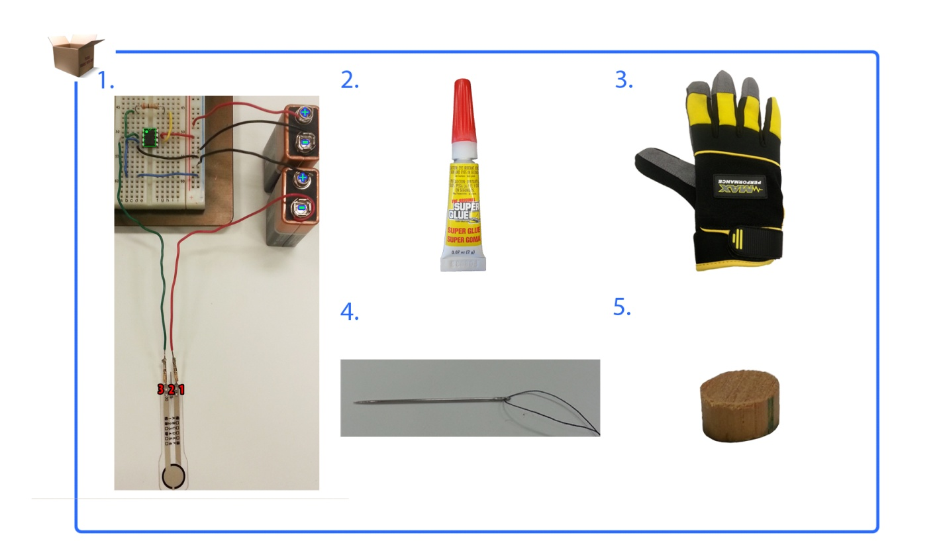
robotic hand circuit with sensor
wood puck
threaded needle
super glue
glove

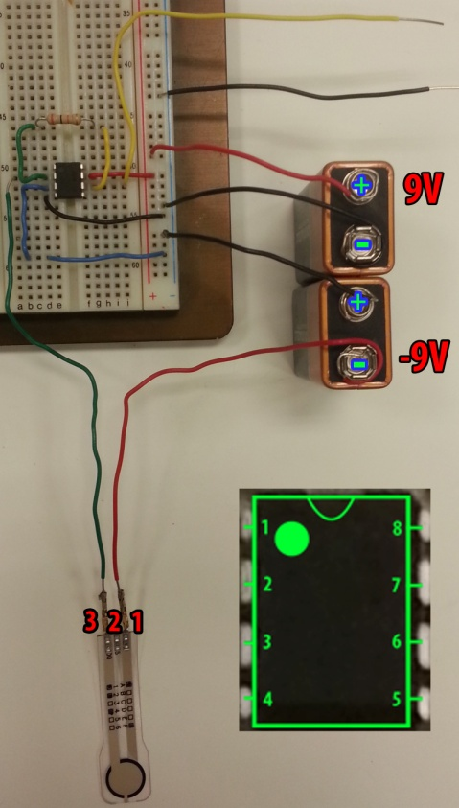
NOTE: Record the minimum force required to crack an egg on the Building an Electric Circuit Evaluation Sheet.

- FlexiForce Sensor
  - Disconnect ONLY the FlexiForce sensor
from the robotic hand circuit.
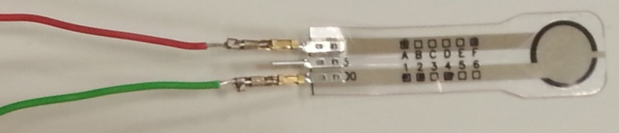
  - You may want to replace some sensor
wires with longer ones.
  - The sensor will be used inside the glove!!
Figure 1

- Glove Stitching Removal
  - Turn glove inside out.
  - Choose any glove finger and remove the stitching from the upper half.
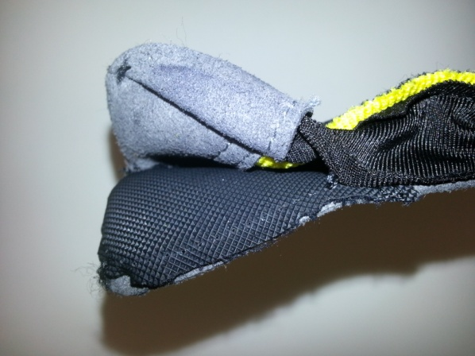
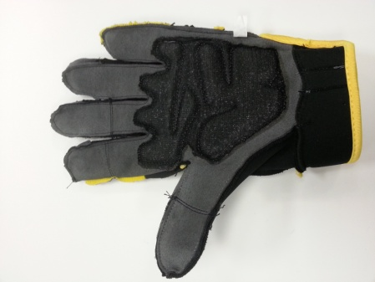

Figure 2A
Figure 2B

- Sensor
  - Turn glove inside out.
  - Place the FlexiForce sensor inside the chosen glove finger.
Tip: The sensor sensing area should be facing DOWN.
  - Secure the sensor inside by sewing around it from side to side.
Tip: Make sure not to pierce the sensor!

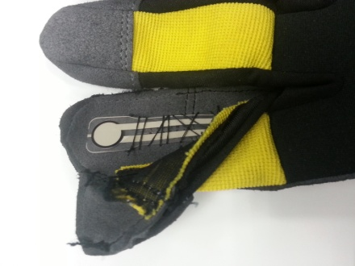
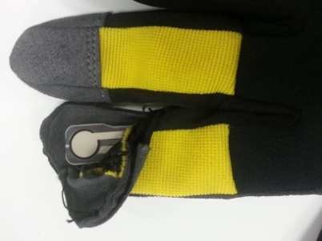

Figure 3A
Figure 3B

- Puck
  - Glue the puck to the sensor sensing area.
The puck is between the sensing area and the glove surface.
  - Sew the glove finger back to its original state.

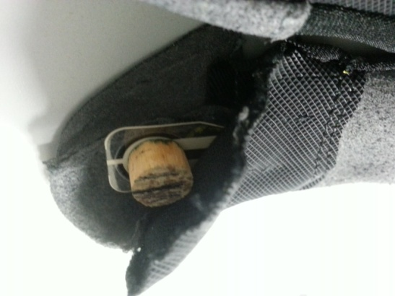

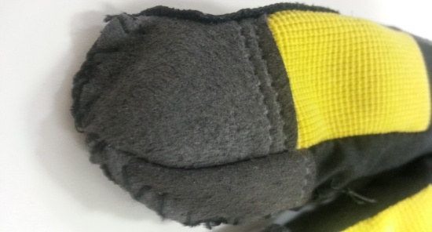

Figure 4B
Figure 4A

- Glove Testing
  - Connect the glove to the robotic hand circuit.
  - Connect the multimeter, if it is not already connected.
  - Add pressure to an object (the egg).
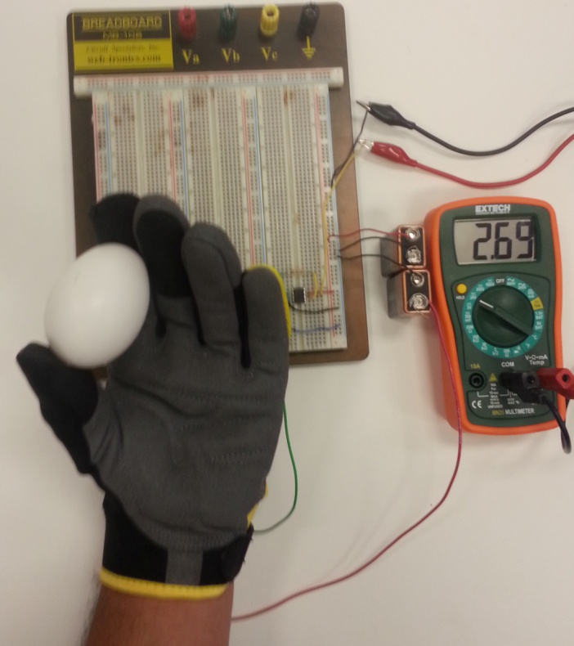
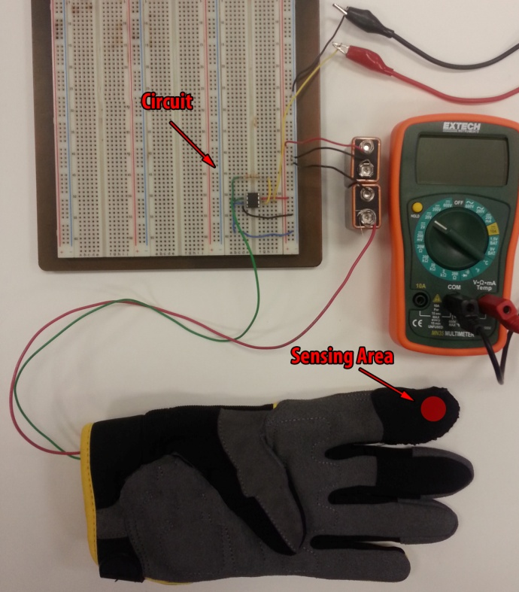

Figure 5B
Figure 5A

