Calibrating the Infrared Range Sensor Worksheet
Follow these instructions to calibrate the sensor and use it to calculate distances.
Materials: infrared range sensor (already assembled), mini multimeter, TI-84 graphing calculator, metric measuring tape
Instructions
- Connect the ground cable (black) of the sensor to the ground cable (black) of the mini multimeter.
- Connect the voltage cable (red) of the sensor to the voltage cable (red) of the mini multimeter.
- Turn on the mini multimeter and sensor.
- Complete the table below.
Extend the measuring tape to 160 cm on the floor (tape it so that it does not move). Place the sensor at 0 on the measuring tape. Position an object (such as a box, book or the wall) at the distances given in the table. Record the voltage readings at each distance.

Distance (cm) | Voltage
20
30
40
50
60
70
80
90
100
110
120
130
140
150

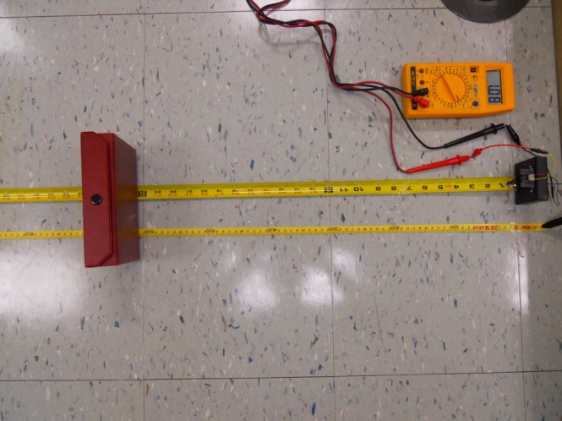

- Input the distances in L1 in your calculator by following these steps.
  - Press the STAT key.
  - Select 1: Edit > press ENTER.
  - Make sure L1 and L2 are clear. If they have information, use the up arrow to select L1 > press CLEAR > and then ENTER. Repeat these steps for L2.
  - Input the distances in L1.
  - Input the voltages in L2.
  - Press STAT > use the right arrow to select CALC > go down to QUART REG > press ENTER > scroll down to STORE REGEQ > press VARS > select Y-VARS > and press ENTER twice.
  - Press WINDOW > set the Xmin = 0, Xmax = 160, Xscl = 10, Ymin = 0, Ymax = 3, Yscl = 0.01 > and press GRAPH.
  - Press 2nd GRAPH to view the table with possible x and y values.
You will use this information to calculate the slant range (distance between the airplane and the radar) in the next part of the activity.
The graph should look similar to the one below.

