Catching the Perfect SAR Waves: “Radar” System Calibration

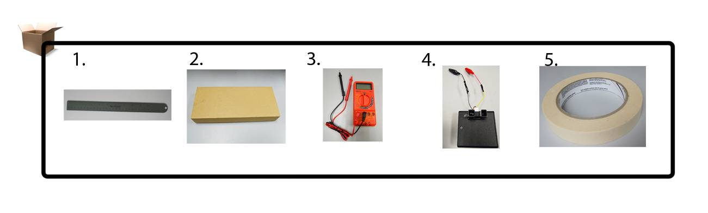
1. Standard Ruler | 2. Small Box or Indoor wall | 3. Multimeter | 4. Sharp® GP2Y0A02YK0F Sensor | 5. Masking Tape
Note: The GP2Y0A02YK0F infrared takes a continuous distance reading and returns a corresponding analog voltage with a range 20 cm to 150 cm.

- Measuring Tape Setup
  - Choose a relatively flat surface.
  - Place 170 cm of masking tape on the surface.
  - Using a ruler and marker, label 10 cm apart starting at 20 cm and ending at 150.
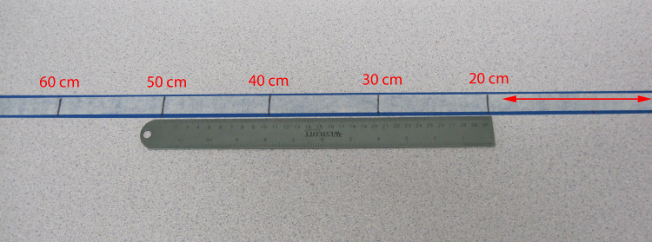
- Sensor and Multimeter Setup
  - Place the front of the sensor’s light emitter/detector at 20 cm.
  - Connect a multimeter to read analog voltages (set at 20 V).
  - Turn on your “radar” system unit and record voltage and distance using the
Mathematical Model handout.
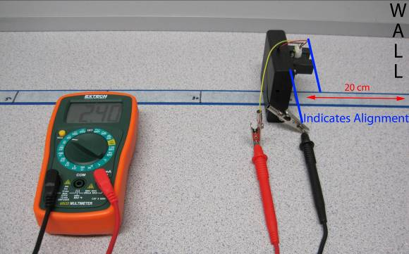

- Sensor Relocation
  - Shift the front of the sensor’s light emitter/detector to 30 cm.
  - Record voltage and distance.
  - Keep shifting sensor back 10 cm and record voltage and distance until it reaches 150 cm.

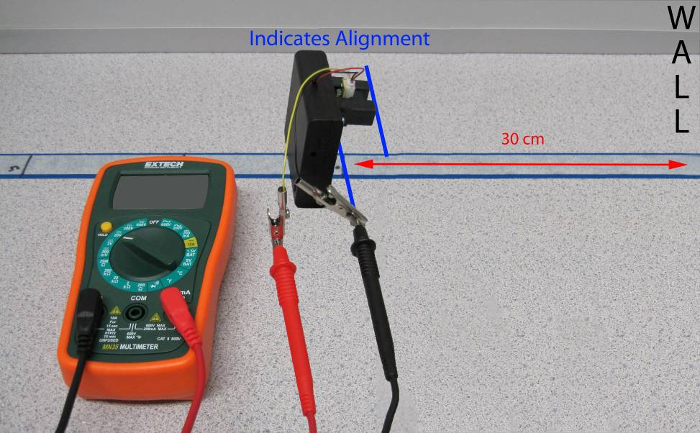

Alternative Calibration using Box and Measuring Tape Placement

