Catching the Perfect SAR Waves: “Radar” System Construction

Materials:

1. Sharp® GP2Y0A02YK0F Sensor
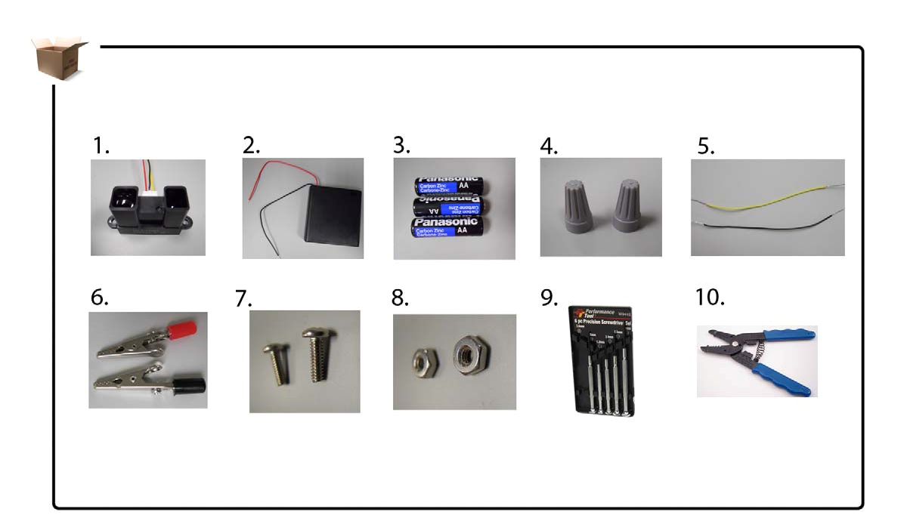

6. Alligator
clips
2. Four AA battery holder with cover & switch
7. 2 #4-40 x 3/4 screws
3. 3 AA alkaline batteries

8. 2 combo hex nuts from each screw
4. 2 wire connectors

9. Precision
screw set
5. Yellow and black
2” shield wire

10. Wire
stripper

1. Pre-Mark and Drill
a. Make sure that your four AA battery holder is OFF.
b. Open your four AA battery holder with a Phillips screwdriver.
c. Pre-mark the holder’s lid on the outside with two holes using a 9/64 dill bit about
37 mm apart. The holes should be directly above battery slot #1.
d. Verify that your battery holder doesn’t contain batteries.
e. Identify the lower part of your four AA battery holder (not the lid).
f. Mark and drill into the side of slot #1 of your battery holder.
i. Pre-mark the outside lower part of your holder in the middle.
ii. Drill the hole using the same bit.
g. Mark and drill inside your holder (adjacent to the positive terminal of slot #1). This allows the holder’s VCC and ground wires to enter into slot #1.
i. Pre-mark the edge of your holder above the VCC and ground wire opening with a 4mm diameter. Drill the hole.

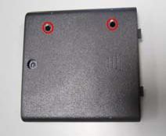
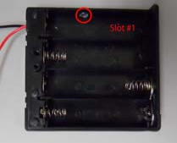

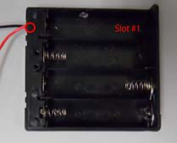

1b 1e 1f

2. Sensor Stabilization
a. Align the drilled holes on the holder’s lid with the sensor earlobe holes. b. Run a #4-40 x 3/4 machined screw through each hole.
c. Secure the sensor by using a hex nut on each screw inside the battery holder.

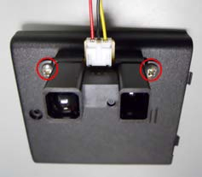
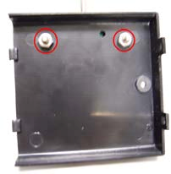

2b 2c

Caution: Your teacher must verify that all wires are making appropriate contact with indicated wires only. Use wire connectors to secure multiple wires.

3. Serial and Parallel Holder Configuration
a. Insert the AA batteries into Slots 2-4 (labeled as S2-S4) correctly.
b. Pop out the ground (negative) terminal in slot #1 with a flat screwdriver. c. Using the yellow shield wire, connect it around the ground terminal.
d. Slide in the ground terminal into slot #1 and slide the other end of the shield wire under the positive terminal or wrap it around the terminal.
e. Note: You may verify that you made a proper configuration with a multimeter.

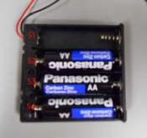
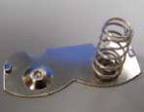

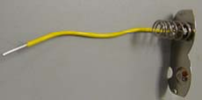

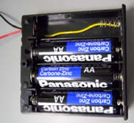

2a 2b 2c 2d
4. Sensor Connections
a. Run the ground (black) and VCC (red) wires coming out of the sensor unit through the hole on the battery holder lid (made in 1e).
b. Run the exiting ground (black) and VCC (red) wires from the lower part of the battery holder back inside to slot #1 (using the hole made in 1f).
c. Group the ground (black) wire from the sensor and the holder along with an additional ground (black) wire inside the battery holder. Connect all three wires with a wire-connector. Run the third wire added out through the hole in lower part of your battery holder (made in 1e).
d. Group VCC wires from the sensor unit and the battery holder. Connect them using a wire connector.
e. Neatly place all connected components inside slot #1 of the battery holder and close the battery holder.

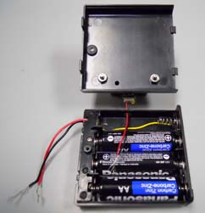
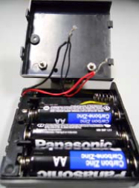

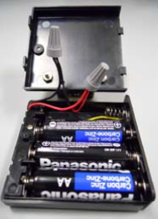

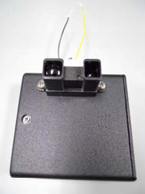

3a 3c 3d 3e

5. Alligator Clips
a. Loosen the screw on both alligator clips using a Phillips screwdriver.
b. Insert exiting yellow and black wires into each alligator clip and wrap around beneath alligator screw head.
c. Tighten each alligator screw.


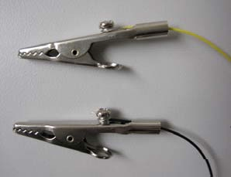

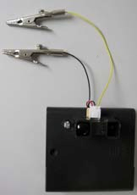

5a 5b 5b

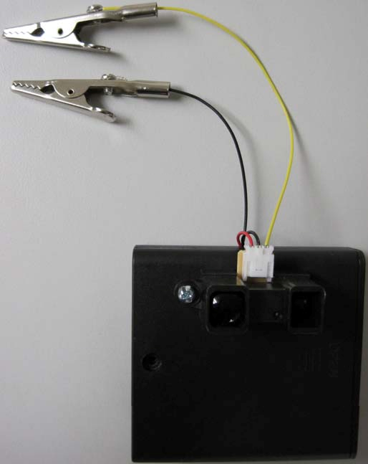
5c

